CSE1500 Database Technology Midterm

Contents

Chapter1. Databases and Database Users 2

Characteristics of the database approach 4

Self-Describing Nature of a Database System (Meta-Data) 4

Data Abstraction 5

Views 6

Multiuser Transaction Processing 6

Database stakeholders 6

Database Administrators (DBA) 6

Database Designer 6

End Users 7

System analysts 7

Application programmers/Software developers/Software engineers 7

DBMS system designers and implementers 7

Tool developers 7

Operators and mantianence personal 7

Chapter 2. Database System concepts and Architecture 7

2.1 Data Models, Schemas and Instances 8

2.1.1 Categories of Data Models 8

2.1.1 Schemas, Instances, and Database State 8

2.2 Three-Schema Architecture and Data Independence 9

Architecture, low/physical level: 10

Conceptual Level 10

View Level 10

2.2.2 Data Independence 10

2.3 Database Languages and Interfaces 11

2.3.1 DBMS Langauges 11

2.3.2 DBMS Interfaces 11

2.4 Database System Environment 12

2.4.1 DBMS Component Modules 12

2.4.2 Database System Utilities 12

2.5 Centralized and Client/Server Architectures for DBMSs 13

Centralized architecture 13

Client/Server architecture 13

Two-tier architectures (use APIs) 14

Three-tier acrchitectures 14

2.6 Categories of DBMS 14

Chapter 5. The Relational Data Model and Relational Database Constraints 15

5.1 Relational Model Concepts 15

5.1.1 Domains, Attributes, Tuples, and Relations 15

5.1.2 Characteristics of Relations 16

5.1.3 Relational Model Notation 16

5.2 Relational Model Constraints and Relational Database Schemas 16

5.2.1 5.2.2 Key Constraints and Constraints on NULL Values 17

5.2.3 Relational Databases and Relational Database Schemas 17

5.2.4 Entity Integrity, Referential Integrity, and Foreign Keys 18

5.3 Insert, Delete, and Update Operations dealing with constraints 20

5. 4 The Transaction Concept 20

Lecture 1 Introduction to Database Systems 20

Chapter 3. Data Modeling with Entity-Relationship (ER) Model 30

3.1 Using High-Level Conceptual Data Models for Database Design 30

Conceptual Design (Schema) 31

3.3 Entity Types, Entity Sets, Attributes and Keys 32

Entity type 33

Example 34

3.4 Relationship Types, Relationship Sets, Roles, and Structural Constraints 35

3.7 ER Diagram Naming Conventions 37

Lecture 2. Introduction to Modelling 39

Chapter 4. The Extended EER Model 56

4.1 Subclasses, Superclasses, and Inheritance 56

Subtype/subclass entity type 56

4.2 Specialization and Generalization 57

4.2.1 Specialization 57

4.2.2 Generalization 57

4.3 Constraints and Characteristics of Specialization and Generalization Hierarchies 57

4.3.1 Constraints on Specialization and Generalization 57

4.3.2 Specialization and Generalization Hierarchies and Lattices 58

4.7 Ontology 58

Lecture 3. The Relational Model 59

Lecture 4. More on Modelling 75

Lecture 5. Functional Dependencies and Normalization 84

Chapter 14. 99

14.1 Informal Design Guidelines for Relation Schemas 99

14.2 Functional Dependencies 100

14.3 Normal Forms Based on Primary keys 101

Lecture 6 103

Lecture 7 – SQL 107

6.1 SQL Data Definition and Data Types 107

Data types 108

Constraints 109

6.3 Basic Retrieval Queries in SQL 111

Duplicates 112

Set Operators 112

Substring Pattern Matching 112

Ordering 113

INSERT, DELETE and UPDATE 113

Comparison involving NULL and three-valued logic 114

Nested Queries 115

Lecture - Joins 116

Alter Tables 125

Add column 125

Drop column 125

Add constraint 125

Drop constraint 125

Change default, data type 125

Renaming column, table 125

Lecture 8 126

# Chapter1. Databases and Database Users

An app where operations with a database are central it’s called a database application. New platforms have pushed the creation of databses that store nontraditional data (images, video, etc. instead of plain text and numbers).

New types of database systems are often referred to as big data storage systems or NOSQL systems, which have been created to manage data for social media applications, and are used by companies such as Google, Amazon and Yahoo to manage the data requried in their web search engines as well as to provide cloud storage.

OLAP = online analytical processing systems used to extract and analyze useful business information from large databases to support decision making.

real-time active and active database technology = used to control industrial and manufacturing processes

database search techniques = used by search engines.

**database:** collection of related data. Furthermore, a database has the following implicit properties:

1. It **represents an aspect of the real world**, and changes of the world are reflected in the database.
2. It is a **logically coherent collection of data** with some inherent meaning. Random assortment of data cannot be referred to as a database
3. It is designed, built and populated with data **for a specific** **purpose**. It has an intended group of **users** and an application in which the users are interested.

A database can be of any size and complexity.

A database can be distributed over several servers and be acessed by millions of users.

A database can be manually mantained (such as a library card system) or computeried (the same thing but digital).

A **database management system** (DBSM) is a computerized system that enables users to create and mantain a database. It is a **general purpose software system** that facilitates the process of

**defining:** specifying data types, structures and constrains. This descriptive information is stored by the DMS in the form of a “database catalog/dictionary” called meta-data (which can be accessed by queries to skip things and be faster).

**constructing:** storing the data on some storage medium

**manipulating:** querying (SCRUD), and reports.

**and sharing** databses among users and applications.

**a transaction is a type of query that makes a simultaneous read and write in different locations**.

the DBMS also **protects** (crashes and security) and **mantains** (allow for updates and changes) the database.

DBMS is often shortened as **database system**.

Design of a new application for an existing database or design of a brand new database starts off with a phase called **requirements specification and analysis.** These requirements are documented in detail and transformed into a conceptual design that can be represented and manipulated using some computerized tools so that it can be easily maintained, modified, and transformed into a **database implementation.**

The design is then translated to a **logical design** that can be expressed in a data model implemented in a commercial DBMS. The final stage is **physical design**, during which further specifications are provided for storing and accessing the database

## Characteristics of the database approach

**traditional file processing:** each user defines and implements files needed for a specific software application as part of programming the application (i.e. container classes in java). Different users may required different data, that might be related in some sort of way. But you don’t want to constantly merge data into new objects ad-hoc per query.

Instead, the **database approach** has a single repository that mantains the data, where it has been defined once and then such data may be accesed by various users, repteadly, through queries, transactions and application programs. A database approach has:

1. self-describing nature of the database system
2. Insulation between programs and data
3. Support of multiple views of the data
4. Sharing of data and multiuser transaction processing

### Self-Describing Nature of a Database System (Meta-Data)

Database systems not only contain the database itself, but also a complete definition or description of the database structure and constraints, called “meta-data” which is stored in the DBMS catalog, and contains the structure of each file, type and storage format, and data constraints. Newer systems such as NOSQL do not require meta-data because it is “self describing”.

DBMS software can access diverse databases by extracting the database definitions from the catalog and using these definitions.

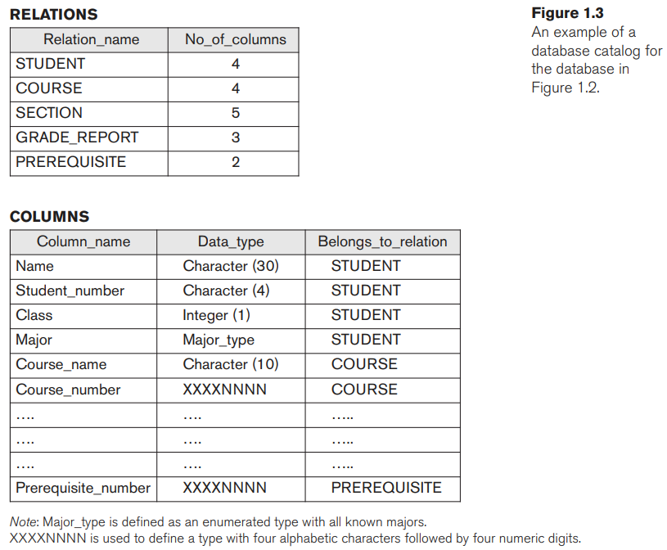

### Data Abstraction

#### Program-data independence

We only need to change the description of a table in the catalog instead of rwriting an entire program:

*In traditional file processing, the structure of data files is embedded in the application programs, so any changes to the structure of a file may require changing all programs that access that file. By contrast, DBMS access programs do not require such changes in most cases. The structure of data files is stored in the DBMS catalog separately from the access programs.*

#### Program-operation independence

An operation (also called a function or method) is specified in two parts. The interface (or signature) of an operation includes the operation name and the data types of its arguments (or parameters). **The implementation (or method) of the operation is specified separately and can be changed without affecting the interface**. **User application programs can operate on the data by invoking these operations through their names and arguments**, regardless of how the operations are implemented.

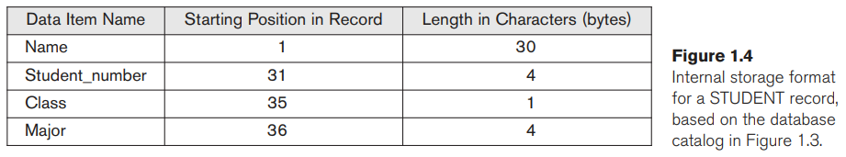

#### Data model

It is a very used term with different definitions, but in the context of data abstraction a data model is a simplified visual representation of a data abstraction by using logic symbols and shapes to define relationships and properties of objects (such as ER or UML models).

SQL is the standard data model and language for relational databases.

NOSQL is generally interpreted as Not Only SQL.

### Views

A DBMS has support for views, a view is a read-only representation of database contents that is originated from a set of SELECT statements often combined with JOIN.

### Multiuser Transaction Processing

**Online transaction processing (OLTP) applications:** A multiuser DBMS, as its name implies, must allow multiple users to access the database at the same time. This is essential if data for multiple applications is to be integrated and maintained in a single database. The DBMS must include concurrency control software to ensure that several users trying to update the same data do so in a controlled manner so that the result of the updates is correct. For instance a DBMS should ensure that each flight seat can be accessed by only one agent at a time for assignment to a passenger.

**Transaction**: A transaction is an executing program or process that includes one or more database accesses, such as reading or updating of database records. It has the following properties:

1. **Isolation:** The isolation property ensures that each transaction appears to execute in isolation from other transactions, even though hundreds of transactions may be executing concurrently
2. **Atomicity:** either all the database operations in a transaction are executed or none are. (i.e. transfering money from one account to another can’t be allowed to be half finished, either money leaves account A AND arrives account B or no money leaves A AND no money arrives B)

## Database stakeholders

### Database Administrators (DBA)

Administrates the database environment: the database itself (primary resource) and the DBMS and related software (secondary resource).

The admin authorizes access to the database, coordinates and monitors its use, mantains the database with software and hardware updates, responsible for security and response time.

### Database Designer

Choose appropiate structures to represent and store the data, before the database is actually implemented and populated. It coordinates the requirements and makes a design that meets them.

### End Users

They access the database for querying, updating, and generating reports.

* **Casual end users**: Use a sophisticated database query interface to specify their requests and a typically middle or high level managers
* **Naive/parametric end users**: They make queries and update the database using standard types of queries and updates (called canned transactions) that have been already programmed and tested (so they use a GUI, they dont write the query themselves)
* **Sophisticated end users**: engineers, scientists, business analysts who directly use the DBMS for their own uses.
* **Standalone users**: mantain personal databases by using ready-to-use packages with GUIs.

### System analysts

Determien the requirement of end users and develop specifications for standard canned transactions to meet these requirements.

### Application programmers/Software developers/Software engineers

Implement these specifications as sprograms (test, debug, comment and mantain too) and are fully familiar with the capabilities by the DBMS.

### DBMS system designers and implementers

Design and implement the DBMS modules and interfaces as a software package.

### Tool developers

design and implement tools—the software packages that facilitate database modeling and design, database system design, and improved performance.

### Operators and mantianence personal

(system administration personnel) are responsible for the actual running and maintenance of the hardware and software environment for the database system.

# Chapter 2. Database System concepts and Architecture

Modern DBMS packages are modular in design, with a client/server system architecture. Old ones where a tightly integrated system.

The rapid growth of data has promoted the trends in computing where large centralized mainframe computers are being replaced by hundreads of distributed workstations.

Cloud computing environments consist of thousand of large servers managing big data for users on the Web.

In a basic client/server DBMS architecture, the system functionality is distributed between two types of modules. A **client module** is typically designed so that it will run on a mobile device, user workstation, or personal computer (PC). Usuall include user-friendly interfaces such as apps for mobile devices, or forms- or menubased GUIs (graphical user interfaces) for PCs. A **server module** typically handles data storage, access, search, and other functions.

## 2.1 Data Models, Schemas and Instances

A data abstraction is a **highlight of the essential features** of the data of a database. A data model is a mean to represent a data abstraction.

**Data models show the structure of a database**, which constitutes, among other things, the data types, relationships, and constraints that apply to the data.

### 2.1.1 Categories of Data Models

* **High level/Conceptural data models:** define high level concepts perceived mostl at the front-end experience of its users. Ubckyde cibceots such as **entities** (represent a real world-object or concept i.e. ‘employee’, ‘supplier’), **atributes** (properties that describe an entity i.e. ‘name’, ‘salary’), **relationships** (i.e. ‘project’ and ‘consultant’).
* **Low level/Physical data models:** describe the details of how data is stored (on the disk) as files in the computer by representing information such as record formats, record orderings, and access paths, these details are not meant for the end users. **acces path:** is **a search structure that makes the search for particular database records efficient, such as indexing or hashing.**
* **Representational/implemention data models:** mid-level description of how data is organized. common in traditional commercial DBMS, include the relational data model, as well as legacy data models (network and hirearchical models commonly used in the past). Representational data models represent data by using record structures and sometimes are called record-based data models.
* **Object data model:** new higher-level implmenation model closer to conceptual models, often referred to as ODMG (Object Data Model Group)
* **Self-describing data models:** The data storage in systems based on these models combines the description of the data with the data values themselves. In traditional DBMSs, the description (schema) is separated from the data. These models include **XML**, as well as many of the key-value stores and NOSQL systems that were recently created for managing big data.

### 2.1.1 Schemas, Instances, and Database State

Schema: description of a database. It is specified during database design adn it is not expected to change very often. A schema diagram displays the structure of each record type but not the actual instances of records. A schema diagram displays only some aspects of a schema, such as the names of record types and data items, and some types of constraints

Each object in the schema (such as STUDENT or COURSE) is a schema construct.

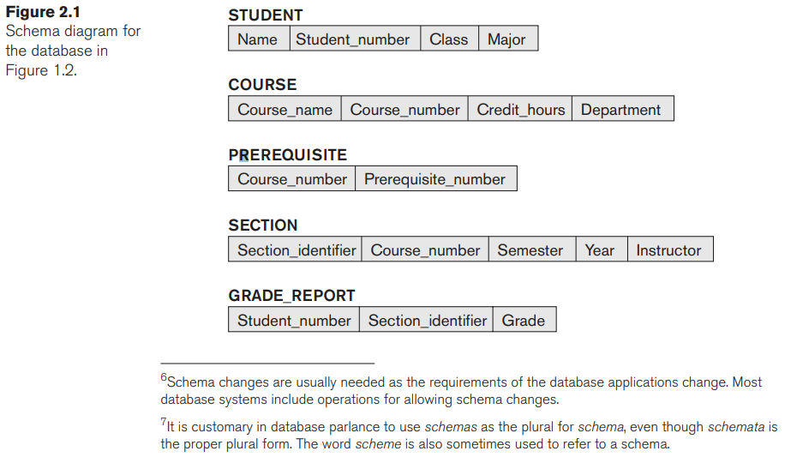

The data in the database at a particular moment in time is called a database state or snapshot. It is also called the current set of occurrences or instances in the database. Every time we insert or delete a record or change the value of a data item in a record, we change one state of the database into another state.

When we define a new database, we specify its database schema only to the DBMS. the corresponding database state is the empty state with no data.

We get the initial state of the database when the database is first populated or loaded with the initial data. From then on each new modification of the data represents a new database state.

The DBMS is partly responsible for ensuring that every state of the database is a valid state—that is, a state that satisfies the structure and constraints specified in the schema.

The schema is sometimes called the intension, and a database state is called an extension of the schema.

Making changes in let’s say STUDENT and adding another field suchas Email is known as schema evolution.

## 2.2 Three-Schema Architecture and Data Independence

1. **Use a catalog to store the database description (Schema) so as to make it self-desribing**The three schemas are only descriptions of data; the actual data is stored at the physical level only. The processes of transforming requests and results between levels are called mappings.
2. **Insulation of programs and data**
3. **Support of multiple user views**

### Architecture, low/physical level:

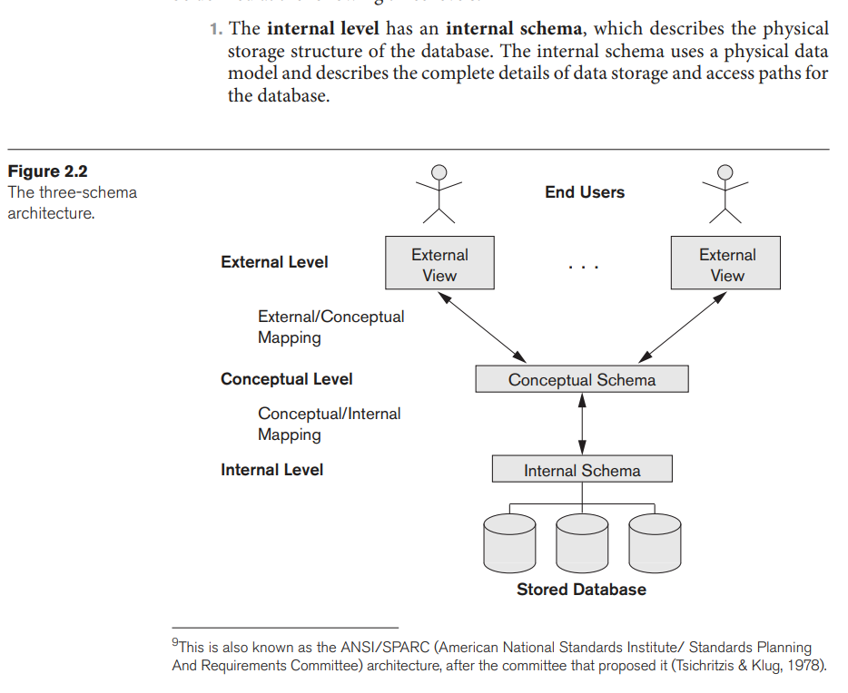

### Conceptual Level

The conceptual level has a conceptual schema, which describes the structure of the whole database for a community of users. This implementation is often based on a conceptual schema design in a high-level data model.

### View Level

The external or view level includes a number of external schemas or user views. , each external schema is typically implemented using a representational data model, possibly based on an external schema design in a high-level conceptual data model

### 2.2.2 Data Independence

The capacity to change the schema at one level of a database system without having to change the schema at the next higher level.

1. Logical data independence is the capacity to change the conceptual schema without having to change external schemas or application programs.
2. Physical data independence is the capacity to change the internal schema without having to change the conceptual schema.

## 2.3 Database Languages and Interfaces

### 2.3.1 DBMS Langauges

One language, called the **data definition language** (**DDL**), is used by the DBA and by database designers to define conceptual and internal schemas. The DBMS will have a DDL compiler whose function is to process DDL statements in order to identify descriptions of the schema constructs and to store the schema description in the DBMS catalog.

The DDL is used to specify the conceptual schema only. Another language, the **storage definition language** (**SDL**), is used to specify the internal schema.

In most relational DBMSs today, there is no specific language that performs the role of SDL. Instead, the internal schema is specified by a combination of functions, parameters, and specifications related to storage of files.

**View definition language** (**VDL**): to specify user views and their mappings to the conceptual schema, but in most DBMSs the DDL is used to define both conceptual and external schemas.

Once the database schemas are compiled and the database is populated with data, users must have some means to manipulate the database, The most common “SCRUD” select, create, read, update, delete are supported by the **data manipulation language** (**DML**). **SQL** is the most common relational database language, which represents a **combination** of **DDL, VDL and DML**. The SDL was a component in early versions of SQL but has been removed from the language to keep it at the conceptual and external levels only.

A query in a high-level DML often specifies which data to retrieve rather than how to retrieve it; therefore, such languages are also called declarative.

A high-level DML used in a standalone interactive manner is called a query language.

### 2.3.2 DBMS Interfaces

User-friendly interfaces provided by a DBMS may include the following:

1. Menu-based Interfaces for Web Clients or Browsing.
2. Apps for Mobile Devices
3. Forms-based Interfaces
4. Graphical User Interfaces
5. Natural Language Interfaces
6. Keyword-based Database Search
7. Speech Input and Output
8. Interfaces for Parametric Users (small commands to minimize data entry time)
9. Interfaces for the DBA (that support his exclusive admin rights activites)

## 2.4 Database System Environment

### 2.4.1 DBMS Component Modules

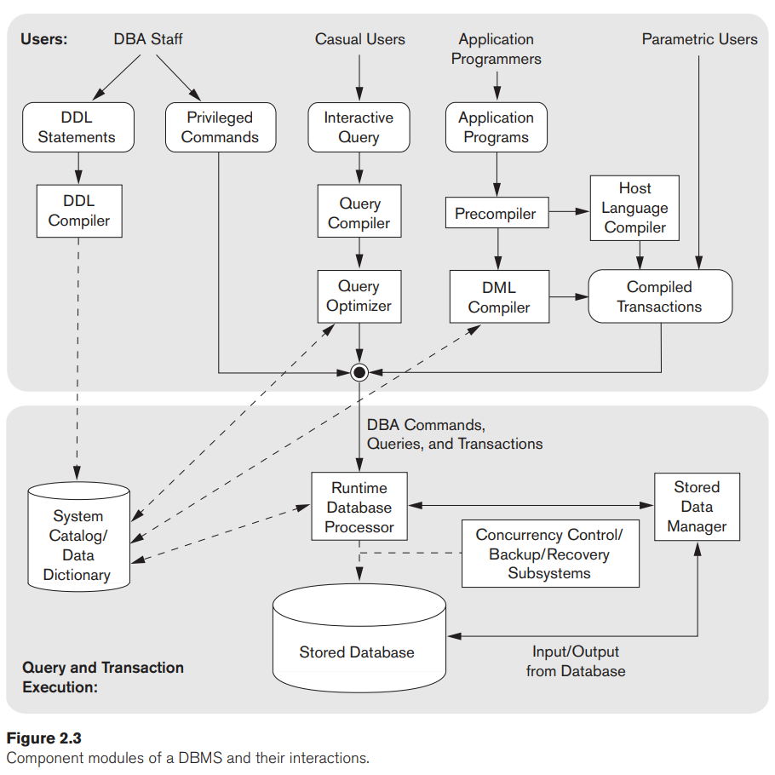

### 2.4.2 Database System Utilities

1. **Loading:** A loading utility is used to load existing data files—such as text files or sequential files—into the database.
2. **Backup:** A backup utility creates a backup copy of the database, usually by dumping the entire database onto tape or other mass storage medium.
3. **Database storage reorganization:** This utility can be used to reorganize a set of database files into different file organizations and create new access paths to improve performance.
4. **Performance monitoring:** monitors database usage and provides statistics to the DBA.

### 2.5 Centralized and Client/Server Architectures for DBMSs

### Centralized architecture

At the beginning the DBMS itself was centralized where the DBMS functionality, application program execution, and user interface processing were carried out on one machine. Allocating all of the processing power at the DBMS side (people did not have resourceful PCs back then and connected to the DBMS via terminals so mostly Display operations were carried at the user side).

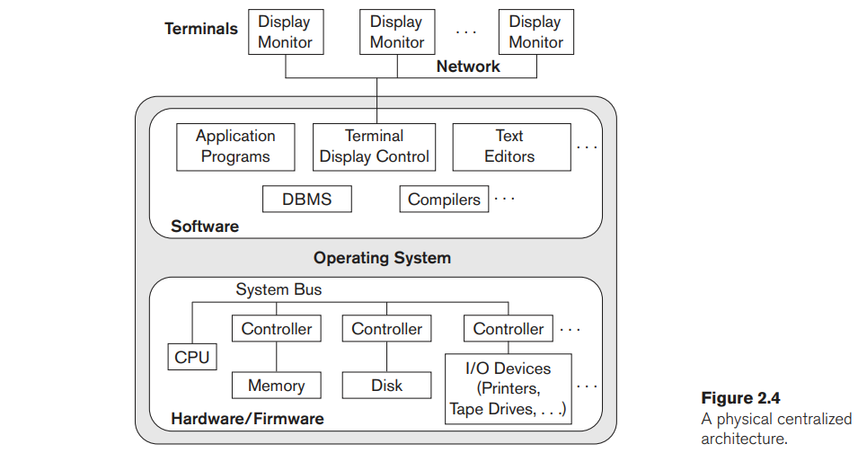

### Client/Server architecture

The client/server architecture was developed to deal with computing environments in which a large number of PCs, workstations, file servers, printers, database servers, Web servers, e-mail servers, and other software and equipment are connected via a network.

The idea is to define specialized servers with specific functionalities. For example, it is possible to connect a number of PCs or small workstations as clients to a file server that maintains the files of the client machines. Another machine can be designated as a printer server by being connected to various printers; all print requests by the clients are forwarded to this machine. Web servers or e-mail servers also fall into the specialized server category. The resources provided by specialized servers can be accessed by many client machines. The client machines provide the user with the appropriate interfaces to utilize these servers, as well as with local processing power to run local applications.

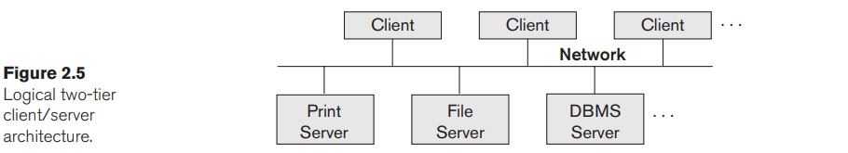

### Two-tier architectures (use APIs)

A standard called Open Database Connectivity (ODBC) provides an application programming interface (API), which allows client-side programs to call the DBMS, as long as both client and server machines have the necessary software installed.

A related standard for the Java programming language, called JDBC, has also been defined. This allows Java client programs to access one or more DBMSs through a standard interface.

### Three-tier acrchitectures

Adds an intermediate layer between the client and the database server.

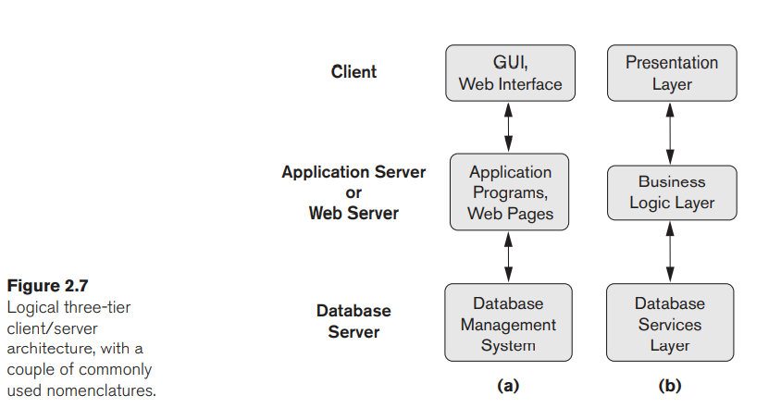

## 2.6 Categories of DBMS

We can categorize DBMSs based on the **data model**: relational, object, object-relational, NOSQL, key-value, hierarchical, network, and other (such as tree-structured XML data model).

The second criterion used to classify DBMSs is the **number of users** supported by the system. Single-user systems support only one user at a time and are mostly used with PCs. Multiuser systems, which include the majority of DBMSs, support concurrent multiple users.

The third criterion is the number of sites over which the database is **distributed**. A DBMS is centralized if the data is stored at a single computer site. A centralized DBMS can support multiple users, but the DBMS and the database reside totally at a single computer site. A distributed DBMS (DDBMS) can have the actual database and DBMS software distributed over many sites connected by a computer network. Big data systems are often massively distributed, with hundreds of sites. The data is often replicated on multiple sites so that failure of a site will not make some data unavailable.

The fourth criterion is **cost**. It is difficult to propose a classification of DBMSs based on cost. Today we have open source (free) DBMS products like MySQL and PostgreSQL that are supported by third-party vendors with additional services.

We can also classify a DBMS on the basis of the **types of access path options for storing files**. One well-known family of DBMSs is based on inverted file structures.

Finally, a DBMS can be **general purpose or special purpose**. When performance is a primary consideration, a special-purpose DBMS can be designed and built for a specific application; such a system cannot be used for other applications without major changes. Many airline reservations and telephone directory systems developed in the past are special-purpose DBMSs. These fall into the category of online transaction processing (OLTP) systems, which must support a large number of concurrent transactions without imposing excessive delays.

# Chapter 5. The Relational Data Model and Relational Database Constraints

## 5.1 Relational Model Concepts

The relational model represents the database as a collection of relations.

Each relation resembles a table of values or, to some extent, a flat file of records.

When a relation is thought of as a table of values, each row in the table represents a record, which multiple attributes (columns).

### 5.1.1 Domains, Attributes, Tuples, and Relations

A domain D is a set of atomic values. By atomic we mean that each value in the domain is indivisible as far as the formal relational model is concerned. A common method of specifying a domain is to specify a data type from which the data values forming the domain are drawn. For example, the column with header Usa_phone_number, has a domain of the set of ten-digit phone numbers valid in the United States. This is a logical defintion of a domain. A data type or format is also specified for each domain. For example, the data type for the domain Usa_phone_numbers can be declared as a character string of the form (ddd)ddd-dddd, where each d is a numeric (decimal) digit and the first three digits form a valid telephone area code. **A domain is thus given a name, data type, and format.**

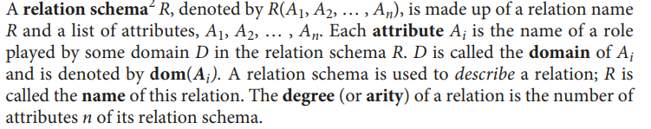

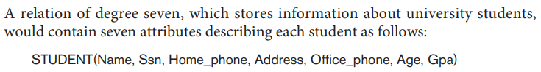

So this relations mean that all the attributes belong to (and define) the same “relation schema” student, aka student entity.

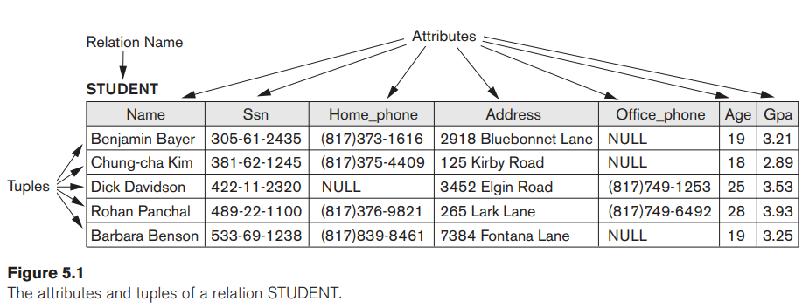

Tuples = records

### 5.1.2 Characteristics of Relations

Tuples in a relation do not have any particular order. That is, records in a table for student entity don’t have a particular order. In a file records are physicall stored on disk so the have an intrinsic order.

The definition of a relation does not specify any order. When a relation is implemented as a file or displayed as a table, a particular ordering may be specified on the records of the file or the rows of the table.

A mapping from R to D is the union of these 2 sets. a tuple can be considered as a set of (<attribute>, <value>) pairs, where each pair gives the value of the mapping from an attribute Ai to a value vi from dom(Ai) The ordering of attributes is not important, because the attribute name appears with its value

**The first normal form assumption, the so called “flat relational model” implies that all records are composed of the exact same attributes, if for any reason a student doesn’t have an office phone, the record still has the Office_phone attribute and the NULL value is used** to denote what ‘null’ means in any other programming language.

### 5.1.3 Relational Model Notation

* A relation schema (for an entity, such as student) R of degree n is denoted by R(A1, A2, … , An) (A is the attribute/field/column).
* The uppercase letters Q, R, S denote relation names
* The lowercase letters q, r, s denote relation states.
* The letters t, u, v denote tuples.

## 5.2 Relational Model Constraints and Relational Database Schemas

Constraints on databases can generally be divided into three main categories:

1. Constraints that are **inherent in the data model**. We call these inherent model-based constraints or **implicit constraints**.
2. Constraints that can be **directly expressed in the schemas of the data model**, typically by specifying them **in the DDL** (data definition language, see Section 2.3.1). We call these **schema-based constraints** or **explicit constraints**.
3. Constraints that **cannot be directly expressed in the schemas of the data mod**el, and hence must be expressed and **enforced by the application programs or in some other way**. We call these application-based or semantic constraints or business rules.

### 5.2.1 5.2.2 Key Constraints and Constraints on NULL Values

See 5.1.1 for normal attributes constraints (mostly data type, size, and format).

By definition, all elements of a set are distinct; hence, all tuples in a relation must also be distinct. No two tuples can have the same combination of values for all their attributes. You can also ensure that a specific (set of) attribute(s) (instead of the combination of the whole record) within an entity must be unique (i.e. social security number, order id, etc). Any such set of attributes is called a **super key**.A superkey SK specifies a **uniqueness constraint** that no two distinct tuples in any state r of R can have the same value for SK (however, some of the fields can have repeated values):

super key {social security number, name, age} (name and age can exist already, the set of these 3 fields is still unique)

Every relation has at least one default superkey— the set of all its attributes.

A more handy tool is to provide a **key**:

1. Two distinct tuples in any state of the relation cannot have identical values for (all) the attributes in the key. This uniqueness property also applies to a superkey.
2. It is a **minimal super key** that is, if you remove (part of) it, you could potentially lose uniqueness, whereas in a superkey you dont need to be minimal (that is, you can have reduncancy).

A key is a superkey but not vice versa.

Any superkey formed from a single attribute is also a key.

A key with multiple attributes must require all its attributes together to have the uniqueness property

**A key is time-invariant** It must continue to hold when we insert new tuples in the relation.

More than one unique fields in a relation can be unique, we would could have then **primary key** and  **candidate key**, the choice can be arbitrary but both have the “uniqueness” constraint. Usually the primary key has a smaller and easier to sort set of attributes.]

NOT NULL is a common constrain, especially among keys, who must be unique.

### 5.2.3 Relational Databases and Relational Database Schemas

A relational database schema S is a set of relation schemas S = {R1, R2, … , Rm} and a set of integrity constraints IC. That is a set of Tables (that often represent an entity) related with each other under a “schema” S. I.e (shopping cart (id, time, quantity, customer), product properties(description, price, product, isAvaiable))

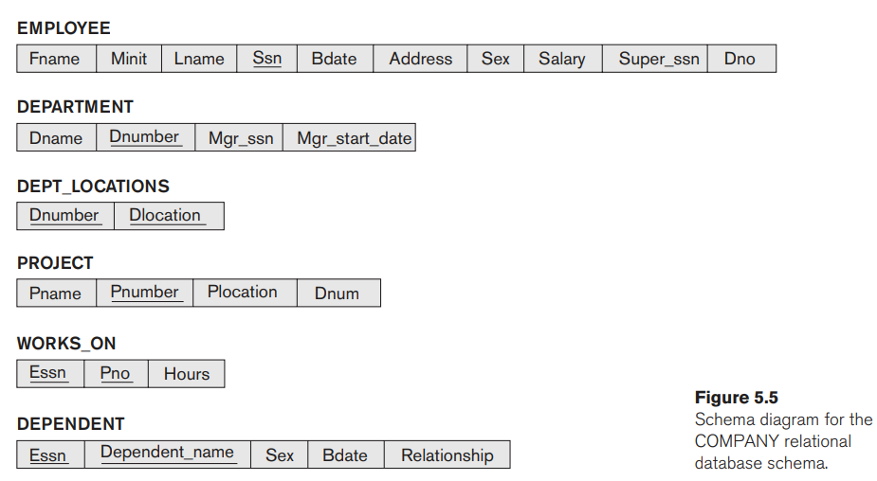

### 5.2.4 Entity Integrity, Referential Integrity, and Foreign Keys

Underline fields are primary keys, when there are 2 underlined fields is because one of them is a **foreign key** that is, a pointer to a primary key at another table that contains the attributes assigned to such id.

The **entity integrity constraint** states that **no primary key value can be NULL**.

The **referential integrity** constraints means that a foregin key must match an existing primary key somewhere.

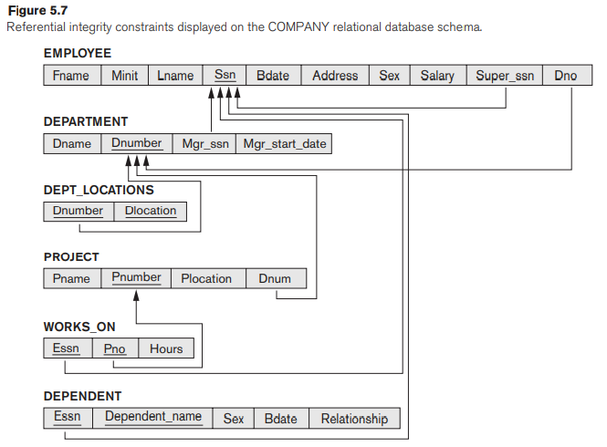

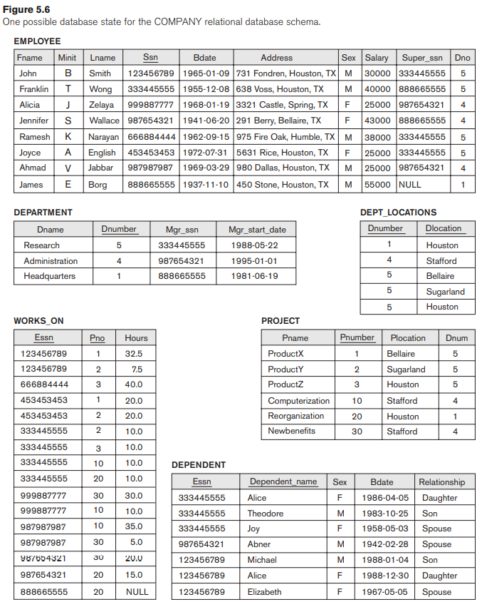

In SQL, the CREATE TABLE statement of the SQL DDL allows the definition of primary key, unique key, NOT NULL, entity integrity, and referential integrity constraints, among other constraints.

## 5.3 Insert, Delete, and Update Operations dealing with constraints

* If an insertion violates one or more constraints, the default option is to reject the insertion.
* The Delete operation can violate only referential integrity. This occurs if the tuple being deleted is referenced by foreign keys from other tuples in the database. Several options are available if a deletion operation causes a violation. The first option, called restrict, is to reject the deletion. The second option, called cascade, is to attempt to cascade (or propagate) the deletion by deleting tuples that reference the tuple that is being deleted. For example, in operation 2, the DBMS could automatically delete the offending tuples from WORKS_ON with Essn = ‘999887777’. A third option, called set null or set default, is to modify the referencing attribute values that cause the violation; each such value is either set to NULL or changed to a reference value. The default option can be specifed by the DDL of the DBMS
* Updating an attribute that is neither part of a primary key nor part of a foreign key usually causes no problems; the DBMS need only check to confirm that the new value is of the correct data type and domain. Just make sure that PK remains unique and check out for dependencies with foreign keys. The same options as with delete apply, most commonly reject or cascade.

## 5. 4 The Transaction Concept

A transaction is an executing program that includes some **database operations that form together an** **atomic unit of work** against the database. Their either **completed as a whole or rejected all**. A large number of commercial applications running against relational databases in online **transaction processing (OLTP)** systems are executing transactions at rates that reach several hundred per second.

# Lecture 1 Introduction to Database Systems

Focus of the course:

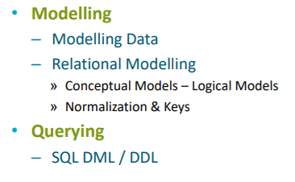 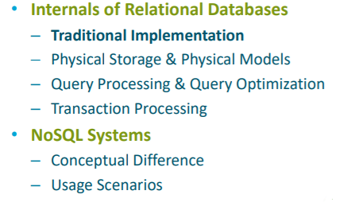

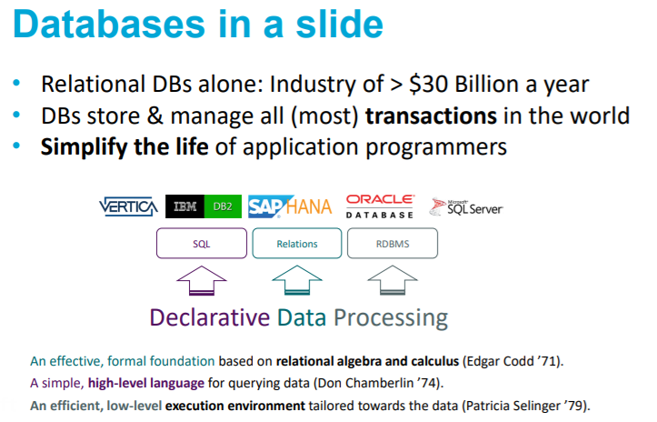

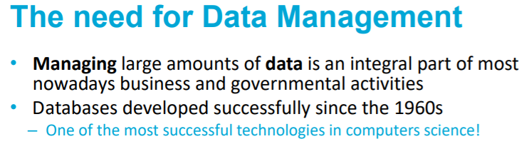

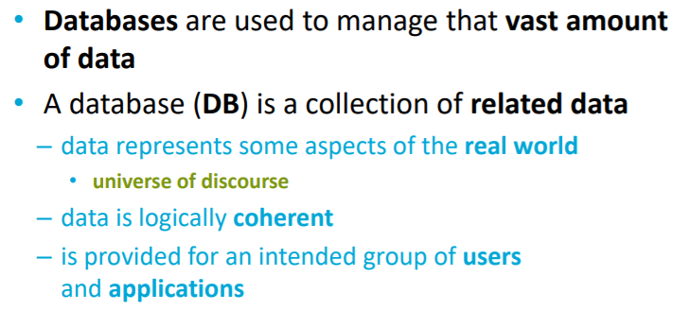

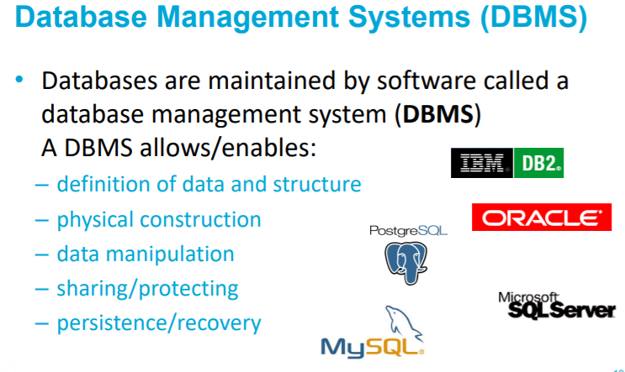

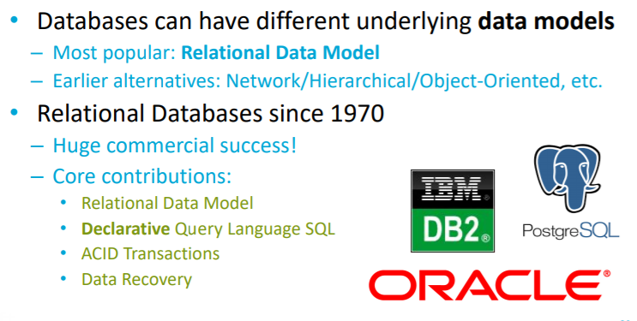

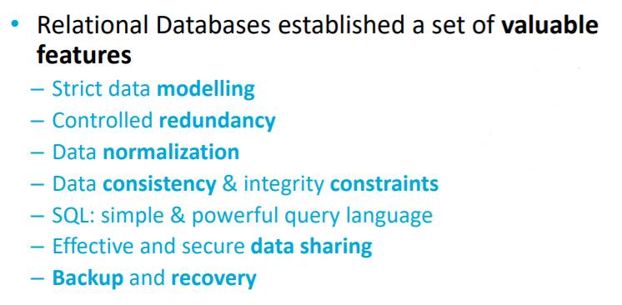

(relational)

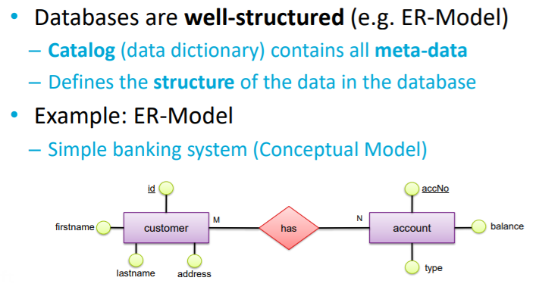

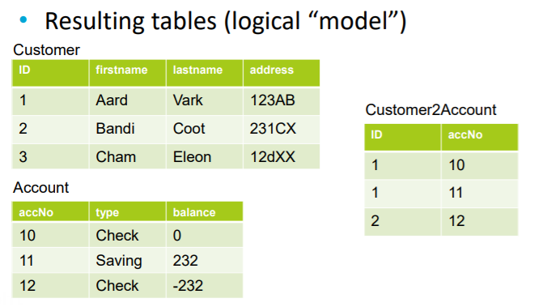

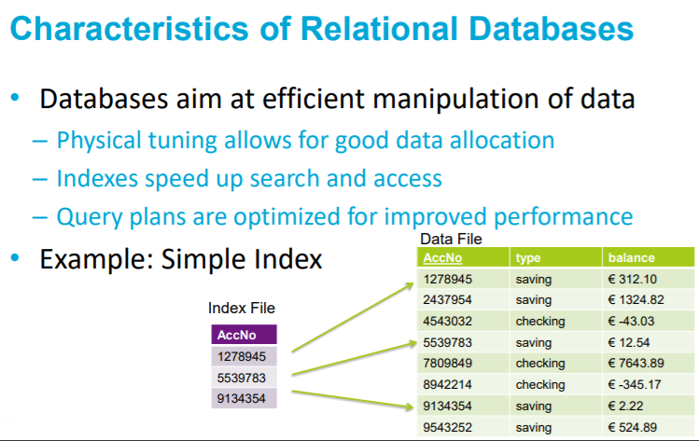

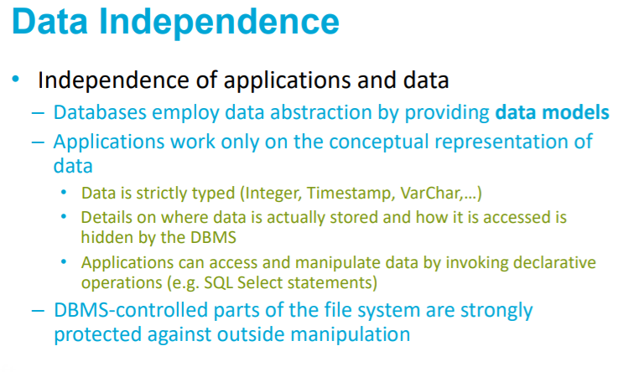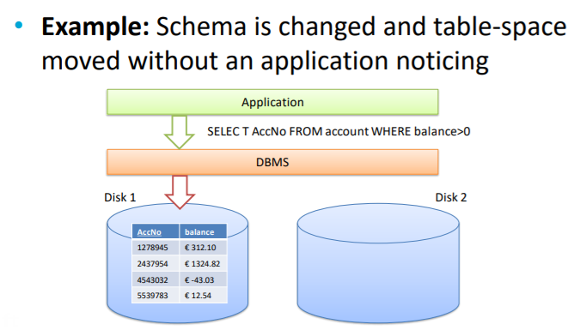 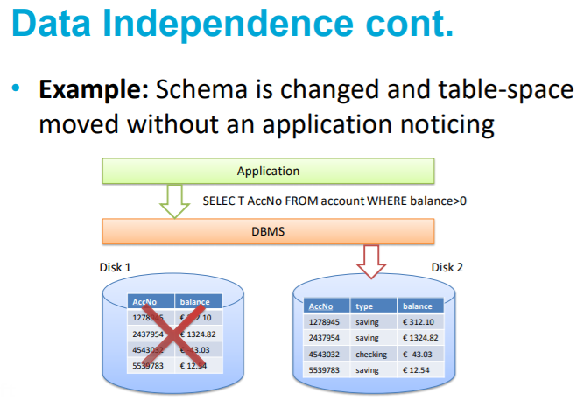

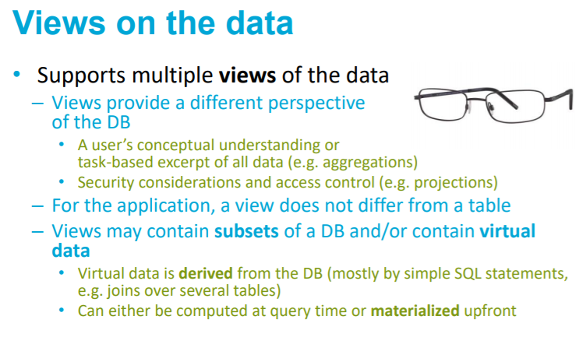

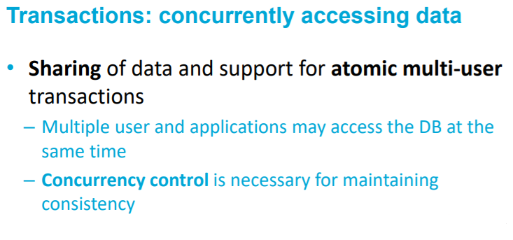

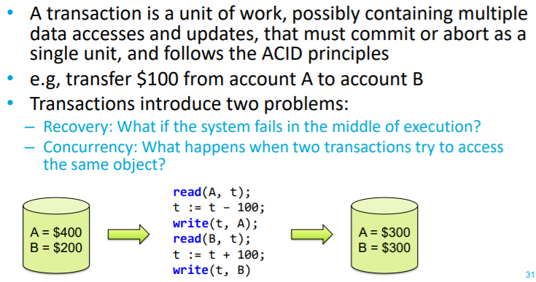

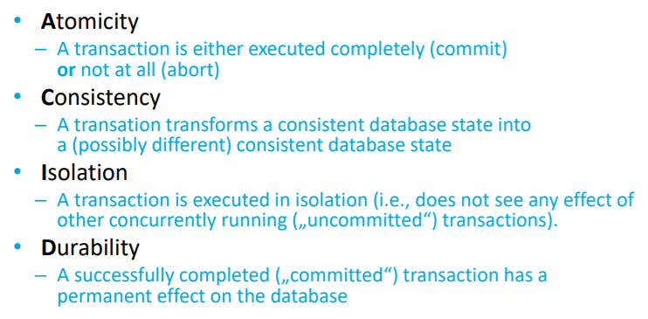

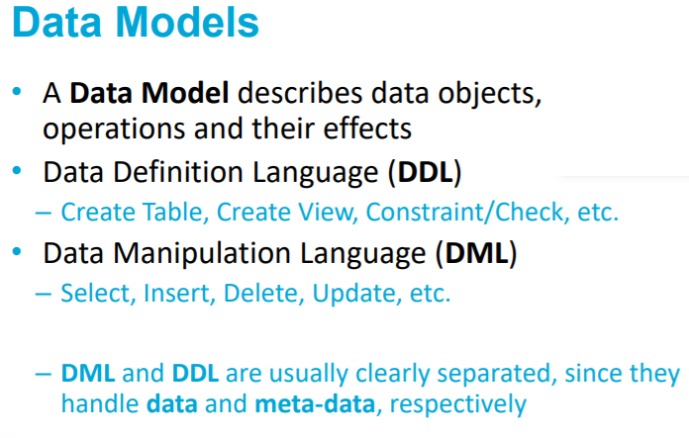

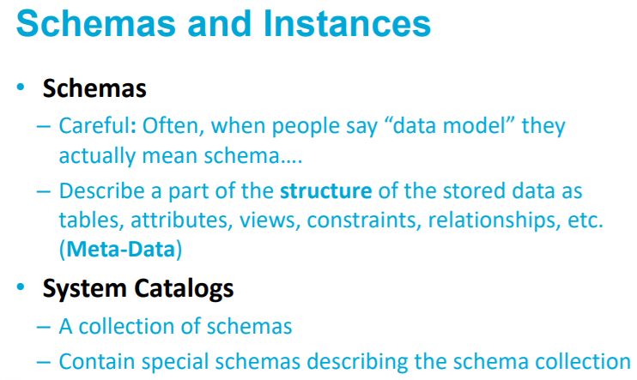

(Schema example: all the relationships between tables, views and table properties of my food app)

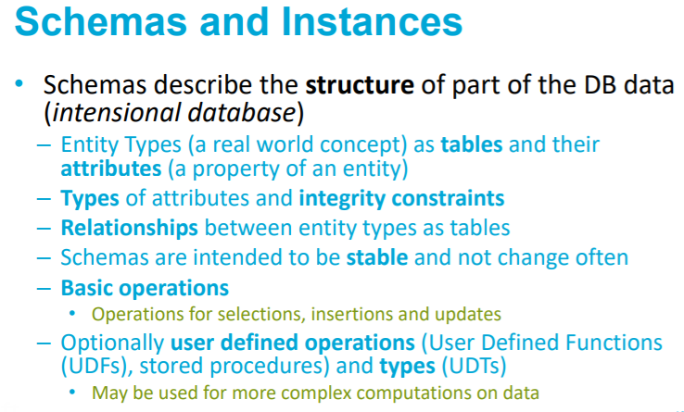

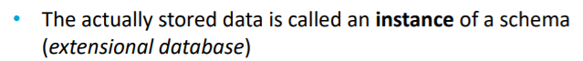

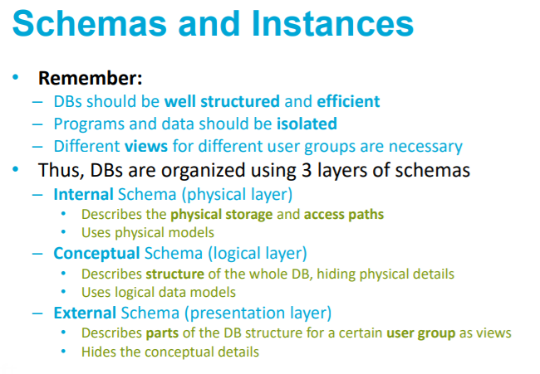

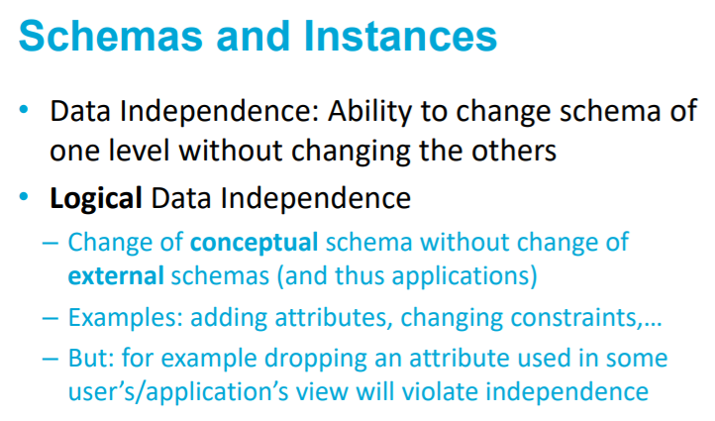

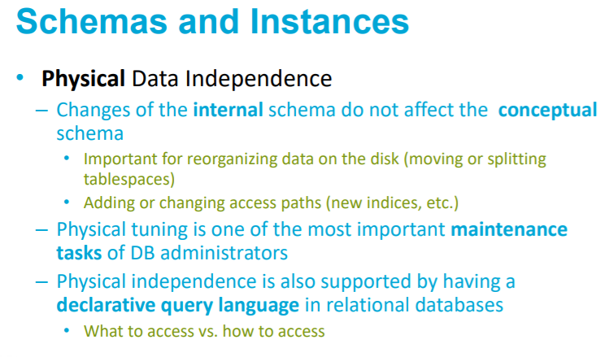

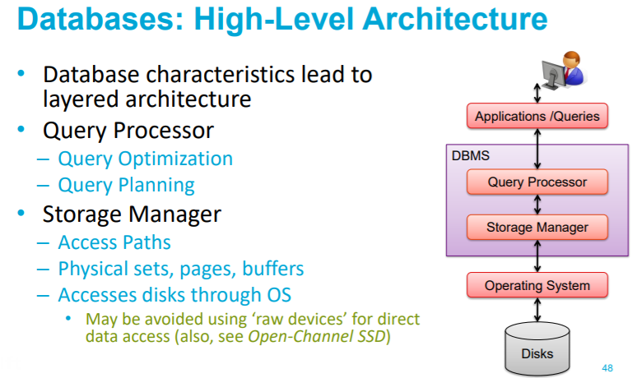

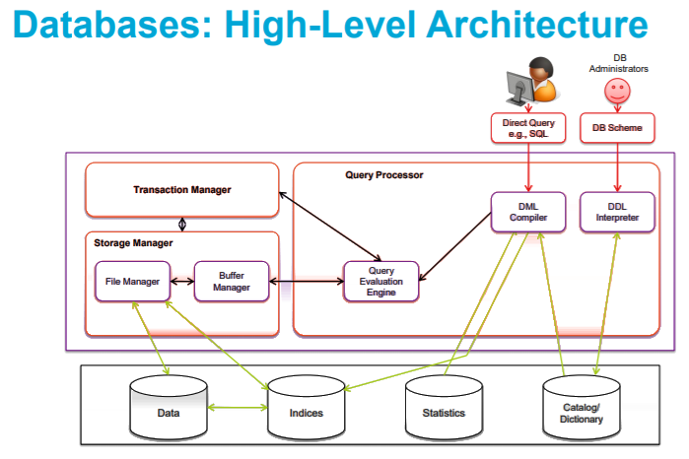

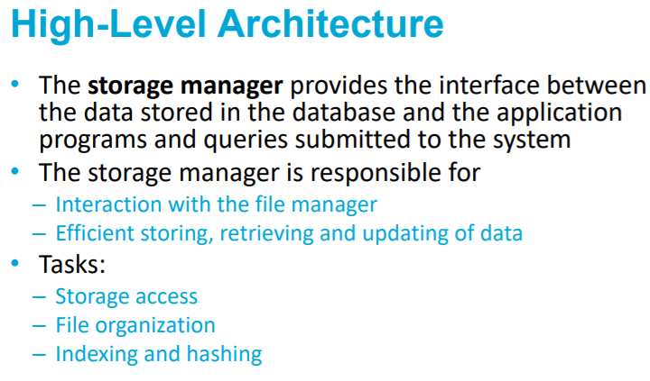

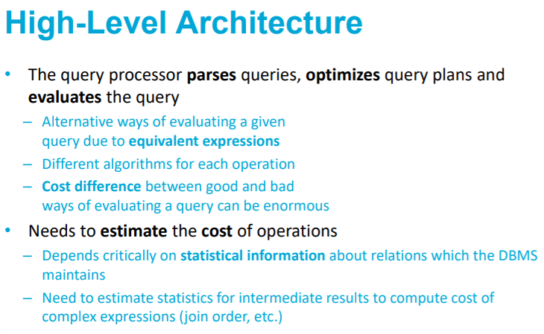

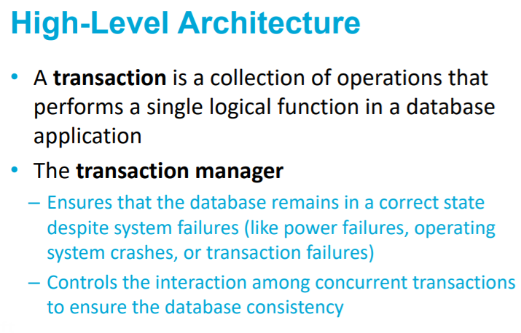

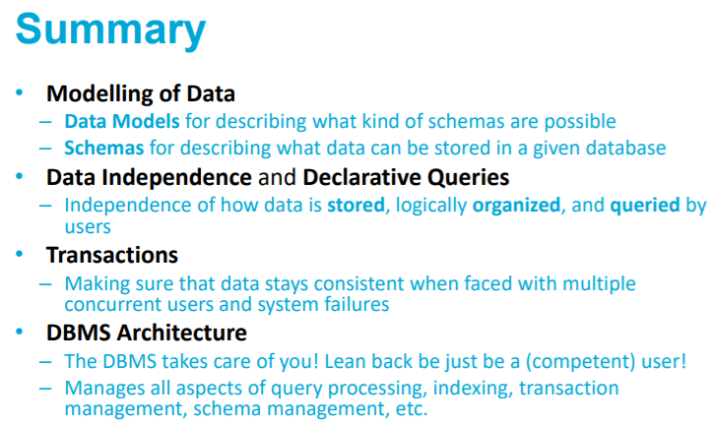

# Chapter 3. Data Modeling with Entity-Relationship (ER) Model

The entity-relationship model is a popular high-level conceptual data model used for the conceptual design of database applications.

Unified Modeling Language is an object modeling methodology that go beyond tabase design to specify detailed design of software modules and their interactions using various types of diagrams. UML’s class diagrams are very similar to ER diagrams.

## 3.1 Using High-Level Conceptual Data Models for Database Design

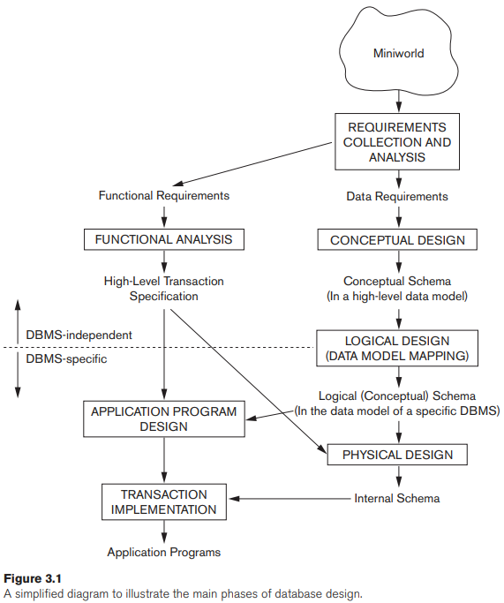

* **Mini world:** the part of the real world that will be represented in the database.
* **Requirements collections and analysis:** The database designers interview prospective database users to understand and document their data requirements
* **Functional requirements:** User defined operations (or transactions) that will be applied to the database, including both retrievals and updates. This is part of Software Engineering.
* **Conceptual schema:** is a concise description of the data requirements of the users and includes detailed descriptions of the entity types, relationships, and constraints.
* **logical design or data model mapping:** implementation of the database, using a commercial DBMS. Most current commercial DBMSs use an implementation data model—such as the relational (SQL) model—so the conceptual schema is transformed from the high-level data model into the implementation data model.
* **physical design:** internal storage structures, file organizations, indexes, access paths, and physical design parameters for the database files are specified.

## Conceptual Design (Schema)

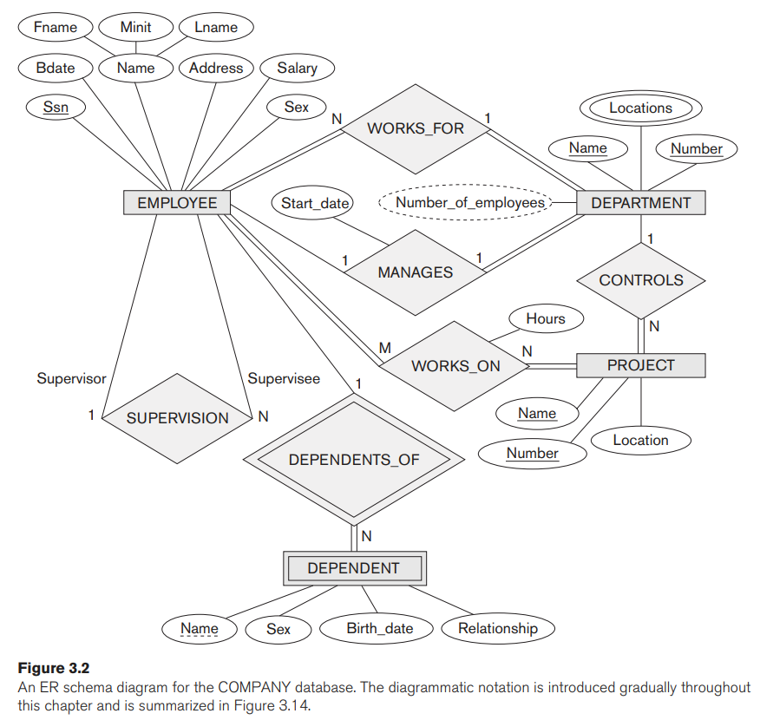

## 3.3 Entity Types, Entity Sets, Attributes and Keys

The basic concept that the ER model represents is an entity, which is a thing or object in the real world with an independent existence. Entities ‘i.e. employee x has attributes (ssn, bank account, email, name, phone number, position, works_for, manages)

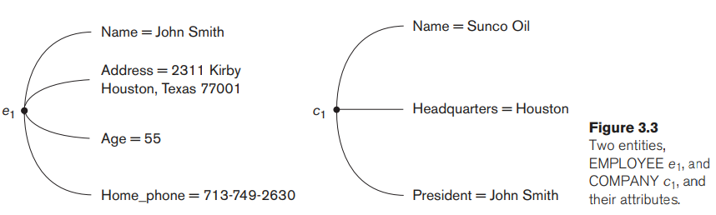

Composite attributes can be divided into smaller subparts, which represent more basic attributes with independent meanings. For example, the Address attribute of the EMPLOYEE entity shown in Figure 3.3 can be subdivided into Street_address, City, State, and Zip, 3 with the values ‘2311 Kirby’, ‘Houston’, ‘Texas’, and ‘77001’. Attributes that are not divisible are called simple or atomic attributes.

The value of a composite attribute is the concatenation of the values of its component simple attributes.

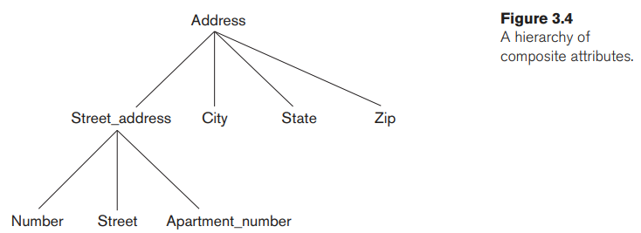

**Single-value vs multivalued**: Some attributes can also have an optional number of values such as “college degree”, where the acceptable values would consist of NULL, degree 1, degree 2..., degree n. There can be an upperbound and lowerbound for n.

**Stored vs derived:** Some values you store, such as Birth_date, others are computed automatically, such as Age, these are derived.

**Complex attributes:** combination of composite (‘{‘ for taxonomy) , and multivalued (comma separated).: 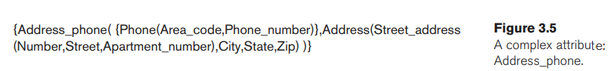

### Entity type

Entity Type is Like a Class, i.e. ‘Student’, where entities are like objects, i.e. var s = new Student(); where s is an instance of Student. The Entity Type and the Entity Type Set are two separate concepts, but they same word i.e. EMPLOYEE may be used to refeer to both these concept. While the Entity Type is like a Java class and defines the properties of its Set in the DBMS schema, tbe Entity (Type) Set refers to the collection (set) of all the records that are instance of (entities) of such Enitity Type.

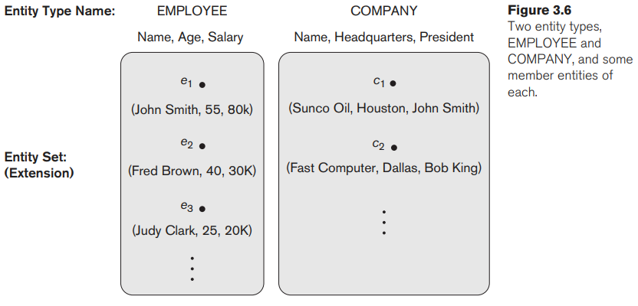

An entity type is represented in ER diagrams5 (see Figure 3.2) as a rectangular box enclosing the entity type name. Attribute names are enclosed in ovals and are attached to their entity type by straight lines. Composite attributes are attached to their component attributes by straight lines. Multivalued attributes are displayed in double ovals.

(foreign) **key** and/or **uniqueness constraint** are underlined. An entity type **without a key** is called a **weak entity type**. It still has a **parial key** if an attribute happens to be unique, or in the worst case scenario it still has a partial key if you take all of the attributes combined.

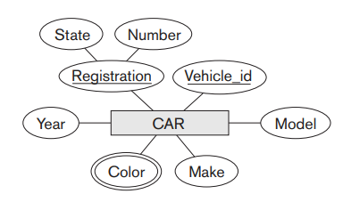

An **entity type** describes the **schema or intension** for a set of entities that share the same structure. The collection of entities of a particular entity type is grouped into an **entity set**, which is also called the **extension of the entity type**.

## Example

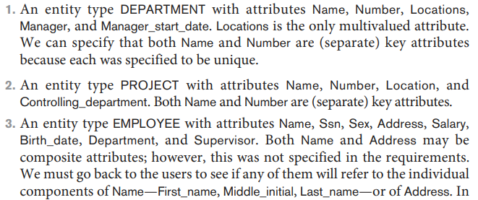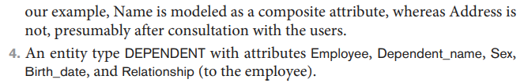

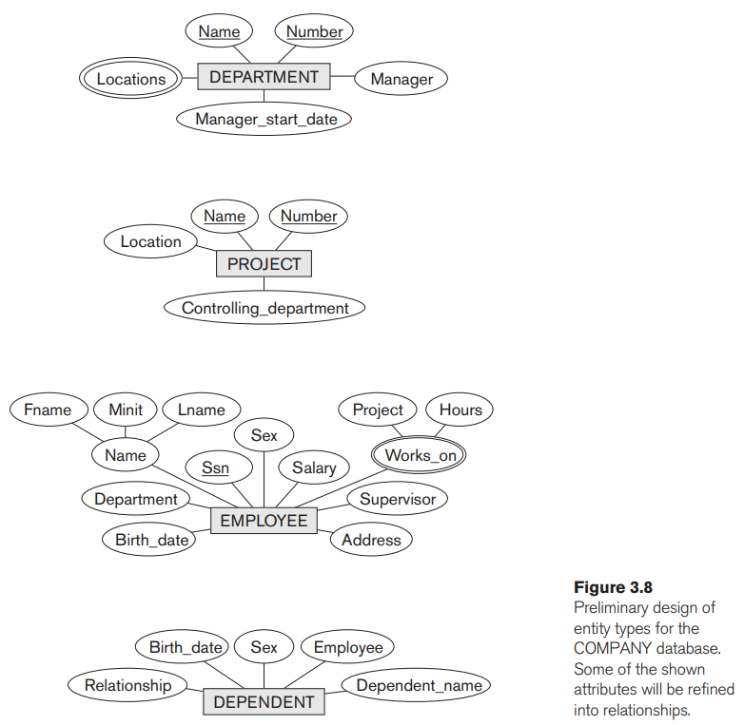

## 3.4 Relationship Types, Relationship Sets, Roles, and Structural Constraints

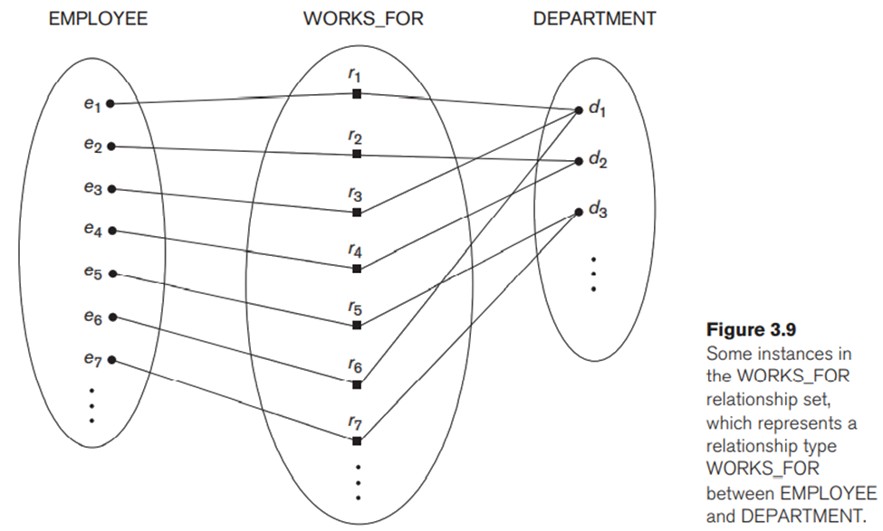

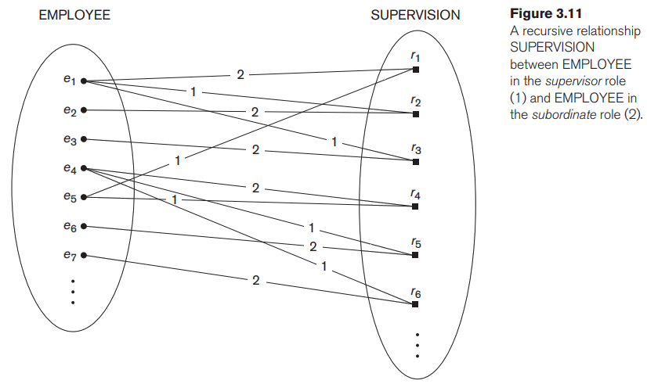

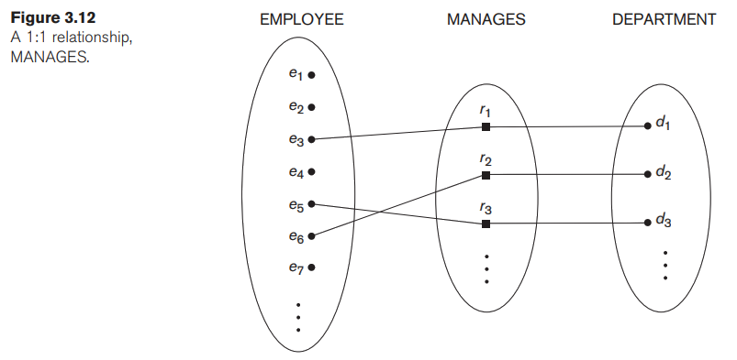

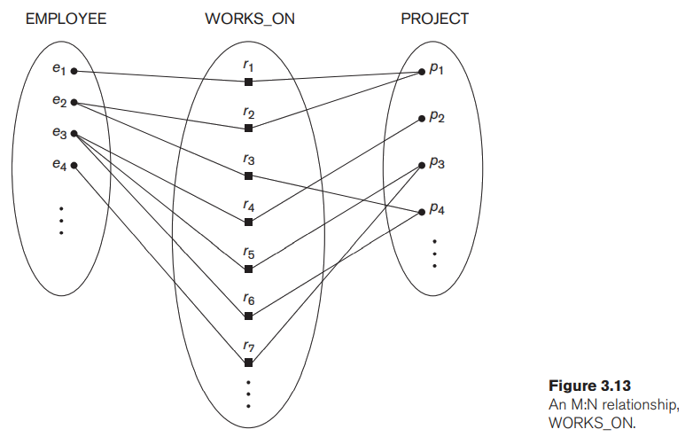

## 3.7 ER Diagram Naming Conventions

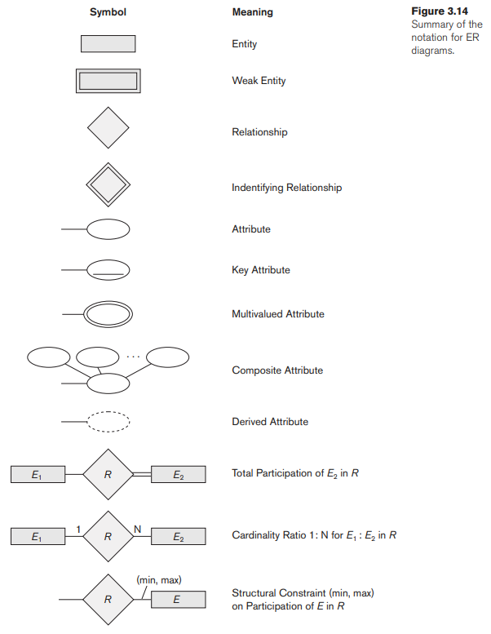



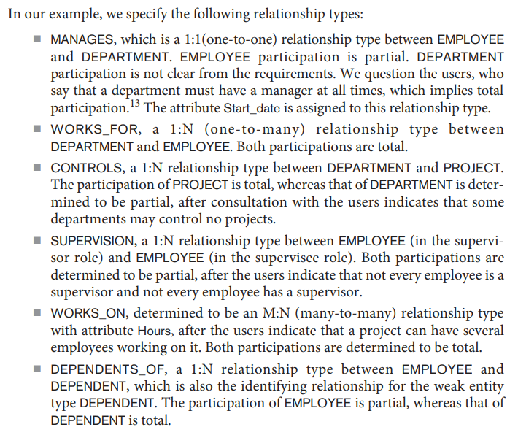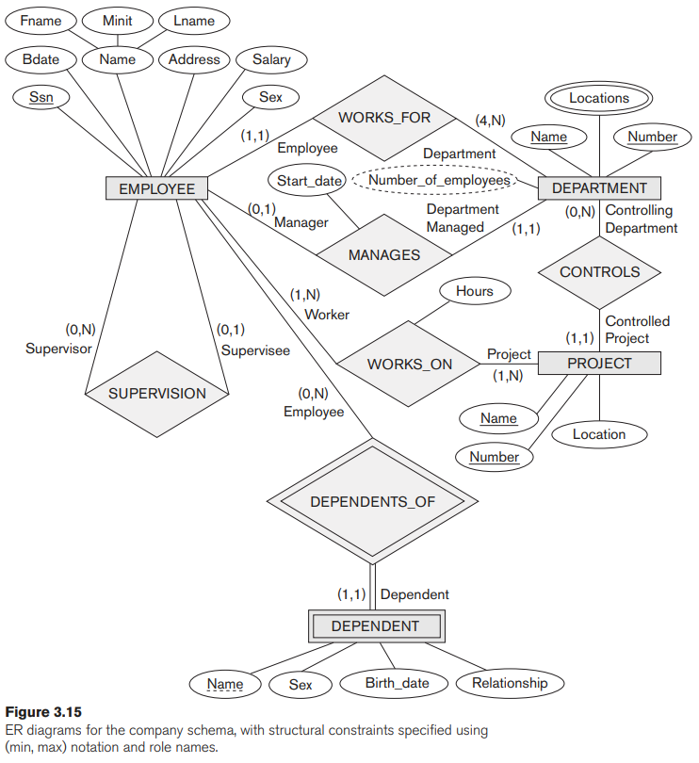

# Lecture 2. Introduction to Modelling

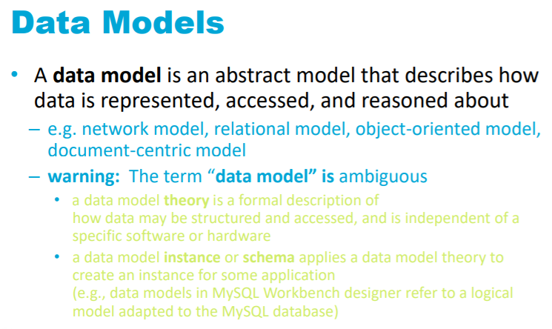

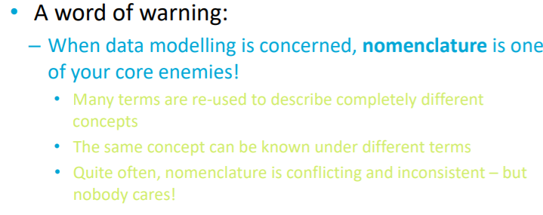

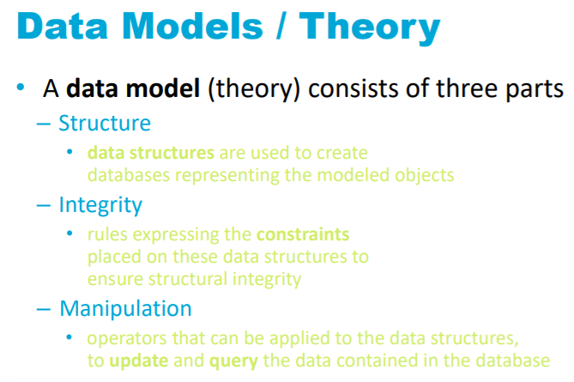

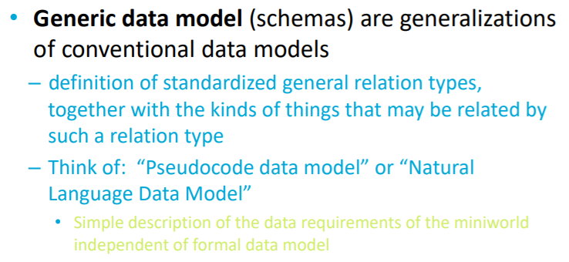

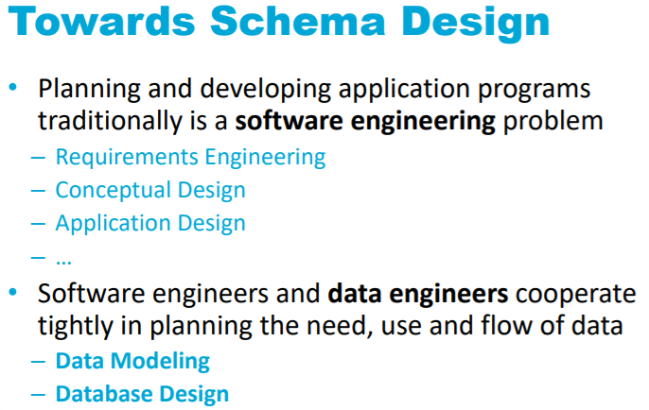



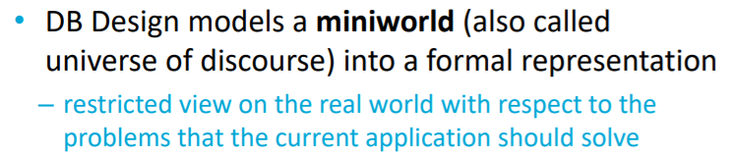

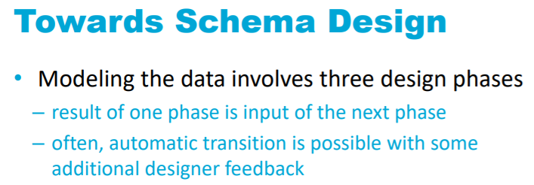





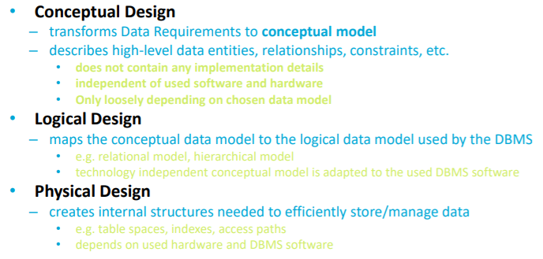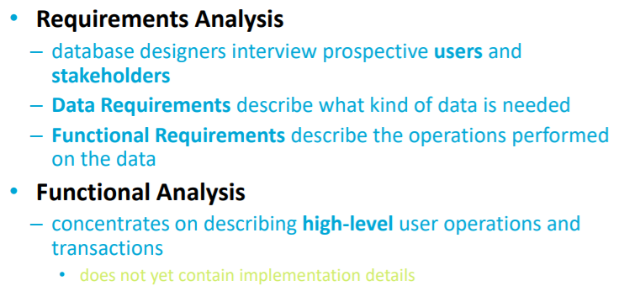



B,C,D are software engineering

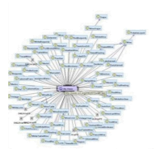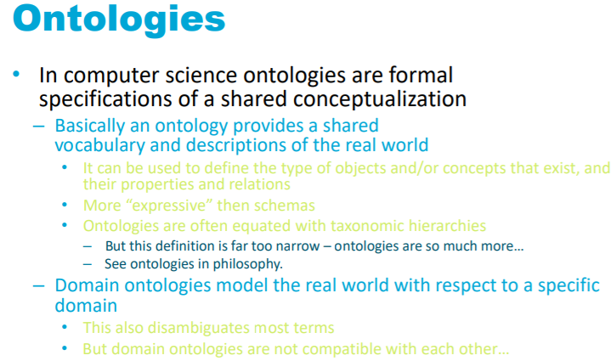

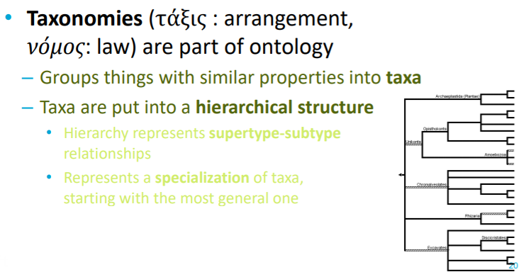

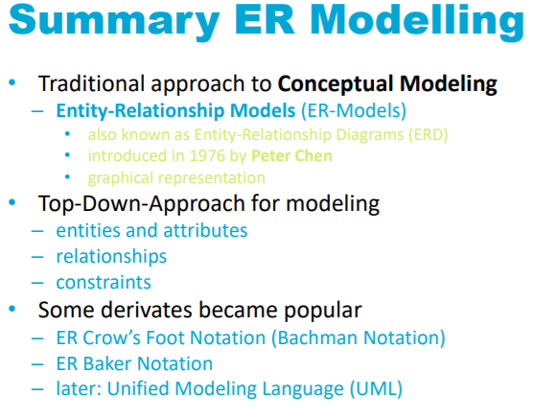

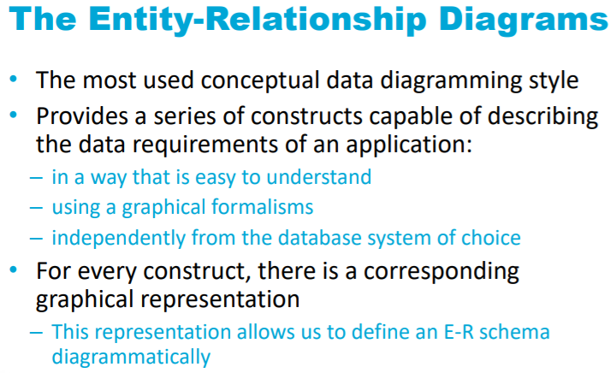

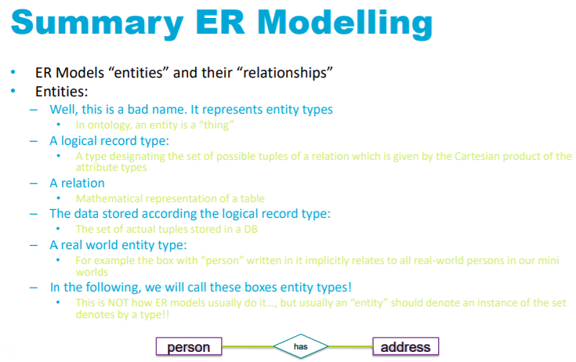



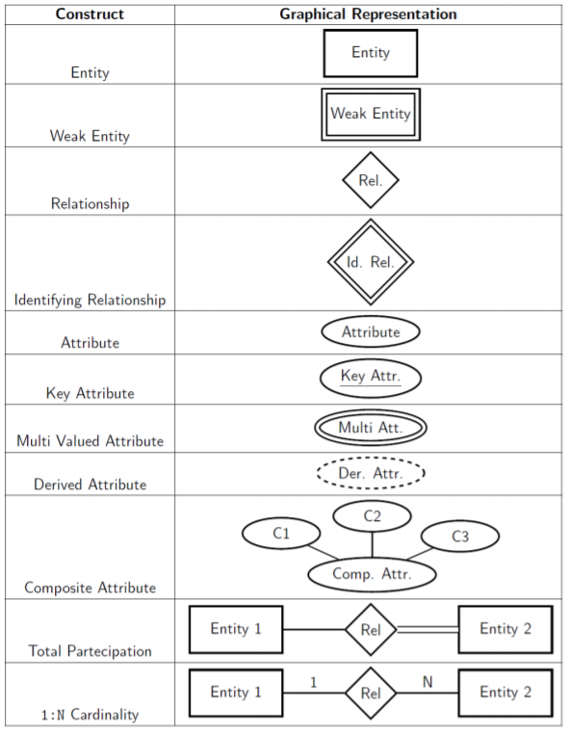

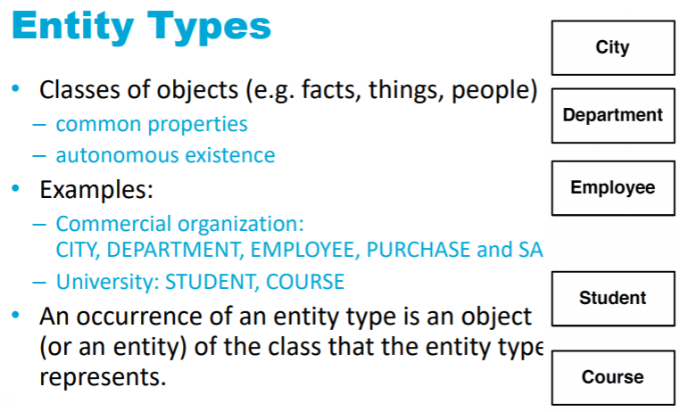

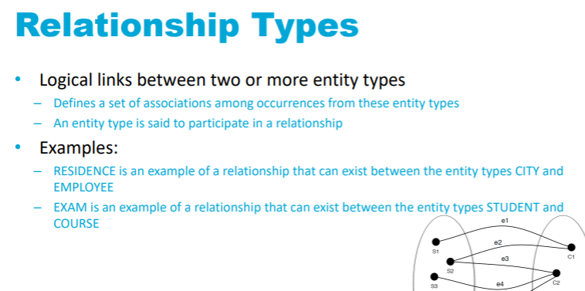

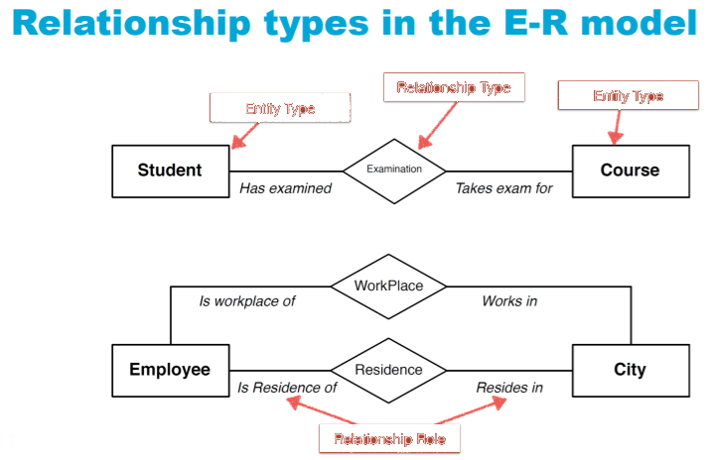

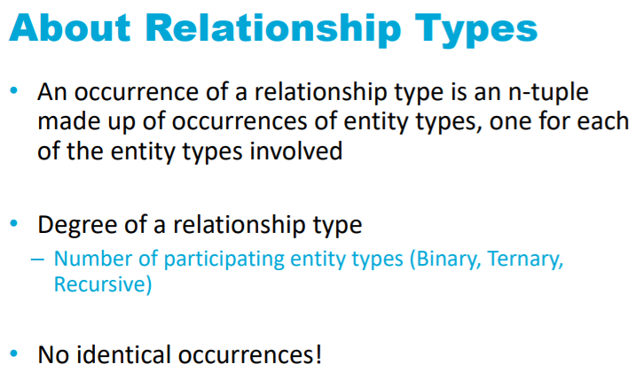

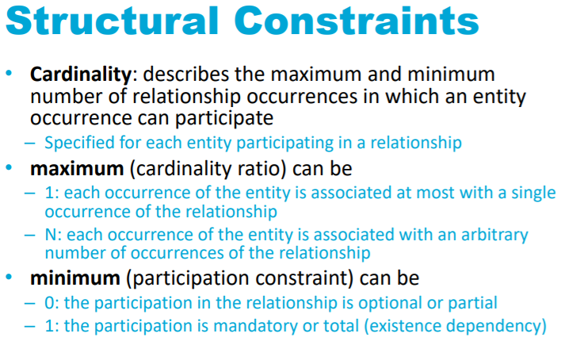

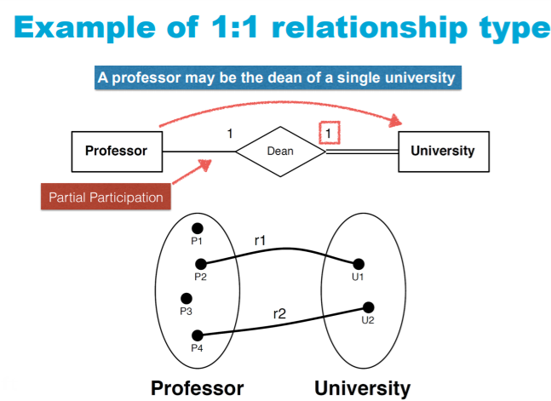

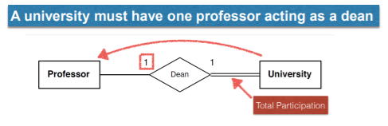

Double line: (must be mapped) All the entities in the university set are mapped to at least 1 professor. All University records must have a Professor Foreign Key (this case 1, but cardinality couuld also be N)

Single line: (optional). Professor records have the Dean_at attribute but can be null

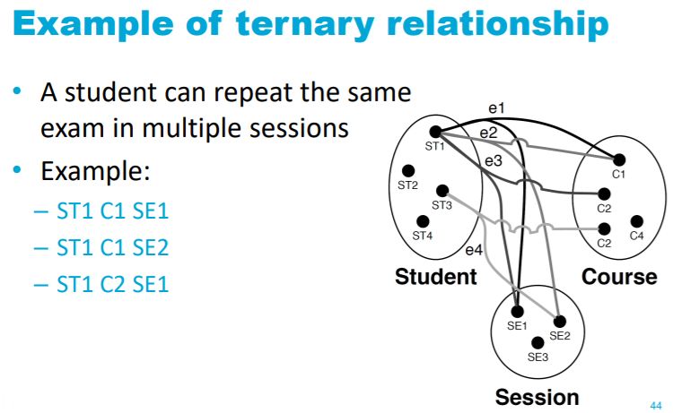

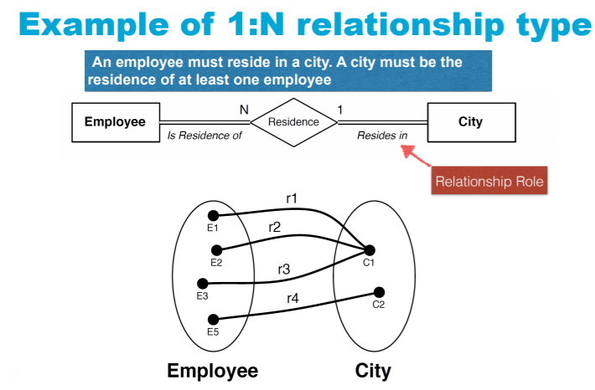

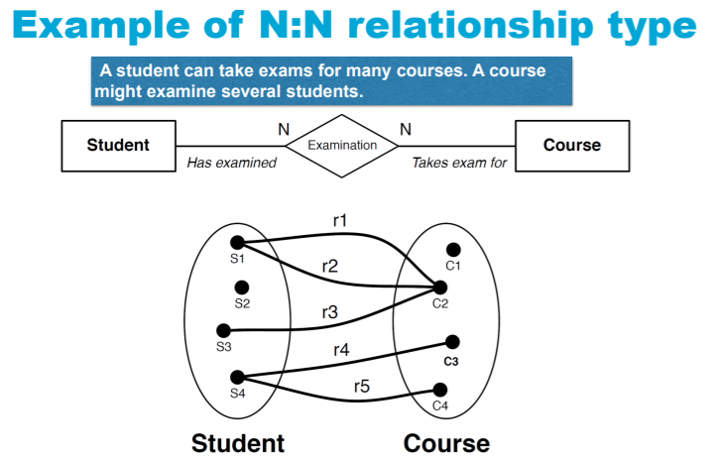

Student takes the same exam in multiple sessions:

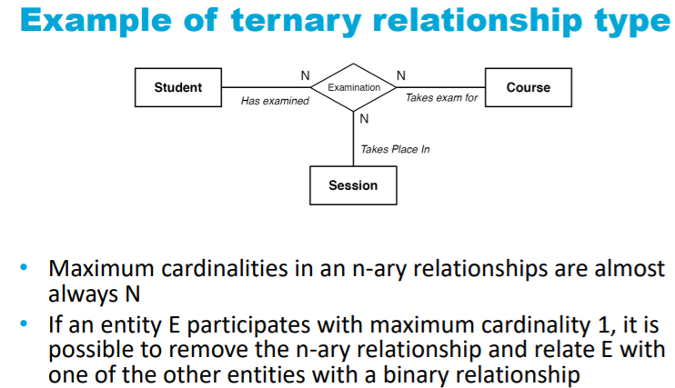

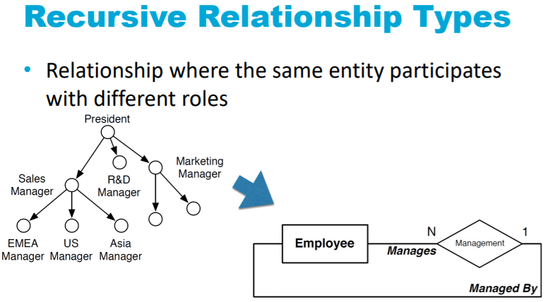

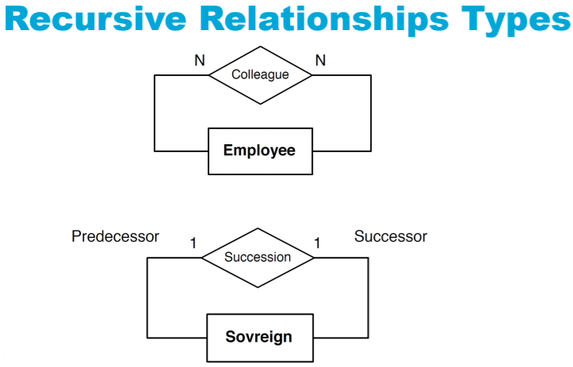

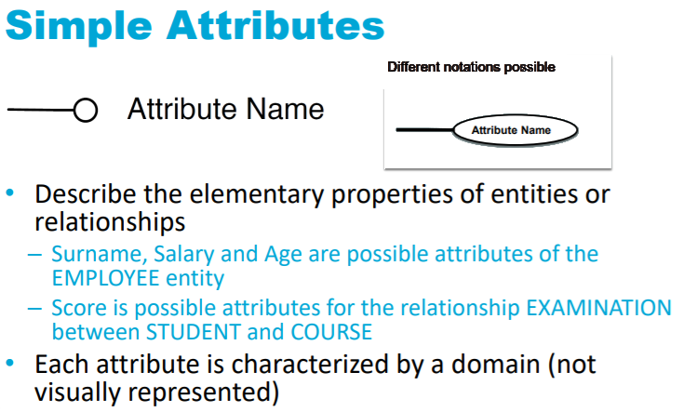

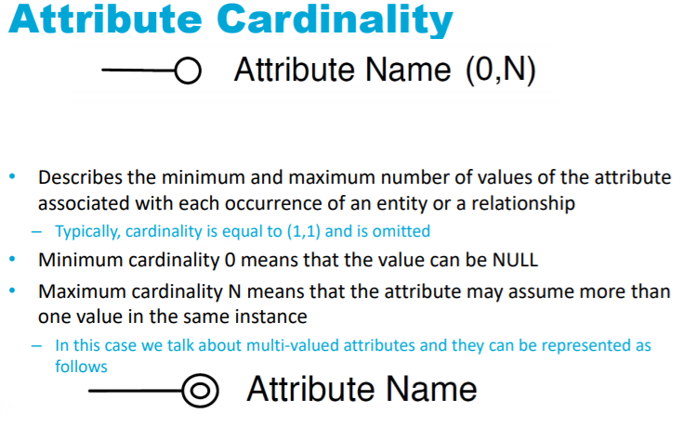

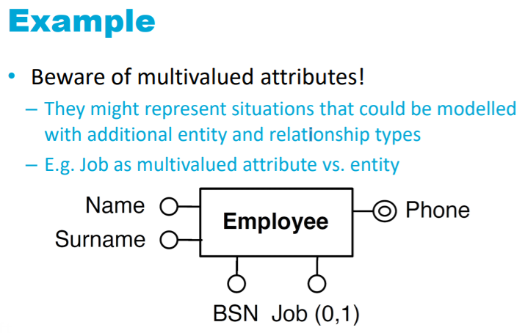

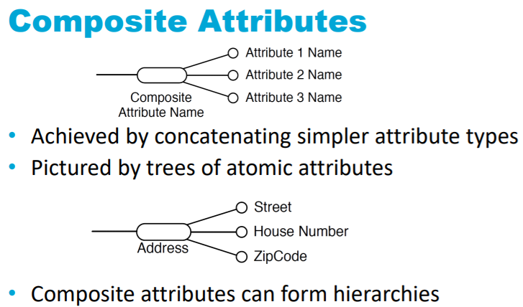

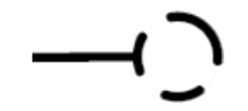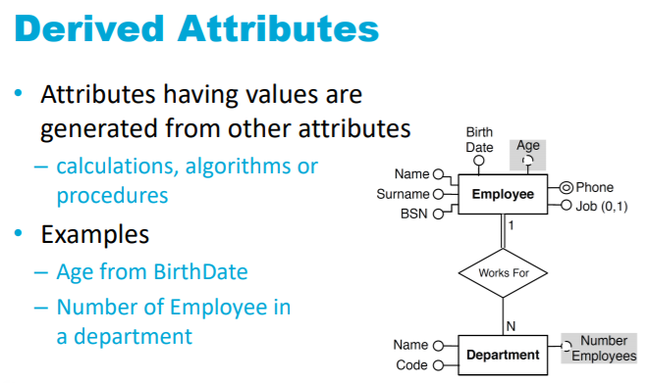

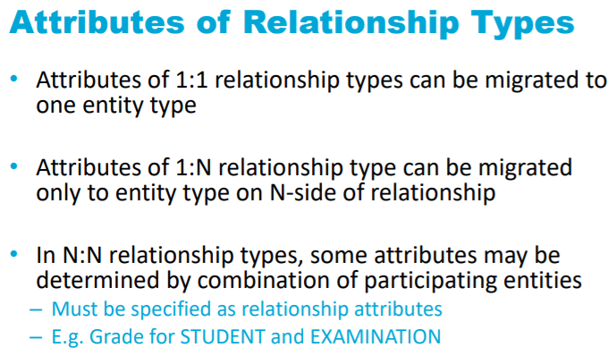

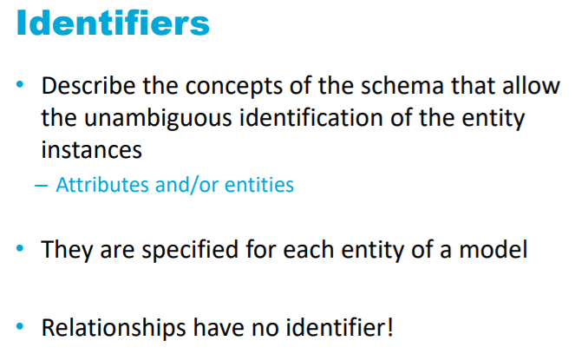

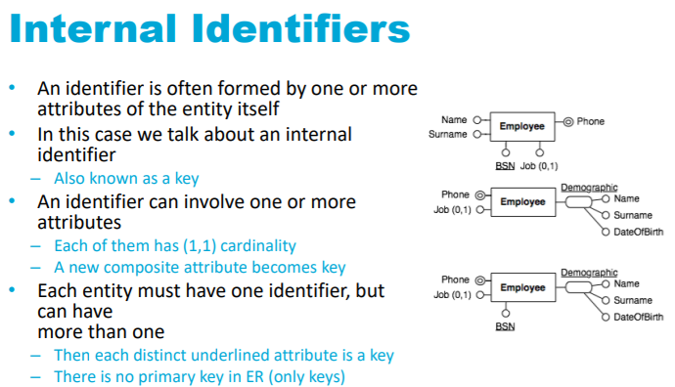

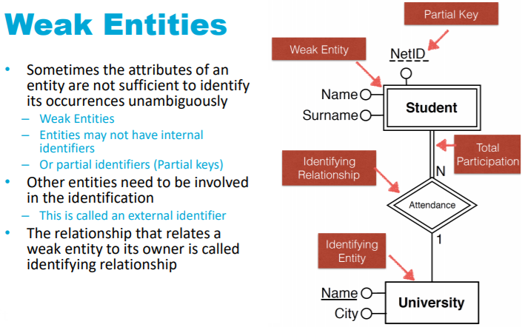

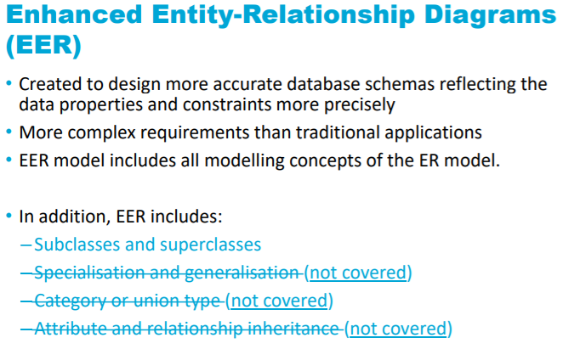

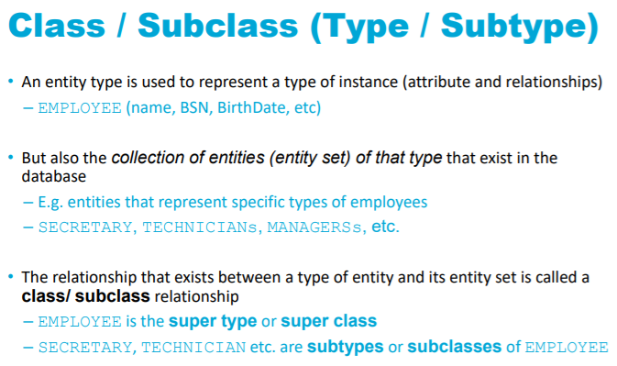

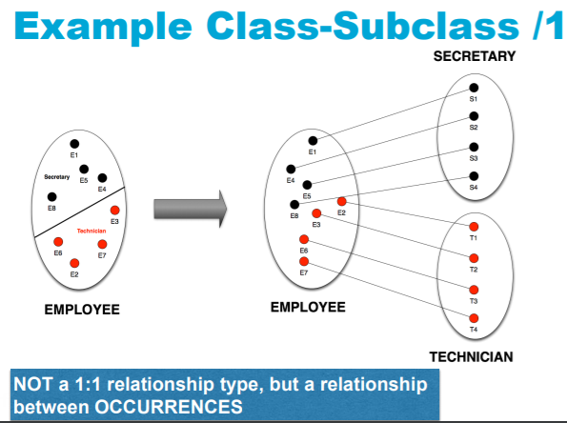

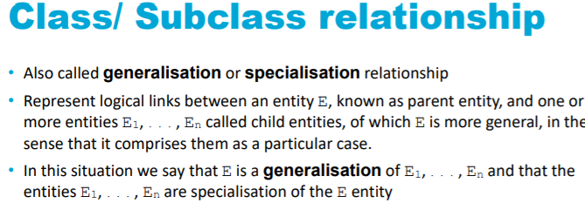

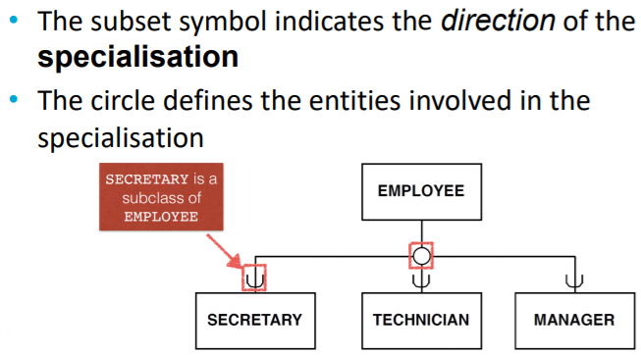

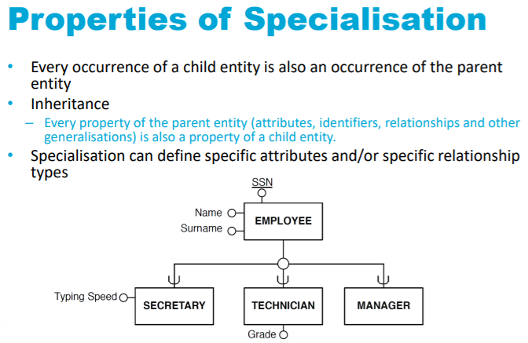

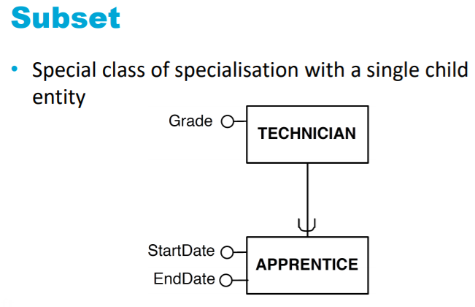

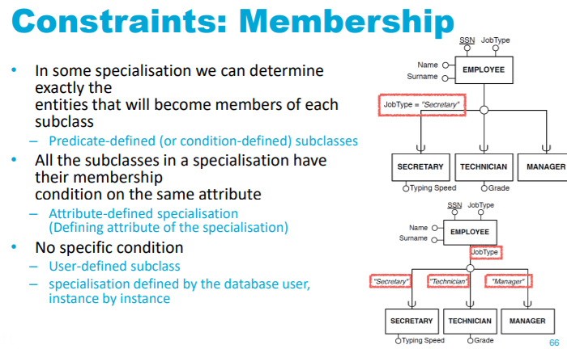

*Week 2. The Relational Model*

# Chapter 4. The Extended EER Model

The ER modeling concepts discussed in Chapter 3 are sufficient for representing many database schemas for traditional database applications, which include many data-processing applications in business and industry. However more complex models exist and in this chapter, we describe features that have been proposed for semantic data models and show how the ER model can be enhanced to include these concepts, which leads to the enhanced ER (EER) model.

## 4.1 Subclasses, Superclasses, and Inheritance

### Subtype/subclass entity type

The entities that are members of the EMPLOYEE entity type may be distinguished further into SECRETARY, ENGINEER, MANAGER, TECHNICIAN, SALARIED_EMPLOYEE, HOURLY_EMPLOYEE, and so on. The set or collection of entities in each of the latter groupings is a subset of the entities that belong to the EMPLOYEE entity set, meaning that every entity that is a member of one of these subgroupings is also an employee. We call each of these subgroupings a subclass or subtype of the EMPLOYEE entity type, and the EMPLOYEE entity type is called the superclass or supertype for each of these subclasses.

We call the relationship between a superclass and any one of its subclasses a superclass/subclass or supertype/subtype or simply class/subclass relationship.

The subclass member is the same as the entity in the superclass, but in a distinct specific role

When we implement a superclass/subclass relationship in the database system, however, we may represent a member of the subclass as a distinct database object—say, a distinct record that is related via the key attribute to its superclass entity.

An entity cannot exist in the database merely by being a member of a subclass; it must also be a member of the superclass. Such an entity can be included optionally, as a member of any number of subclasses. Because an entity in the subclass represents the same real-world entity from the superclass, it should possess values for its specific attributes as well as values of its attributes as a member of the superclass. We say that an entity that is a member of a subclass inherits all the attributes of the entity as a member of the superclass. The entity also inherits all the relationships in which the superclass participates.

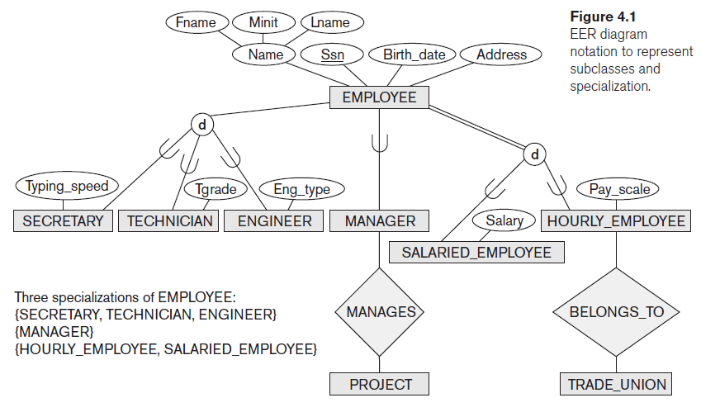Observe how the subclass Manager is a subset of super class Employee   
Manager $⊂$ Employee

And see how the letter d (disjoint/at most) expresses that an employ can be secretary xor technician xor engineer **xor none**; and on top of that it can be or not be a manager.The double line means total participation. So all employees are registered as either salried or hourly, whereas not all employees are registered as secretary, technicitan or engineer, that is, there are some positions in the company that do not have an entity type of their own.

The diamonds are relationships. In Chen notation (this one, the one from the book), relations and cardinalities are represented in active voice. “Many employees have 1 mentor”.

## 4.2 Specialization and Generalization

### 4.2.1 Specialization

Specialization is the process of defining a set of subclasses of an entity type. The set of subclasses that forms a specialization is defined on the basis of some distinguishing characteristic of the entities in the superclass. Attributes that apply only to entities of a particular subclass—such as TypingSpeed of SECRETARY—are attached to the rectangle representing that subclass. These are called specific (or local) attributes of the subclass.

### 4.2.2 Generalization

we suppress the differences among several entity types, identify their common features, and generalize them into a single superclass of which the original entity types are special subclasses.

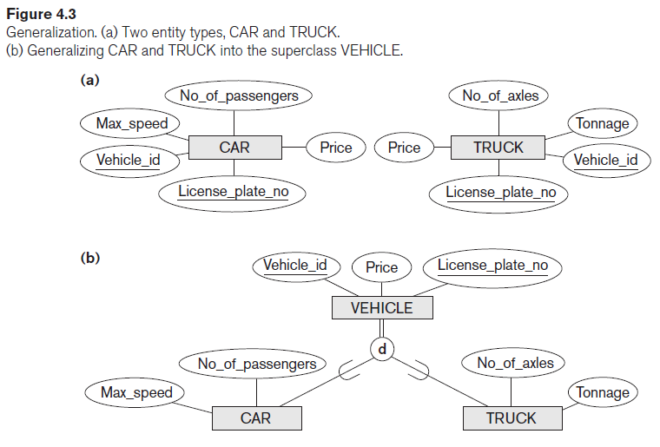

## 4.3 Constraints and Characteristics of Specialization and Generalization Hierarchies

### 4.3.1 Constraints on Specialization and Generalization

In some specializations we can determine exactly the entities that will become members of each subclass by placing a condition on the value of some attribute of the superclass. Such subclasses are called predicate-defined (or condition-defined) subclasses.

For example, if the EMPLOYEE entity type has an attribute Job_type we can specify the condition of membership in the SECRETARY subclass by the condition (Job_type = ‘Secretary’), which we call the defining predicate of the subclass. This condition is a constraint.

When we do not have a condition for determining membership in a subclass, the subclass is called user-defined. membership is specified individually for each entity by the user, not by any condition

that may be evaluated automatically.

The d notation also applies to user-defined subclasses of a specialization that must be disjoint.

Subclasses can also be overlapping ( o ) that is, the same (real-world) entity may be a member of more

than one subclass of the specialization.

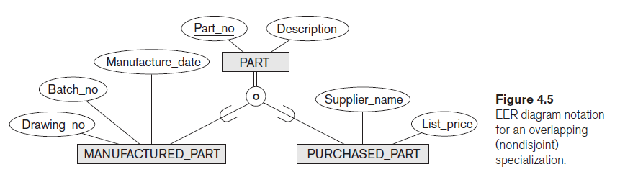

The second constraint on specialization is called the completeness (or totalness) constraint, which may be total or partial. A total specialization constraint specifies that every entity in the superclass must be a member of at least one subclass in the specialization. For example, if every EMPLOYEE must be either an

HOURLY_EMPLOYEE or a SALARIED_EMPLOYEE, then the specialization {HOURLY_EMPLOYEE, SALARIED_EMPLOYEE} in Figure 4.1 is a total specialization of EMPLOYEE. This is shown in EER diagrams by using a double line to connect the superclass to the circle. A single line is used to display a partial specialization, which allows an entity not to belong to any of the subclasses.

### 4.3.2 Specialization and Generalization Hierarchies and Lattices

A specialization **hierarchy** (**single inheritance**) has the constraint that every subclass participates as a subclass in only one class/subclass relationship; that is, each subclass has only one parent, which results in a tree structure or strict hierarchy.

For a specialization **lattice** (**mulitple inheritance**), a subclass can be a subclass in more than one class/subclass relationship. That is a shared subclass. if no shared subclasses existed, we would have a hierarchy rather than a lattice and only single inheritance would exist.

## 4.7 Ontology

The main difference between an ontology and, say, a database schema, is that the schema is usually limited to describing a small subset of a miniworld from reality in order to store and manage data. An ontology is usually considered to be more general in that it attempts to describe a part of reality or a domain of interest (for example, medical terms, electronic-commerce applications, sports, and so on) as completely as possible.

# Lecture 3. The Relational Model

The relational model is based on set theory, which is the foundation of mathematics.

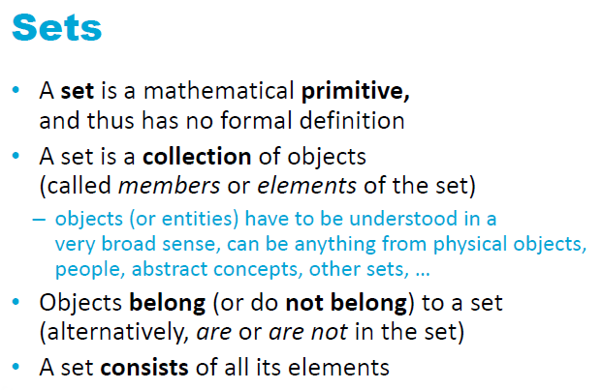 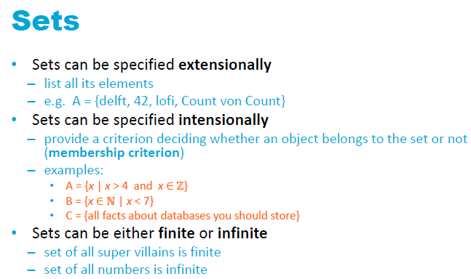

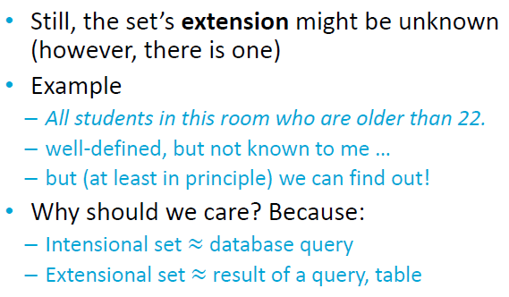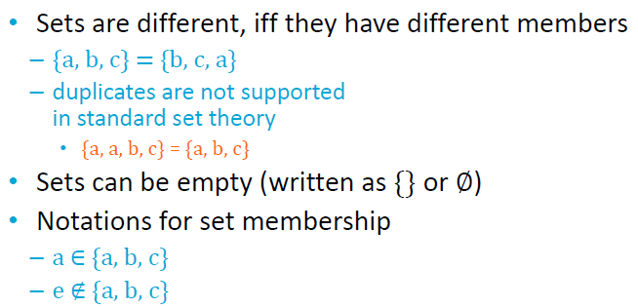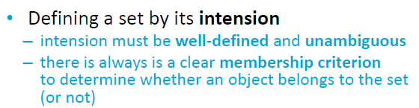

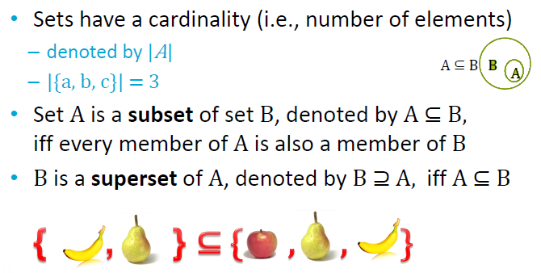

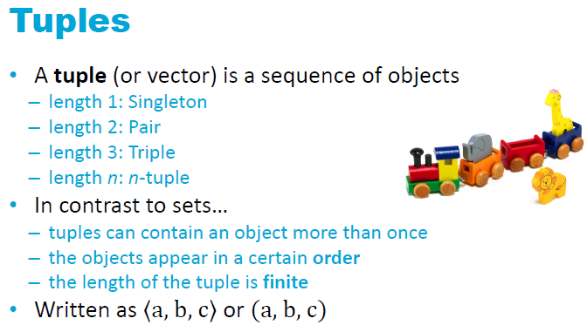

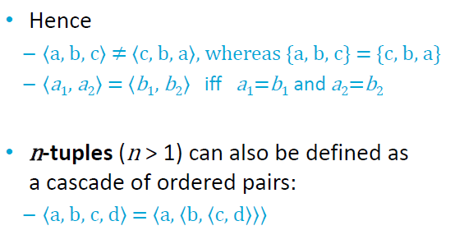

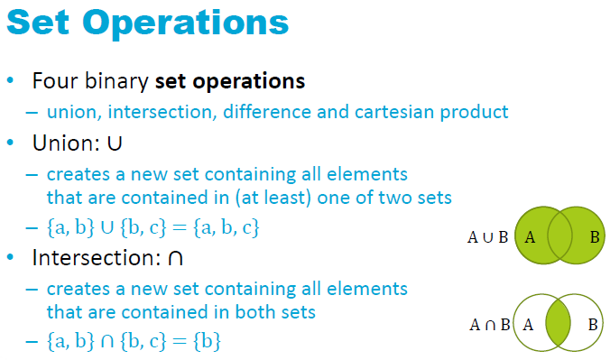

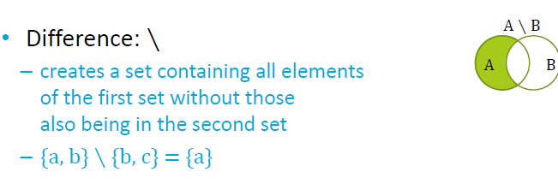

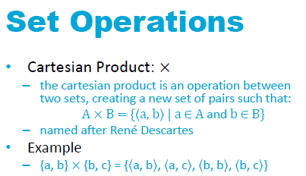

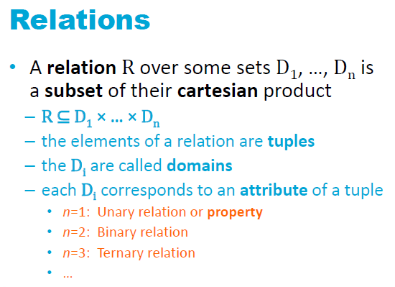

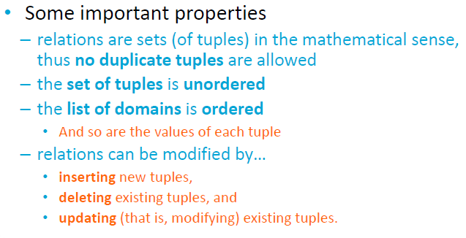

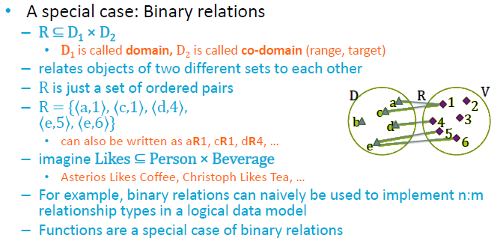

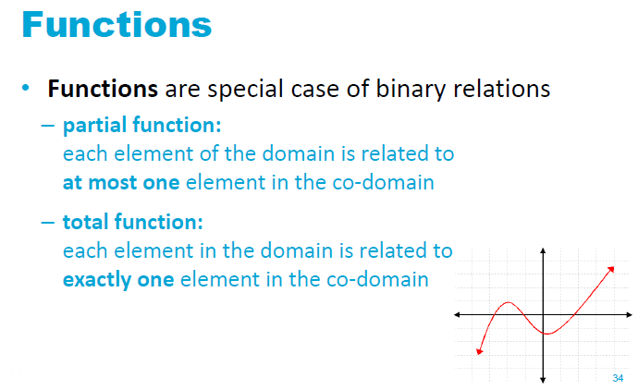

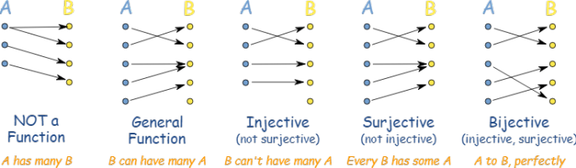

Partial function = injective

Total function = bijective

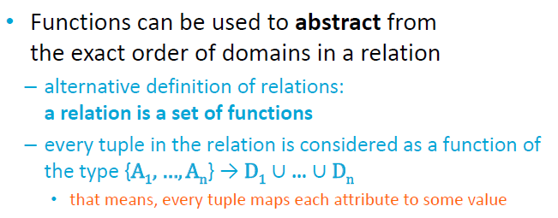

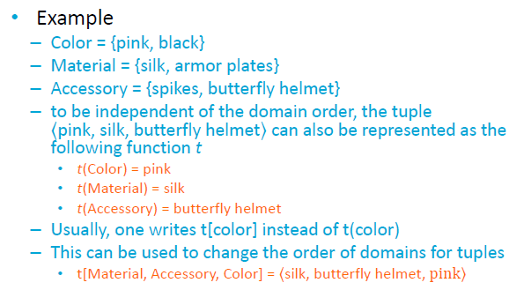

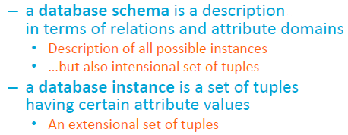

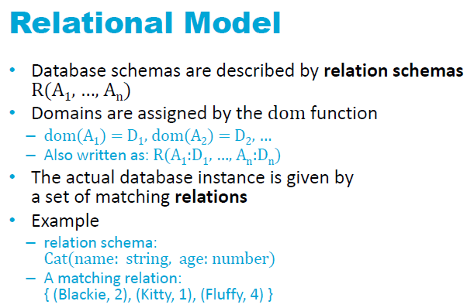

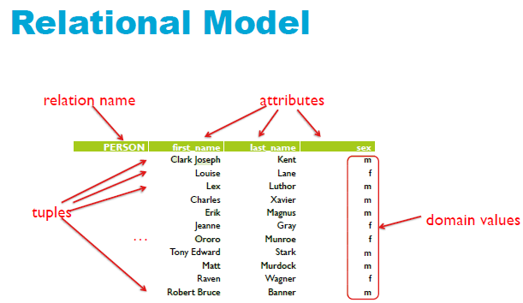

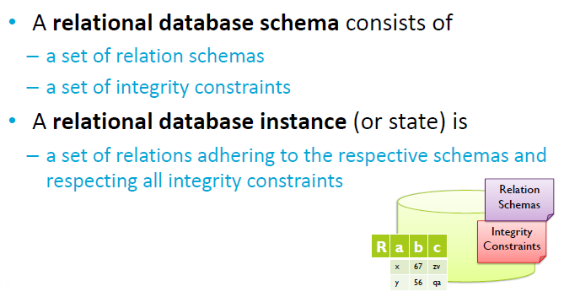

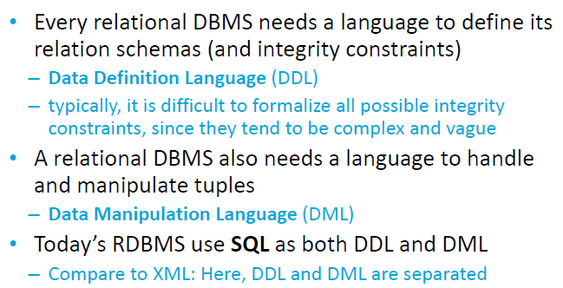

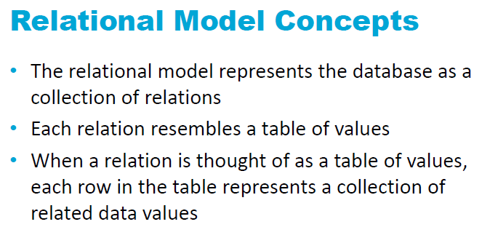

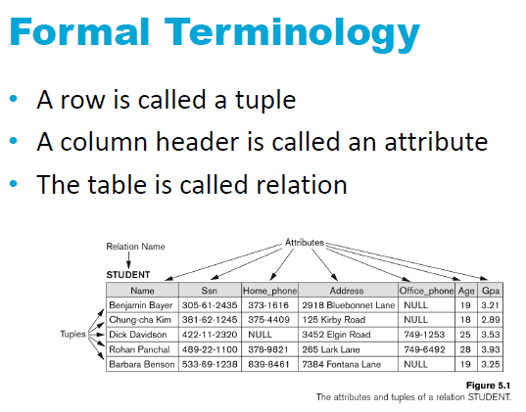

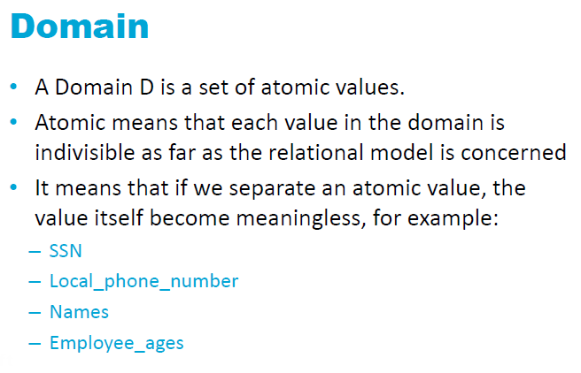

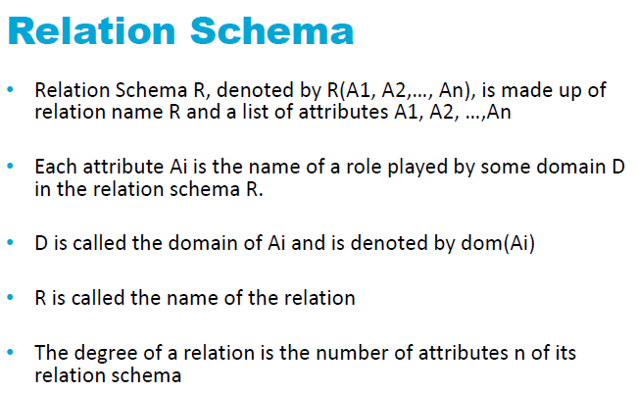

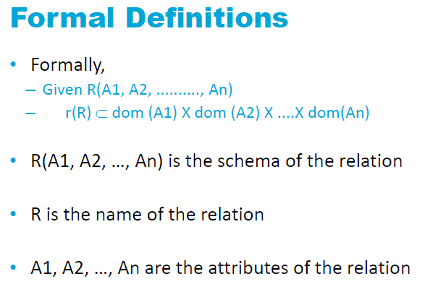

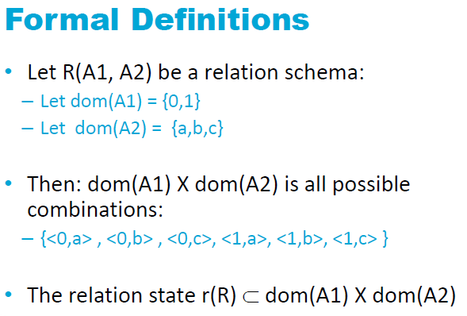

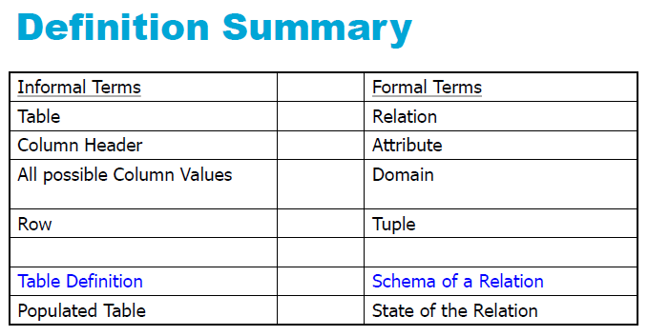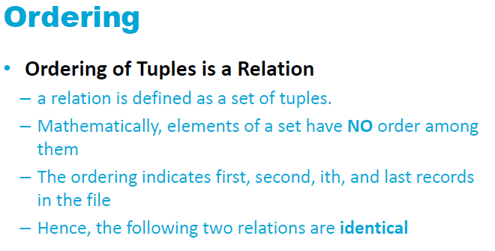

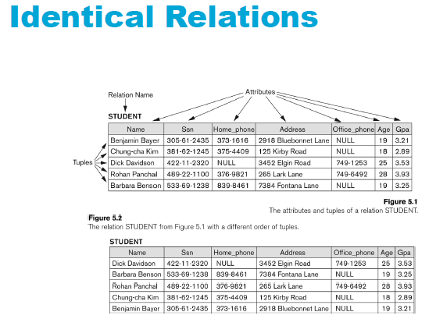

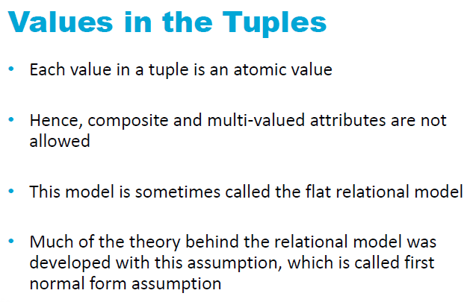

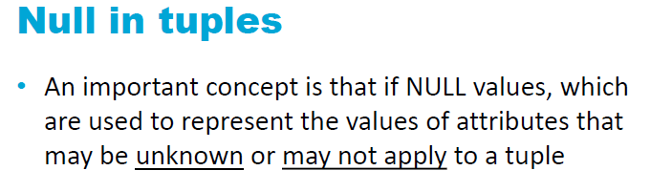

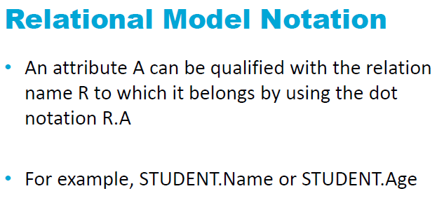

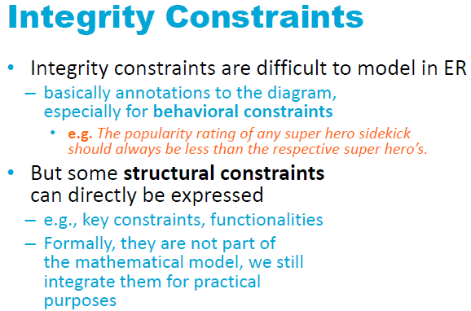

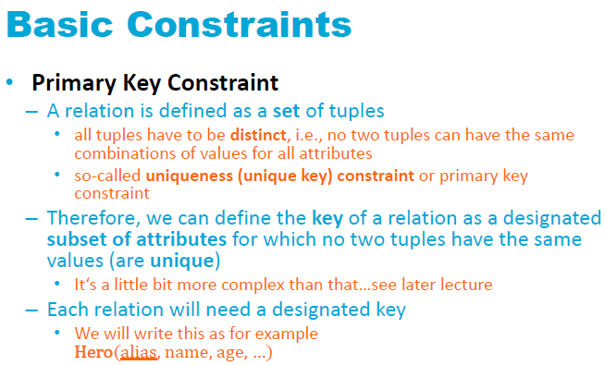

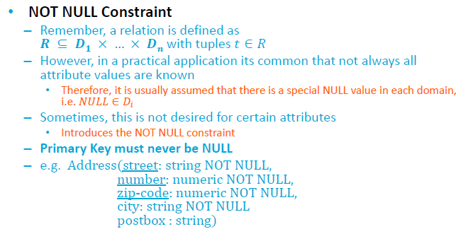

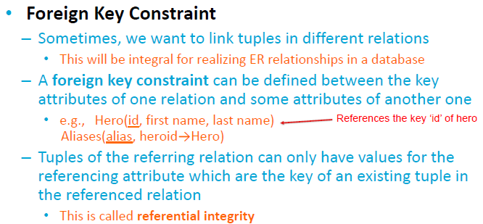

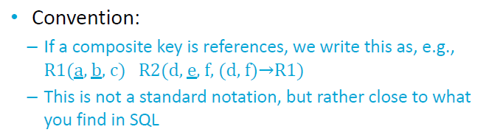

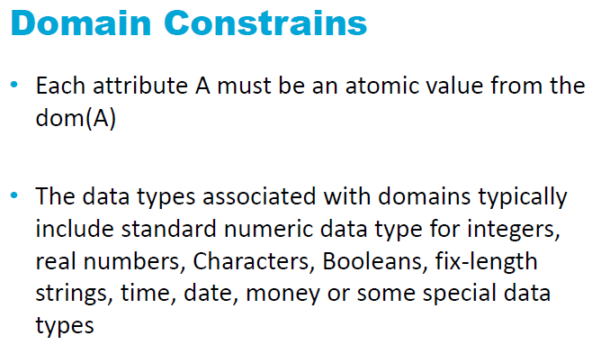

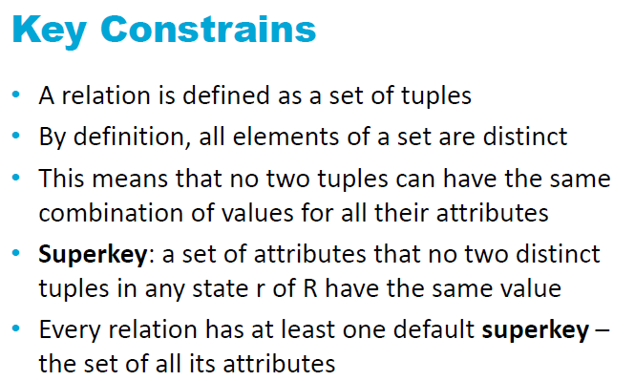

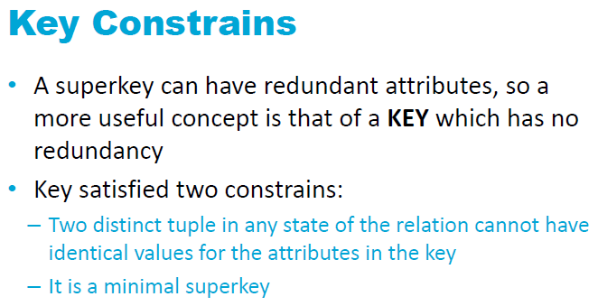

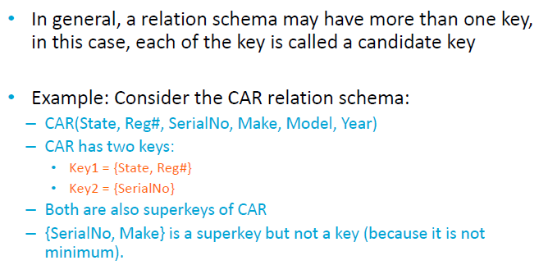

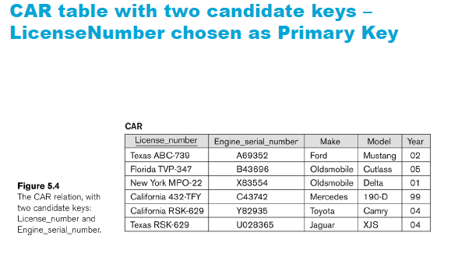

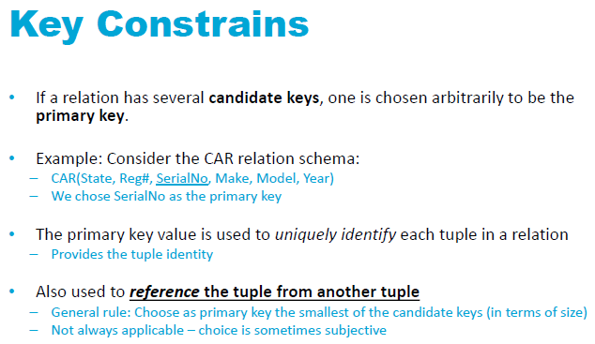

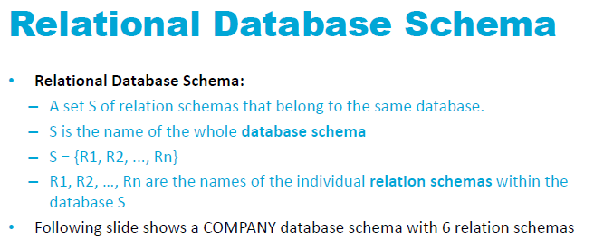

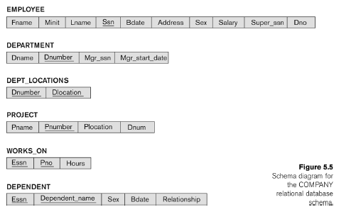

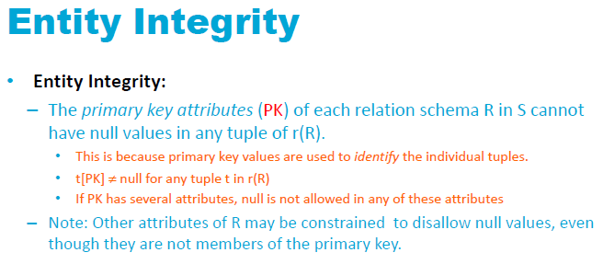

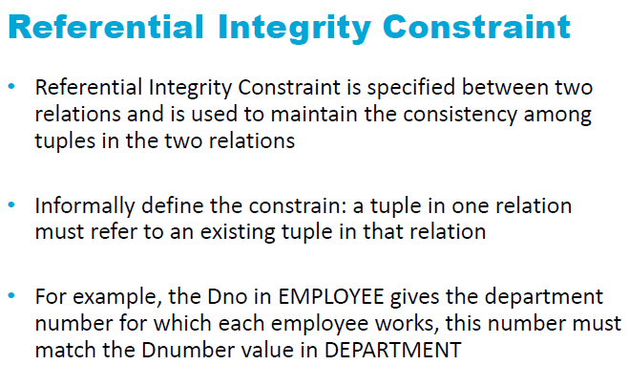

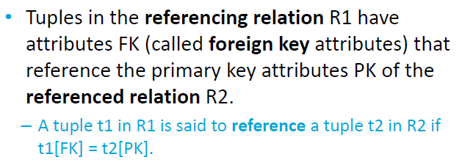

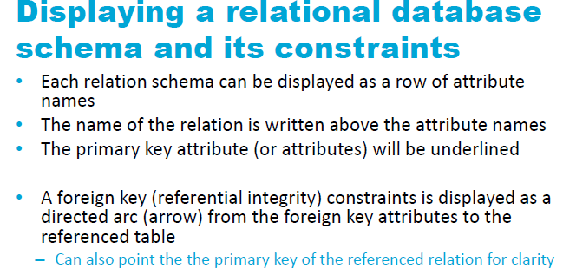

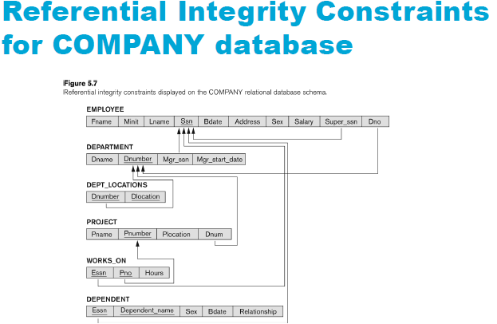

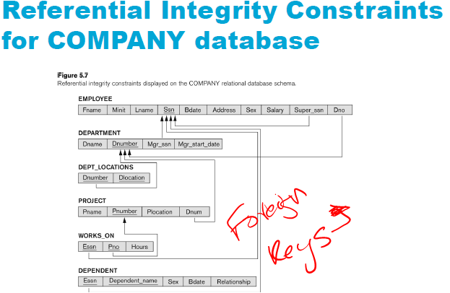

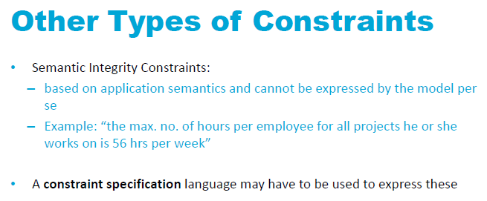

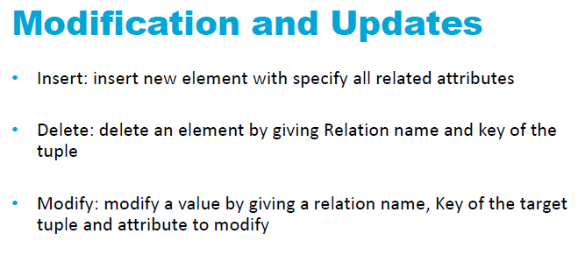

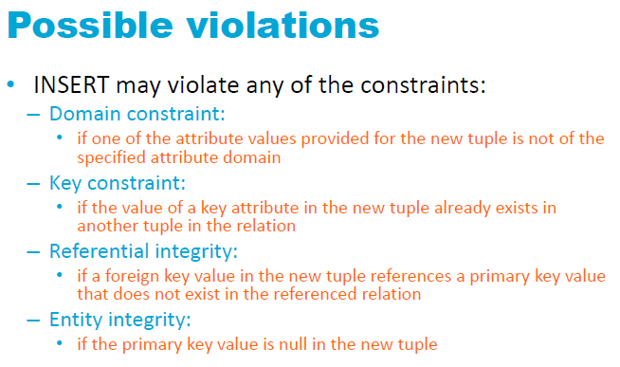

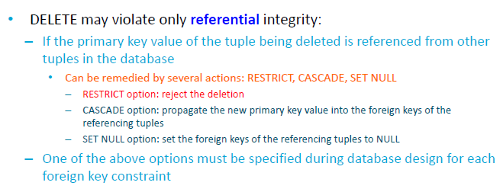

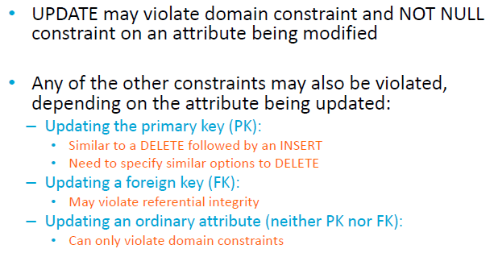

# Lecture 4. More on Modelling

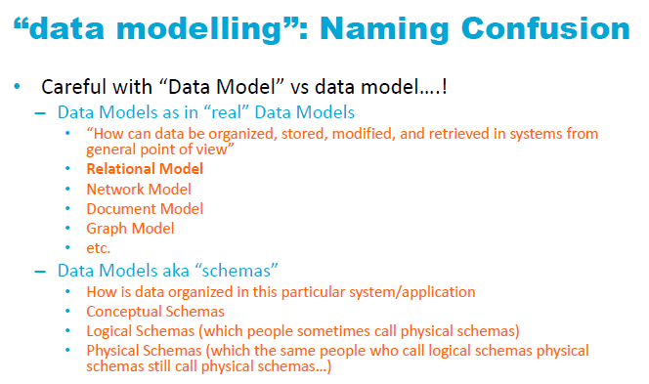

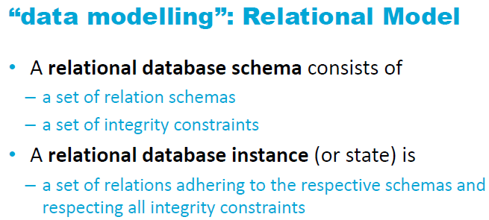



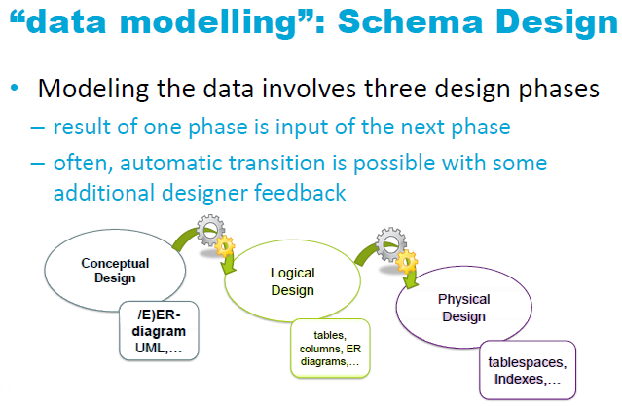

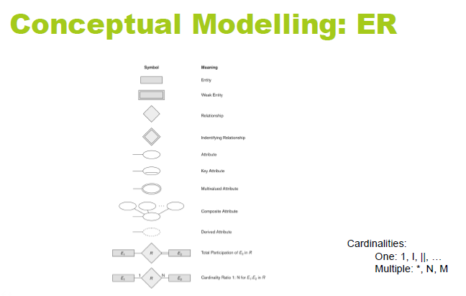

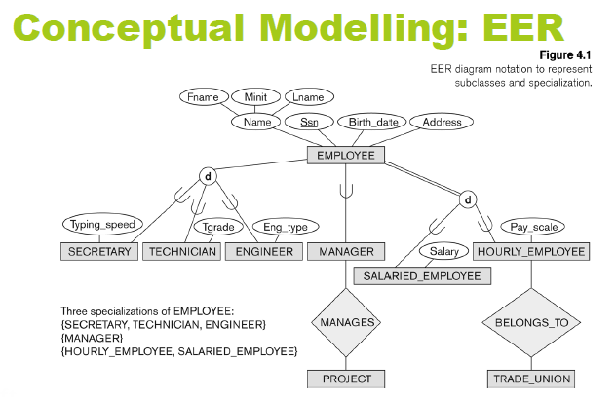

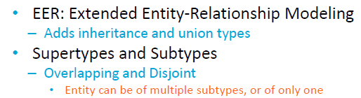

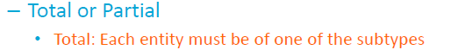

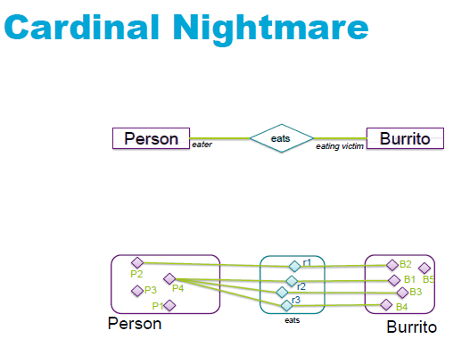

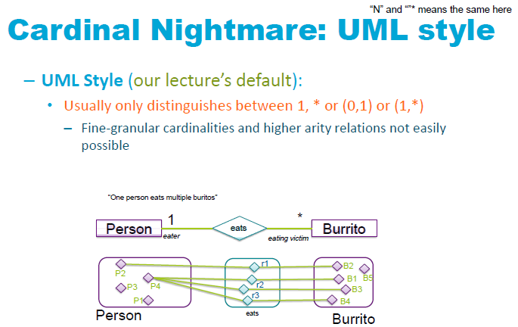

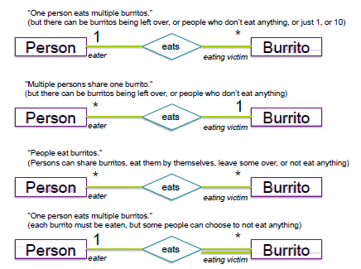

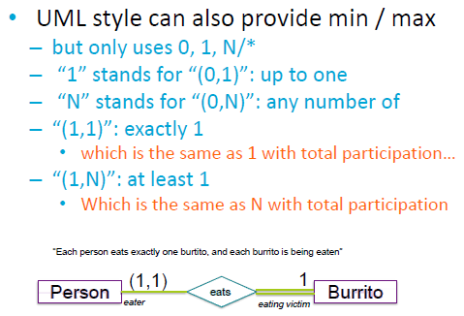

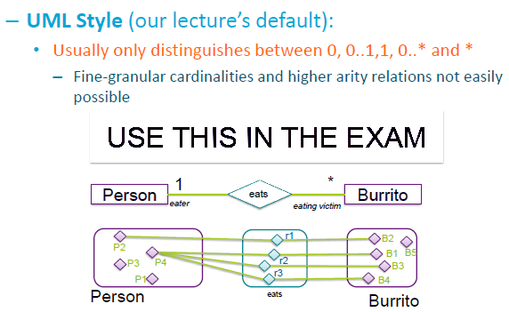

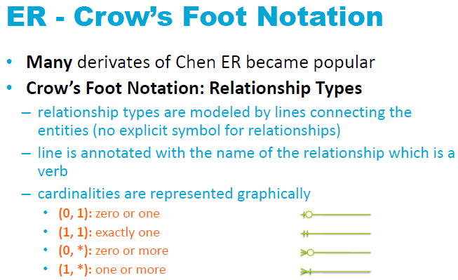

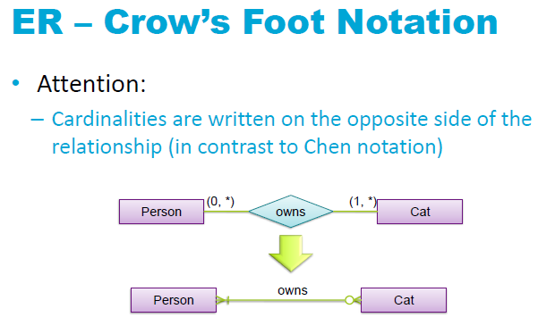

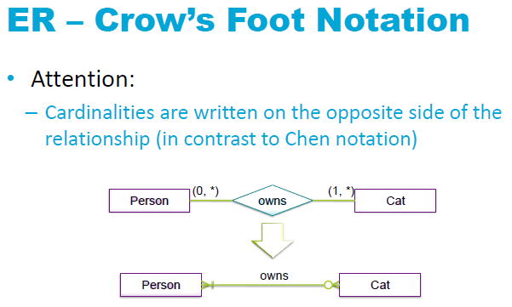

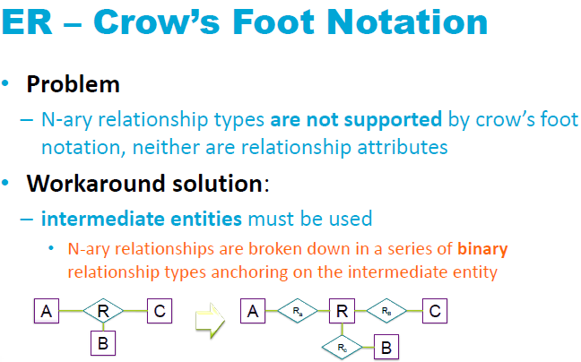

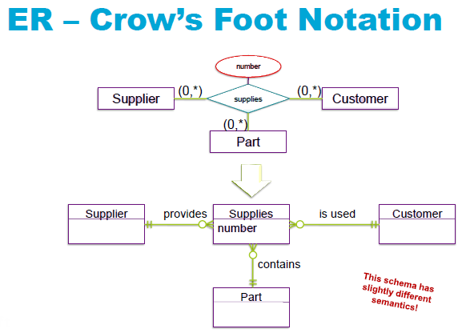

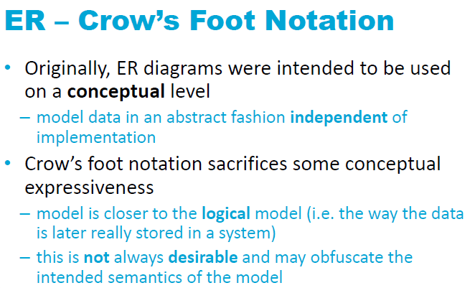

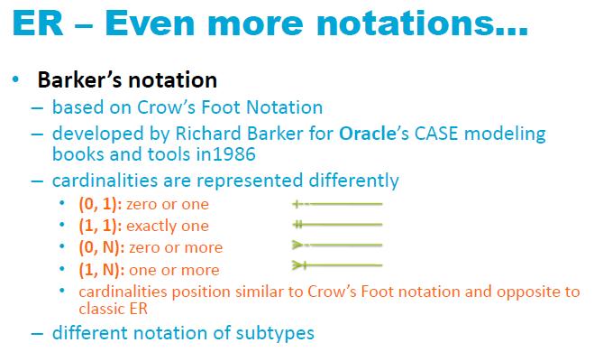

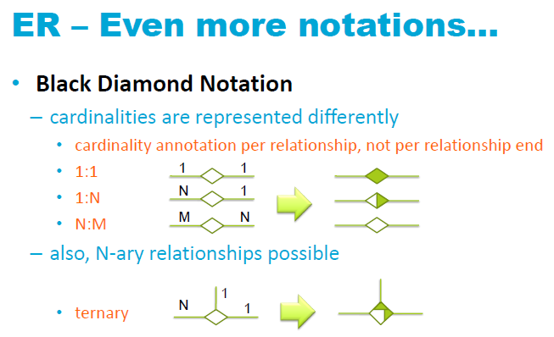

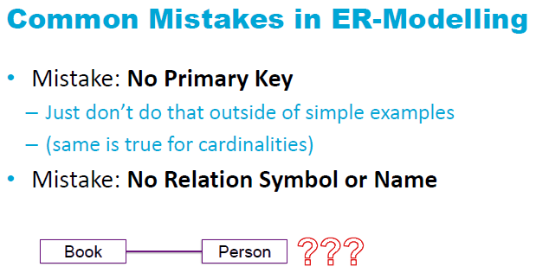





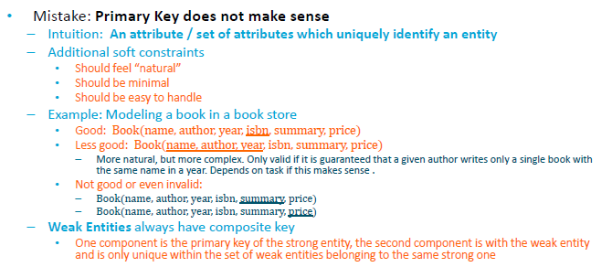

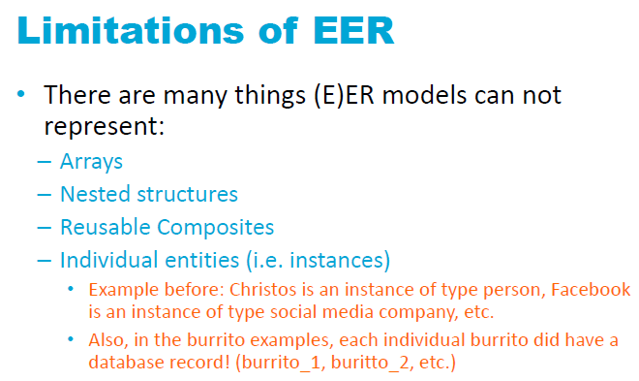

*Week 3.* Functional Dependencies and Normalization

# Lecture 5. Functional Dependencies and Normalization

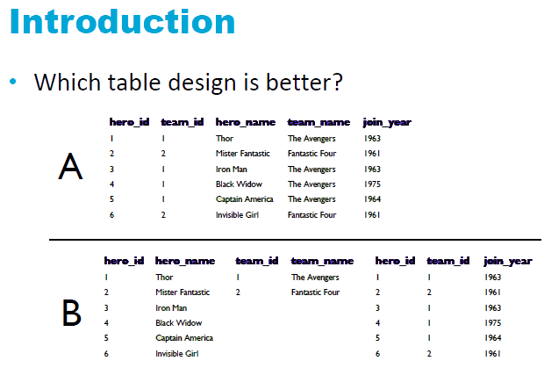

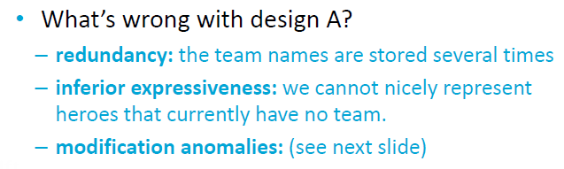

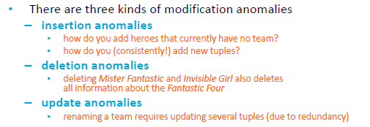

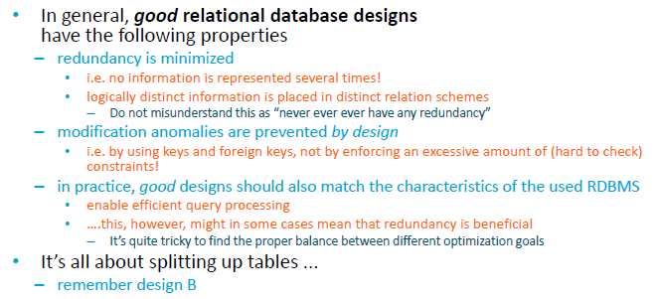

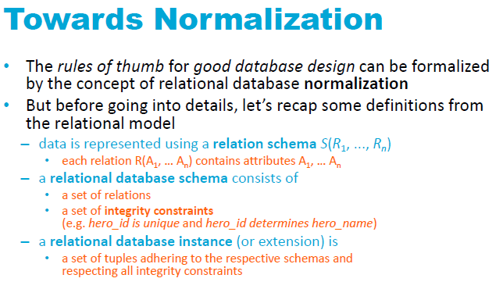

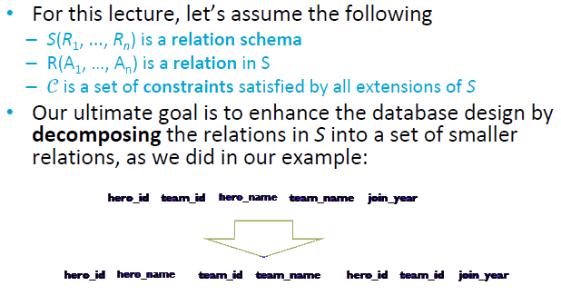

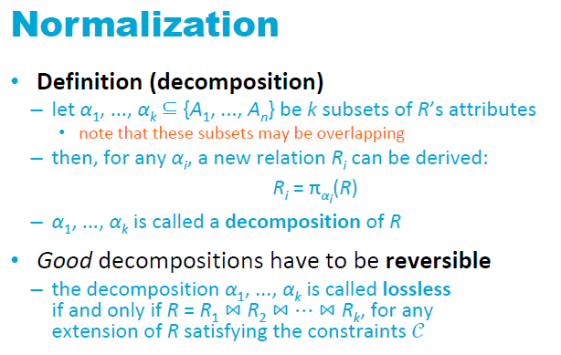

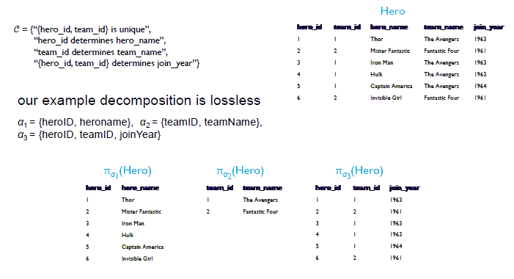

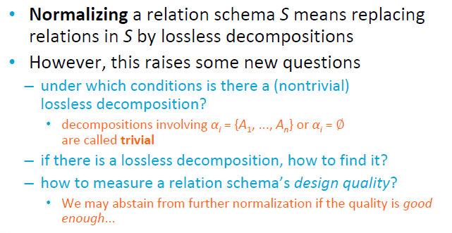

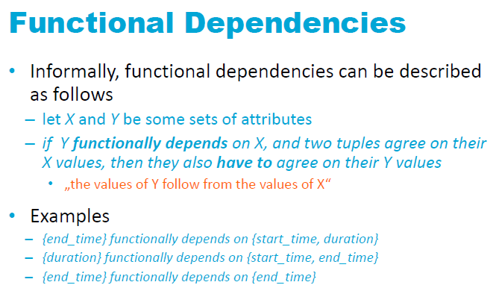

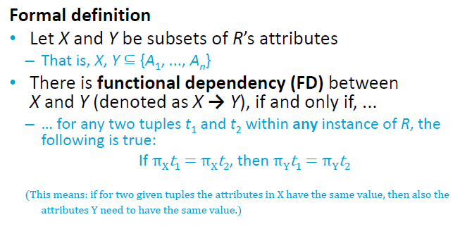

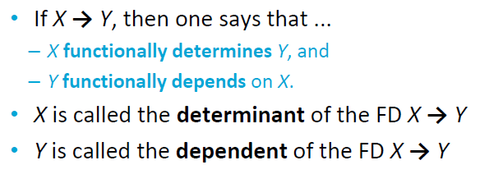

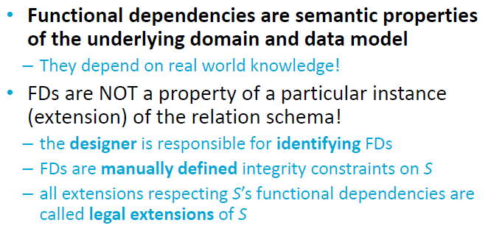

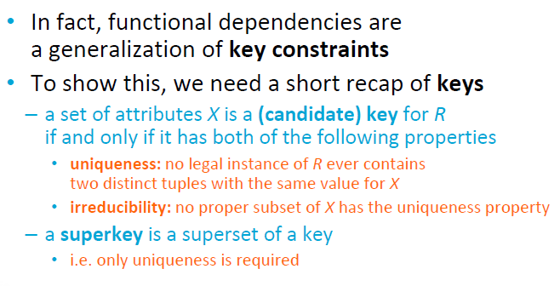

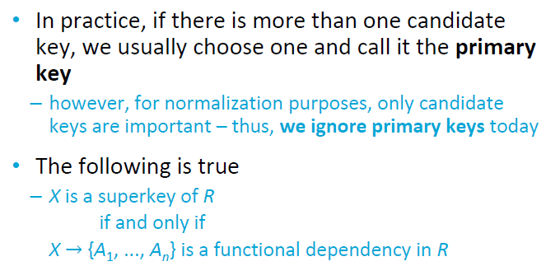

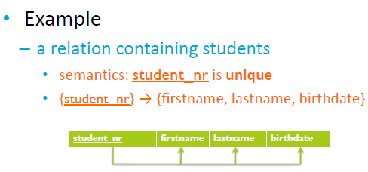

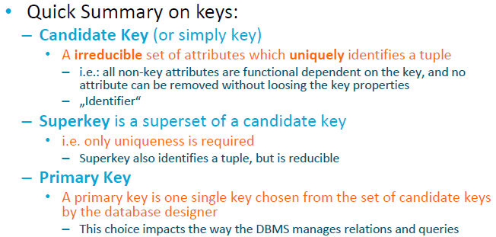

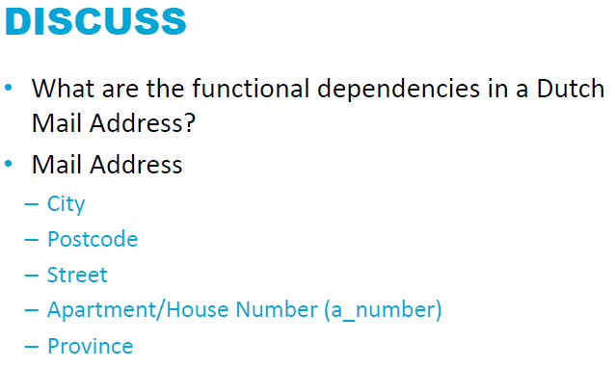

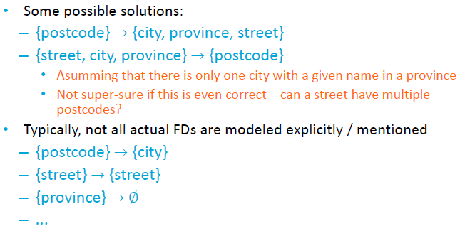

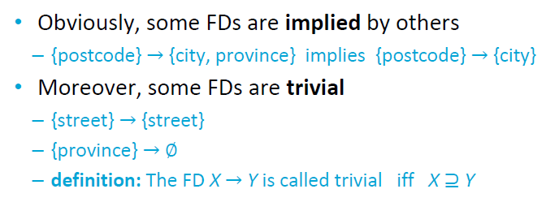

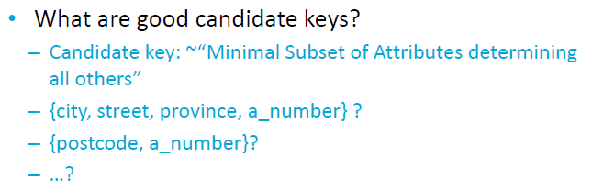

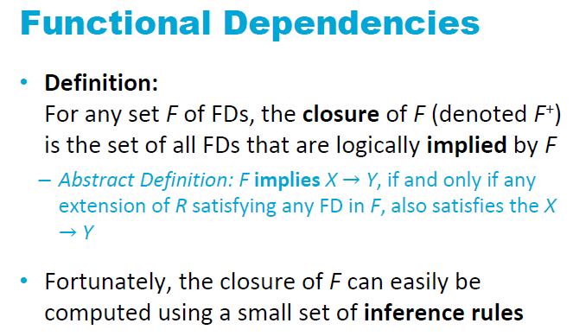

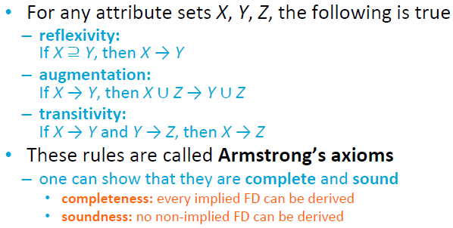

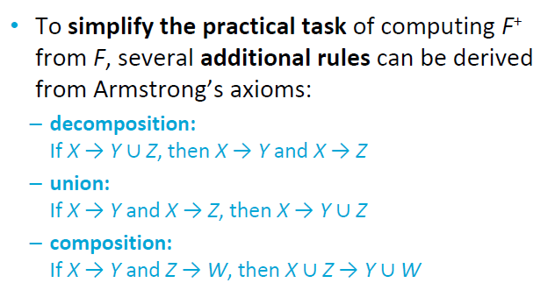

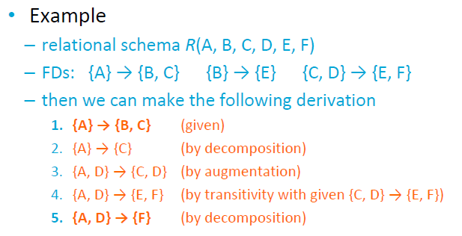

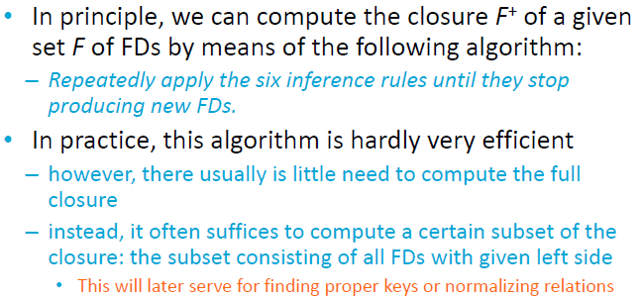

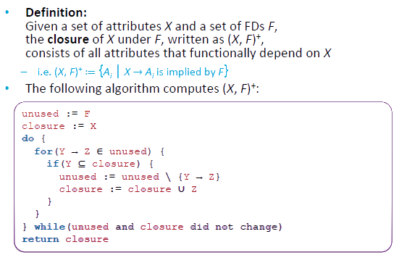

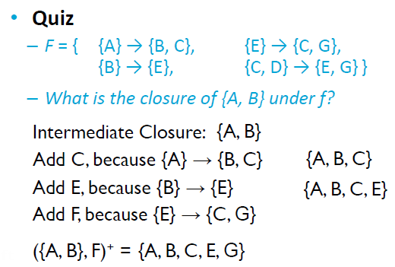

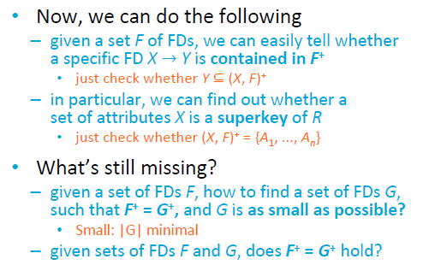

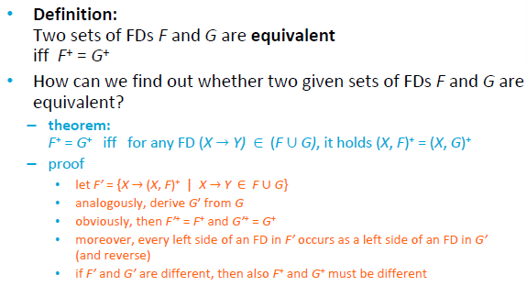

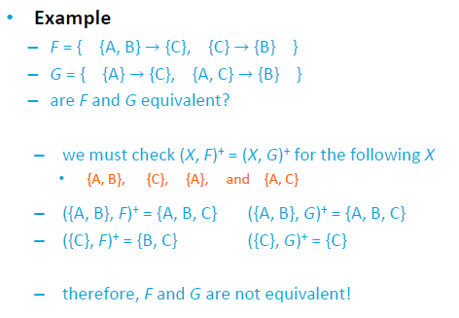

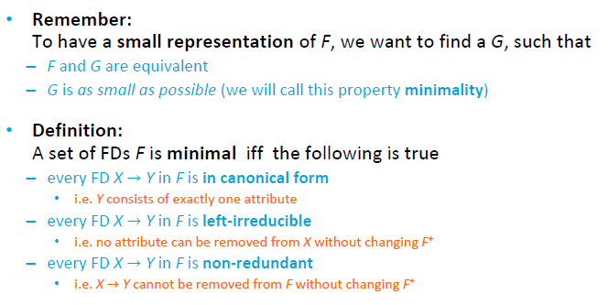

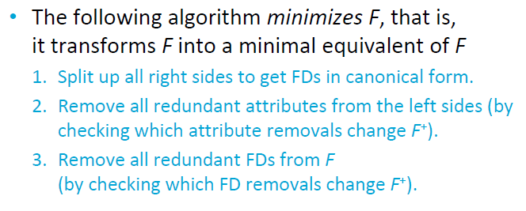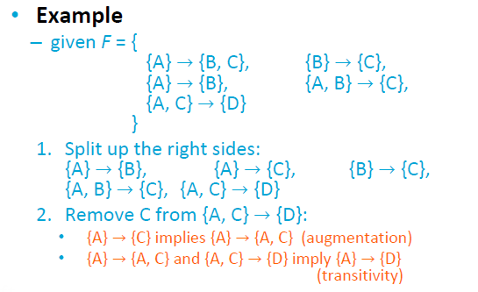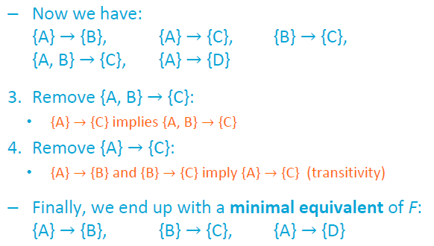

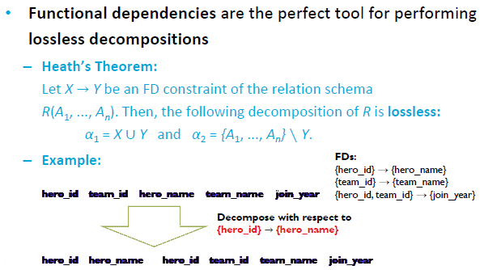

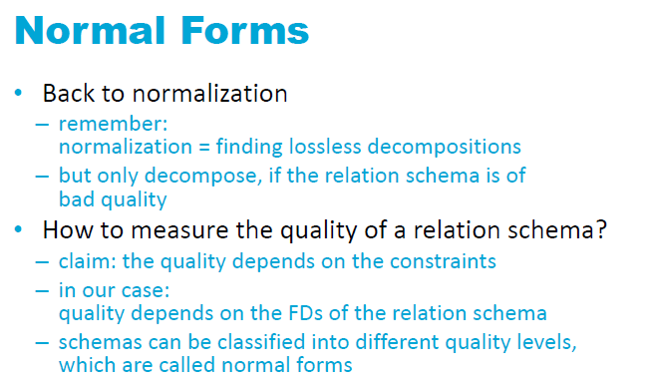

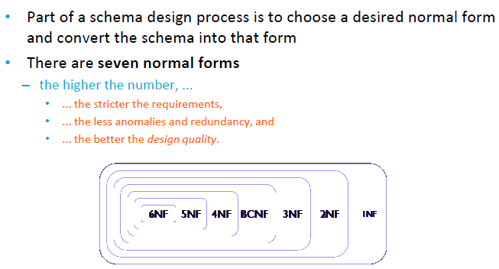

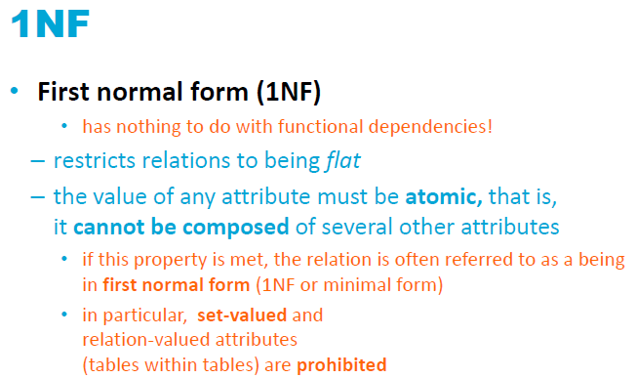

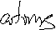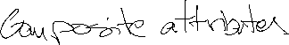

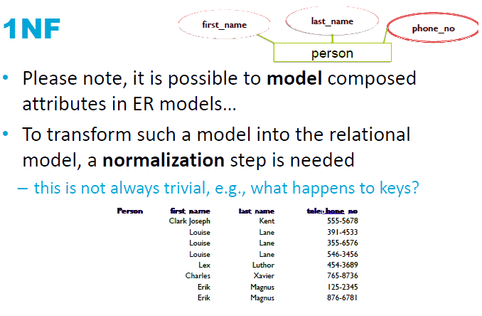

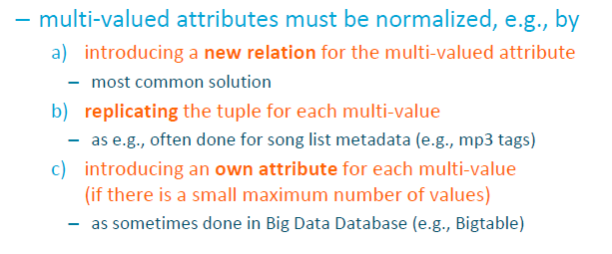

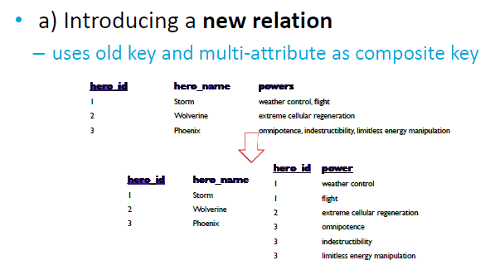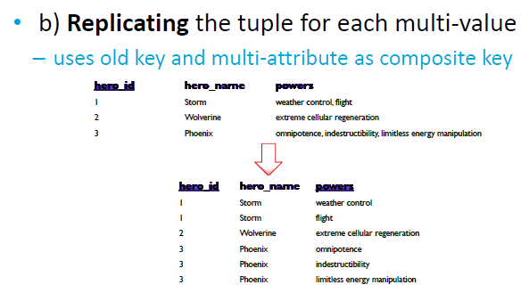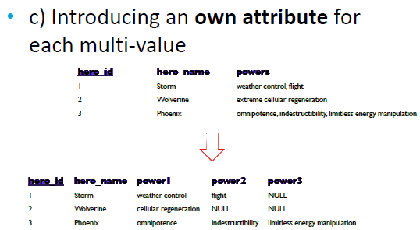

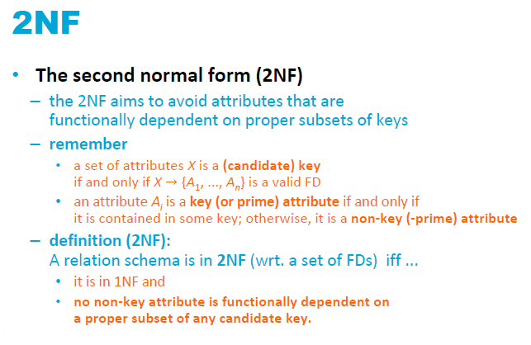

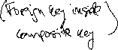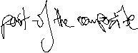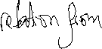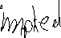

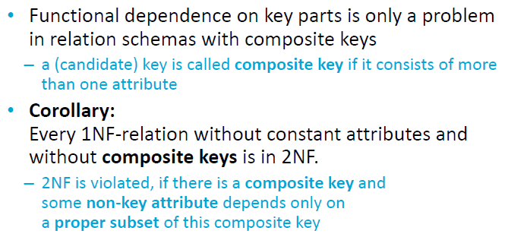

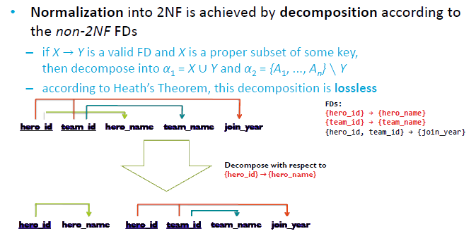

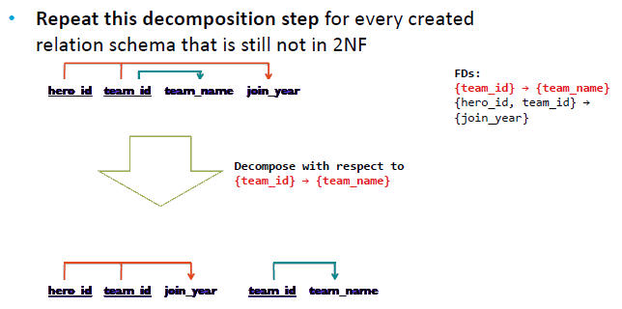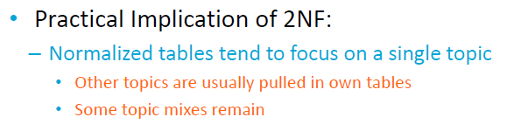

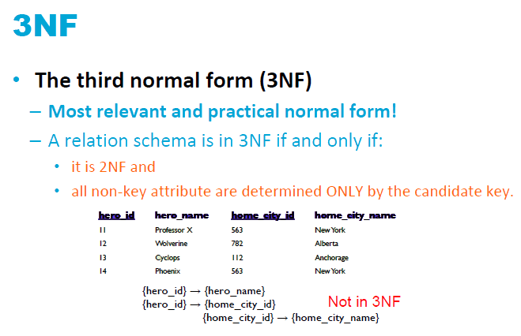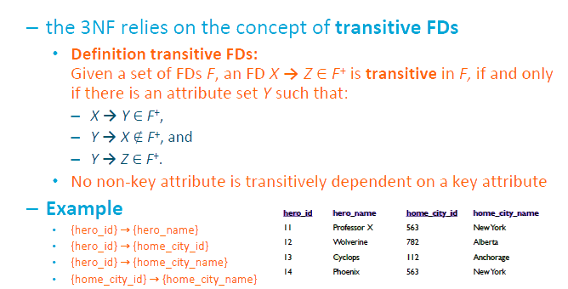

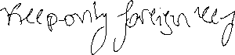

# Chapter 14.

The implicit goals of the design activity are information preservation and minimum redundancy.

Information preservation in terms of maintaining all concepts, including attribute types, entity types, and relationship types as well as generalization/specialization relationships, which are described using a model such as the EER model. Thus, the relational design must preserve all of these concepts, which are originally captured in the conceptual design after the conceptual to logical design mapping. Minimizing redundancy implies minimizing redundant storage of the same information and reducing the need for multiple updates to maintain consistency across multiple copies of the same information in response to real-world events that require making an update.

Successive normal forms are defined to meet a set of desirable constraints expressed using primary keys and functional dependencies. The normalization procedure consists of applying a series of tests to relations to meet these increasingly stringent requirements and decompose the relations when necessary.

## 14.1 Informal Design Guidelines for Relation Schemas

Before discussing the formal theory of relational database design, we discuss four *informal guidelines* that may be used as *measures to determine the quality* of relation schema design:

* Making sure that the semantics of the attributes is clear in the schema
* Reducing the redundant information in tuples
* Reducing the NULL values in tuples
* Disallowing the possibility of generating spurious tuples

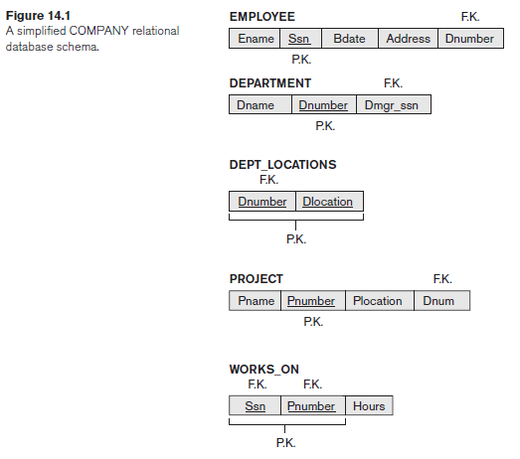These measures are not always independent of one another.

**Guideline** **1**. Design a relation schema so that it is easy to explain its meaning. Do not combine attributes from multiple entity types and relationship types into a single relation. Intuitively, if a relation schema corresponds to one entity type or one relationship type, it is straightforward to explain its meaning. Otherwise, if the relation corresponds to a mixture of multiple entities and relationships, semantic ambiguities will result and the relation cannot be easily explained.

**Guideline 2**. Design the base relation schemas so that no insertion, deletion, or modification anomalies are present in the relations. If any anomalies are present, note them clearly and make sure that the programs that update the database will operate correctly.

**Guideline** **3**. As far as possible, avoid placing attributes in a base relation whose values may frequently be NULL. If NULLs are unavoidable, make sure that they apply in exceptional cases only and do not apply to a majority of tuples in the relation.

**Guideline 4**. Design relation schemas so that they can be joined with equality conditions on attributes that are appropriately related (primary key, foreign key) pairs in a way that guarantees that no spurious tuples are generated. Avoid relations that contain matching attributes that are not (foreign key, primary key) combinations because joining on such attributes may produce spurious tuples.

## 14.2 Functional Dependencies

Any relational database schema can be expressed as a single **universal** Relation Schema R with n Attributes  Such table will have a lot of rows and a lot of null values.

In that huge table, we can ~~identify~~ ask the owner for patterns, called “functional dependencies”.

That is attribute X implies attribute Y. X->Y. This combination of attributes are a proper subset of R. They also specify a constraint on the possible tuples that can be accepted in a valid state for R.

The constraint is that, for any two tuples *t*1 and *t*2 in *r* that have *t*1[*X*] = *t*2[*X*], they must also have *t*1[*Y*] = *t*2[*Y*].

That is also called Y is functionally dependent on X. X is called teh left-hand side of the FD and y the right

That also means that X is a candidate key of R. Then X → R.

Relation extensions r(R) that satisfy the functional dependency constraints are called legal relation states (or legal extensions) of R. Hence, the main use of functional dependencies is to describe further a relation schema R by specifying constraints on its attributes that must hold at all times.

A functional dependency is a property of the relation schema R, not of a particular legal relation state r of R. Therefore, an FD cannot be inferred automatically from a given relation extension r but must be defined explicitly by someone who knows the semantics of the attributes of R.

We can hower use counter examples to prove that certain FD do not hold.

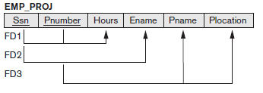These FD indicate that Hours and Ename are attributes of an entity that has ssn as primary key, and Pname and Plocation are attributes of an entity that has Pnumber has primary key.

This table violates 3NF, only attributes of the primary key should be in a table. Attributes of the foreign key should be kept at its own table.

Lecture notation for FD constraints

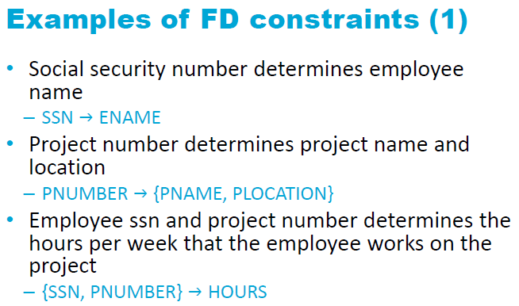

BTW a relation is a table that explicty has foreign keys. A (composite) “key” can be redundant (scrapping things will keep it unique), a superkey is atomic (scrapping thigns will not keep it unique). Single value keys are superkeys by default (what else is left to remove? ;P )

## 14.3 Normal Forms Based on Primary keys

Prime attributes are attributes belonging to a candidate key.

Most practical relational design projects take one of the following two approaches:

* Perform a conceptual schema design using a conceptual model such as ER or EER and map the conceptual design into a set of relations.
* Design the relations based on external knowledge derived from an existing implementation of files or forms or reports.

[Stack Overflow](https://stackoverflow.com/questions/723998/what-are-database-normal-forms-and-can-you-give-examples/724032#724032):

**1NF**

1NF is the most basic of normal forms - each cell in a table must contain only one piece of information, and there can be no duplicate rows.

2NF and 3NF are all about being dependent on the primary key. Recall that a primary key can be made up of multiple columns. As Chris said in his response:

The data depends on the key [1NF], the whole key [2NF] and nothing but the key [3NF] (so help me [Codd](http://en.wikipedia.org/wiki/Ted_Codd)).

**2NF**

Say you have a table containing courses that are taken in a certain semester, and you have the following data:

|-----Primary Key----| uh oh |

V

CourseID | SemesterID | #Places | Course Name |

------------------------------------------------|

IT101 | 2009-1 | 100 | Programming |

IT101 | 2009-2 | 100 | Programming |

IT102 | 2009-1 | 200 | Databases |

IT102 | 2010-1 | 150 | Databases |

IT103 | 2009-2 | 120 | Web Design |

This is **not in 2NF**, because the fourth column does not rely upon the entire key - but only a part of it. The course name is dependent on the Course's ID, but has nothing to do with which semester it's taken in. Thus, as you can see, we have duplicate information - several rows telling us that IT101 is programming, and IT102 is Databases. So we fix that by moving the course name into another table, where CourseID is the ENTIRE key.

Primary Key |

CourseID | Course Name |

---------------------------|

IT101 | Programming |

IT102 | Databases |

IT103 | Web Design |

No redundancy!

**3NF**

Okay, so let's say we also add the name of the teacher of the course, and some details about them, into the RDBMS:

|-----Primary Key----| uh oh |

V

Course | Semester | #Places | TeacherID | TeacherName |

---------------------------------------------------------------|

IT101 | 2009-1 | 100 | 332 | Mr Jones |

IT101 | 2009-2 | 100 | 332 | Mr Jones |

IT102 | 2009-1 | 200 | 495 | Mr Bentley |

IT102 | 2010-1 | 150 | 332 | Mr Jones |

IT103 | 2009-2 | 120 | 242 | Mrs Smith |

Now hopefully it should be obvious that TeacherName is dependent on TeacherID - so this is **not in 3NF**. To fix this, we do much the same as we did in 2NF - take the TeacherName field out of this table, and put it in its own, which has TeacherID as the key.

Primary Key |

TeacherID | TeacherName |

---------------------------|

332 | Mr Jones |

495 | Mr Bentley |

242 | Mrs Smith |

No redundancy!!

One important thing to remember is that if something is not in 1NF, it is not in 2NF or 3NF either. So each additional Normal Form requires everything that the lower normal forms had, plus some extra conditions, which must all be fulfilled.

# Lecture 6



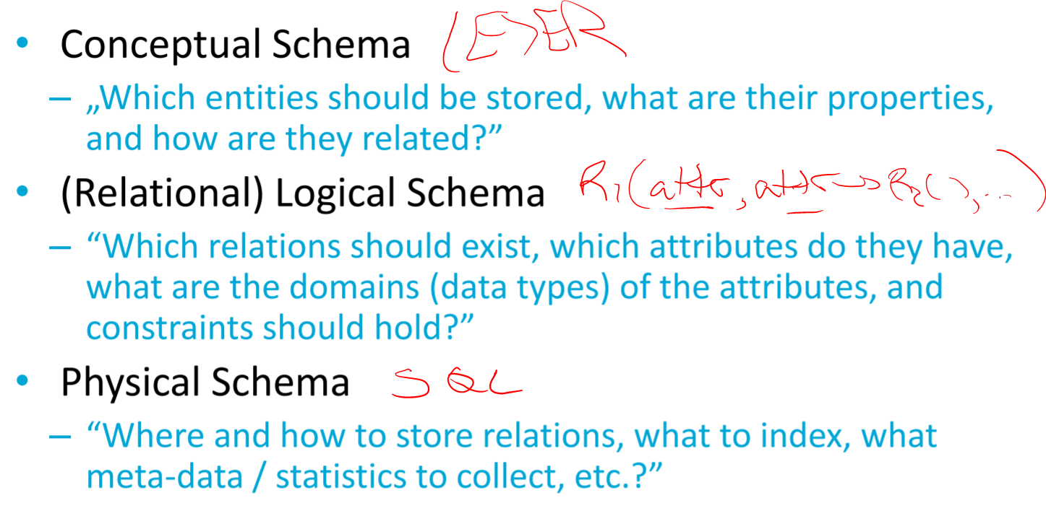

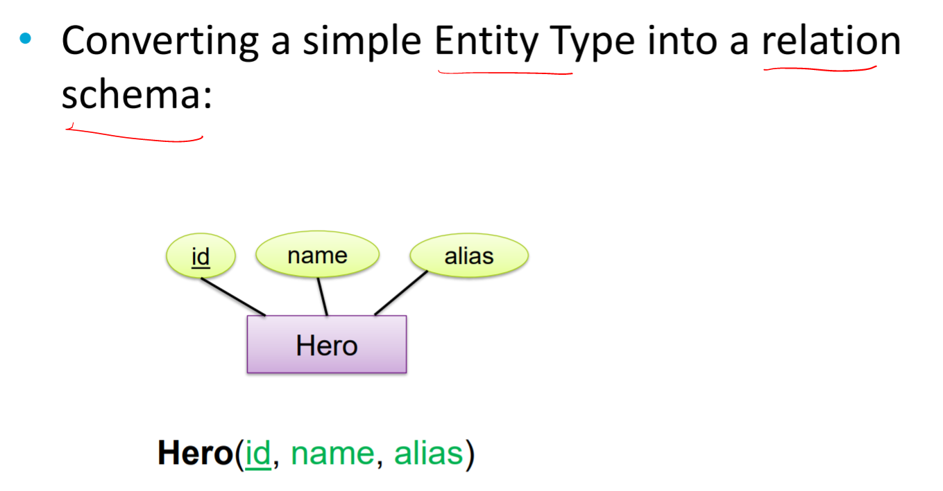

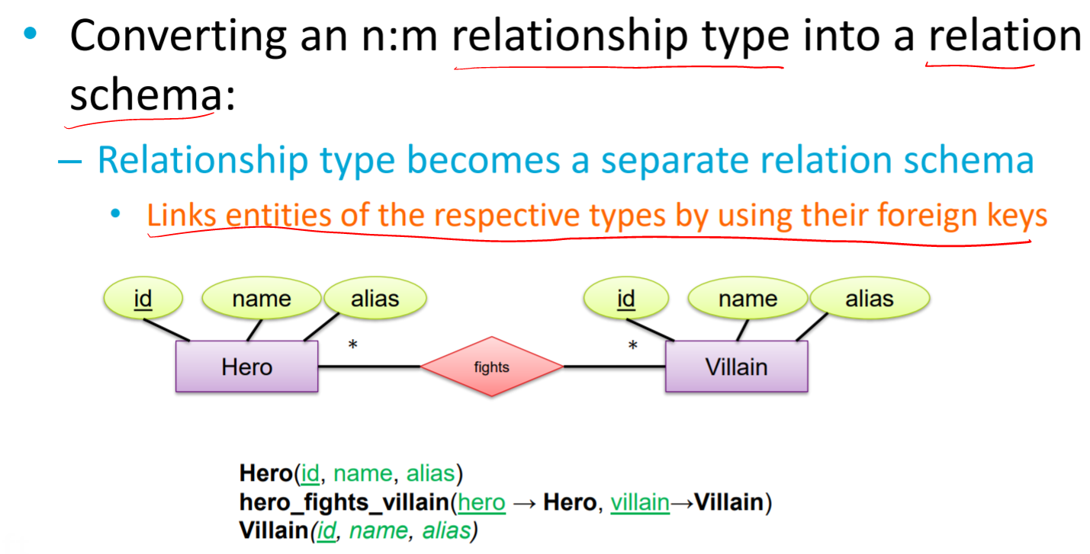

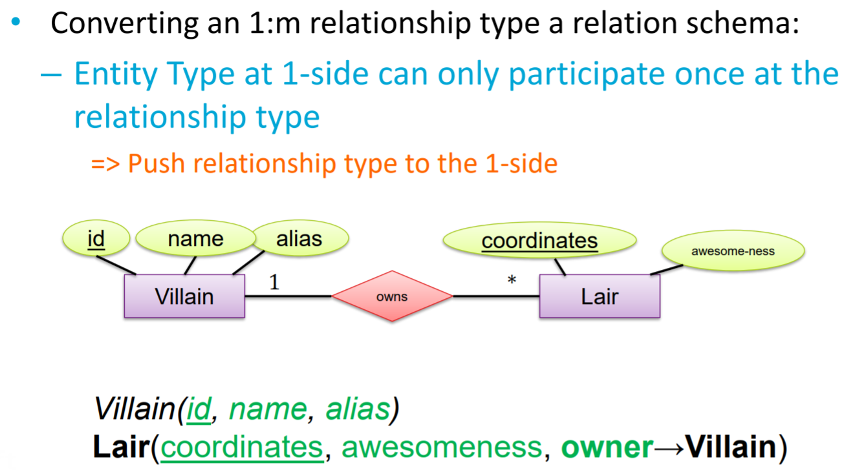

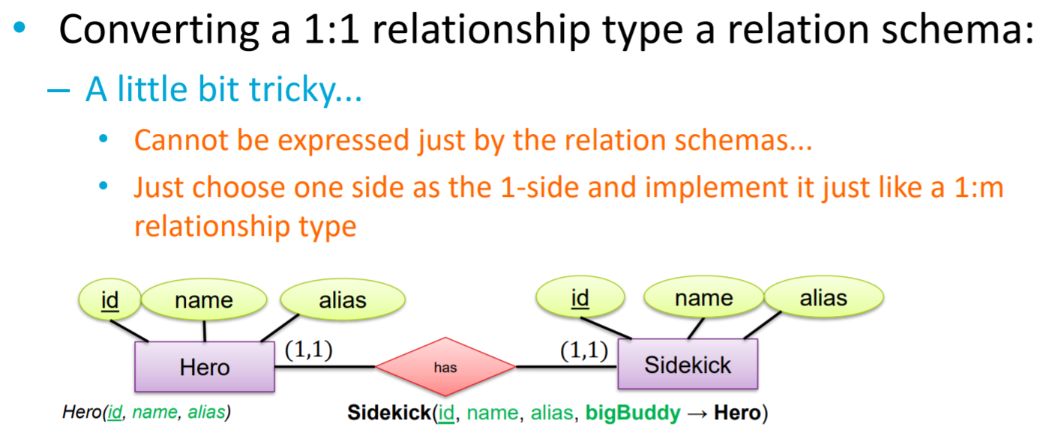

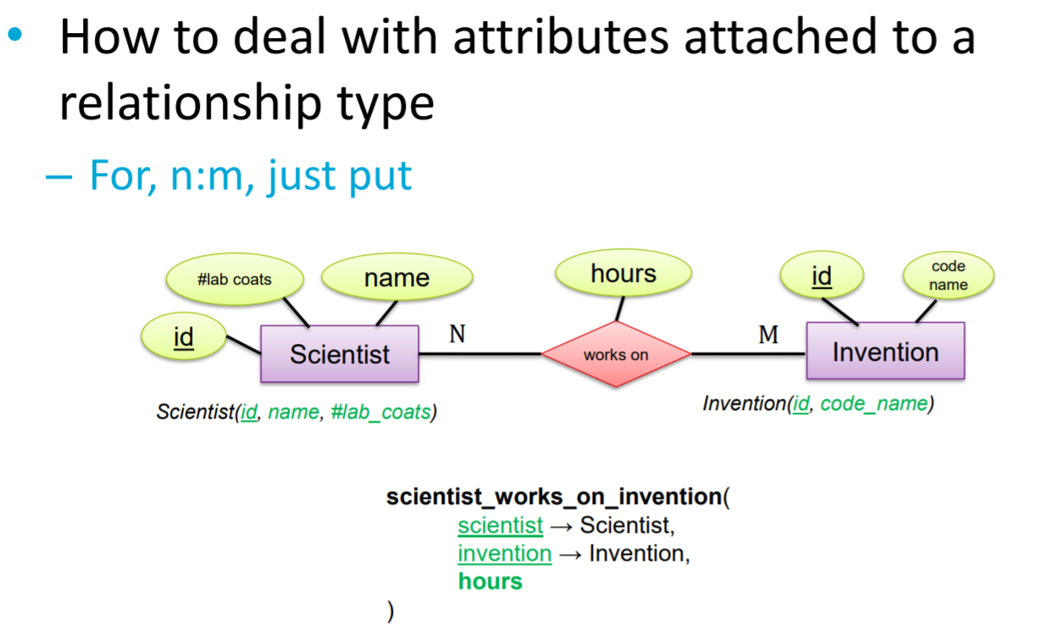

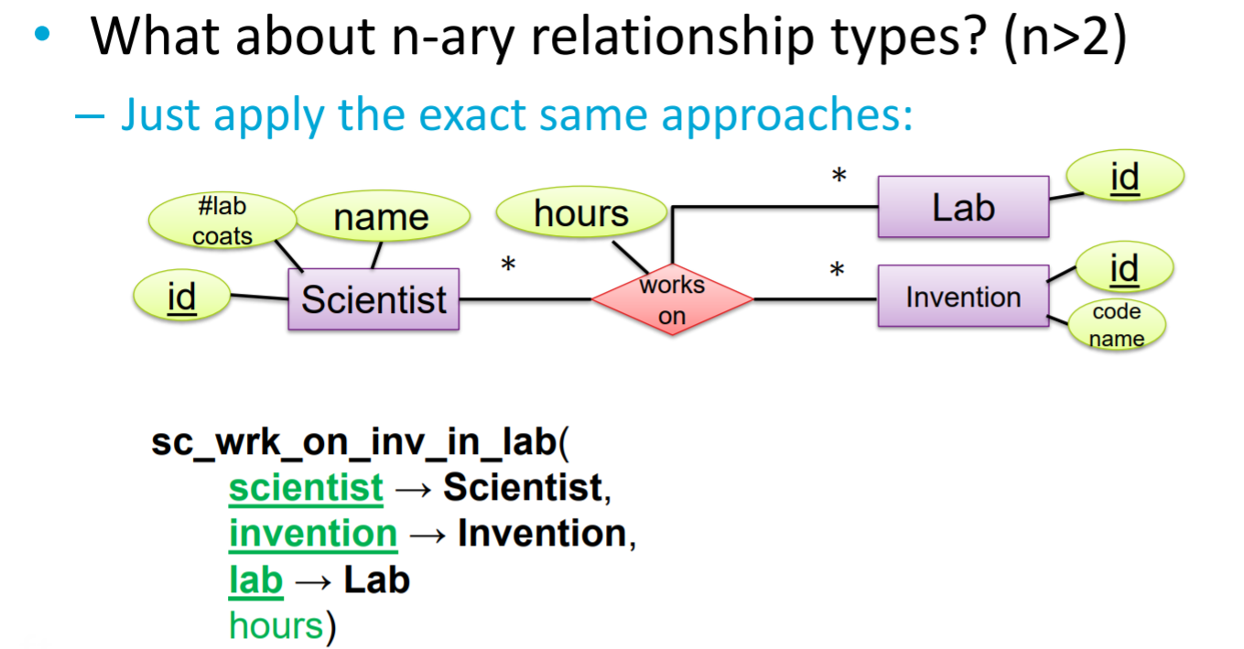

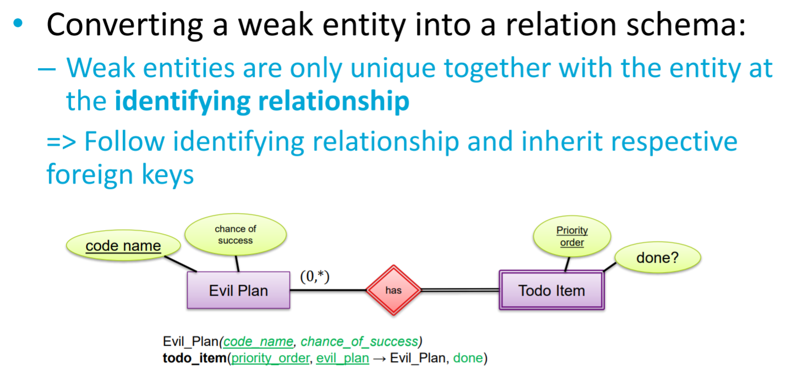

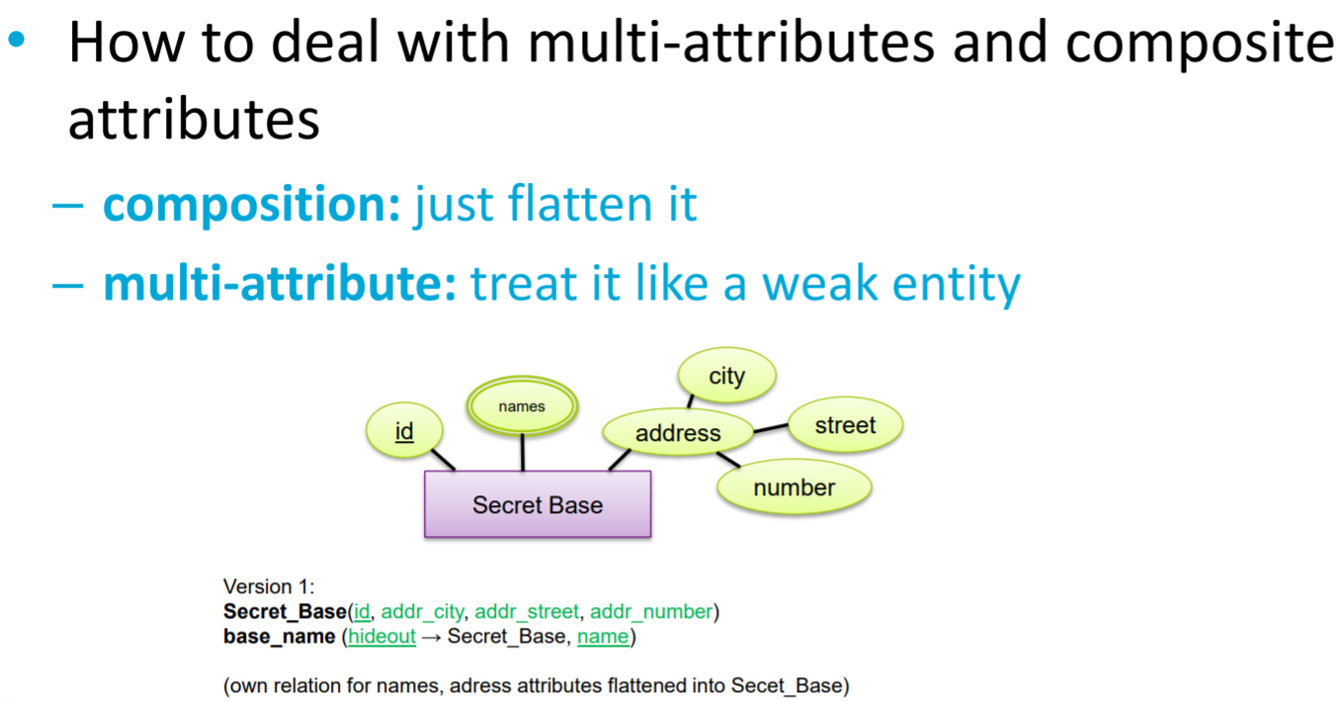

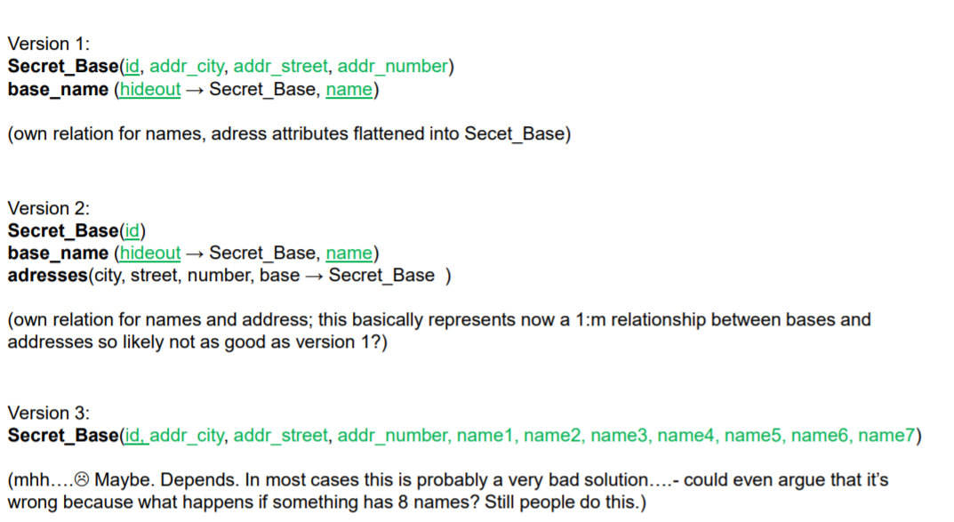

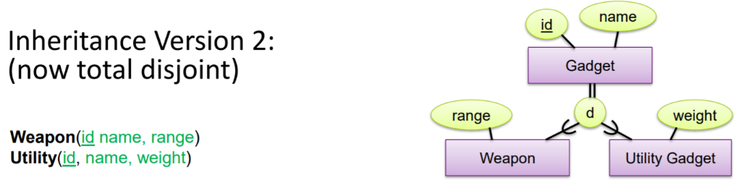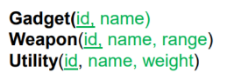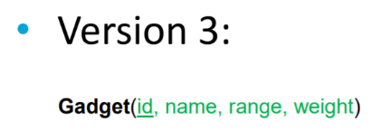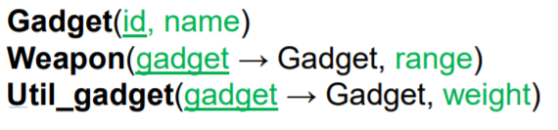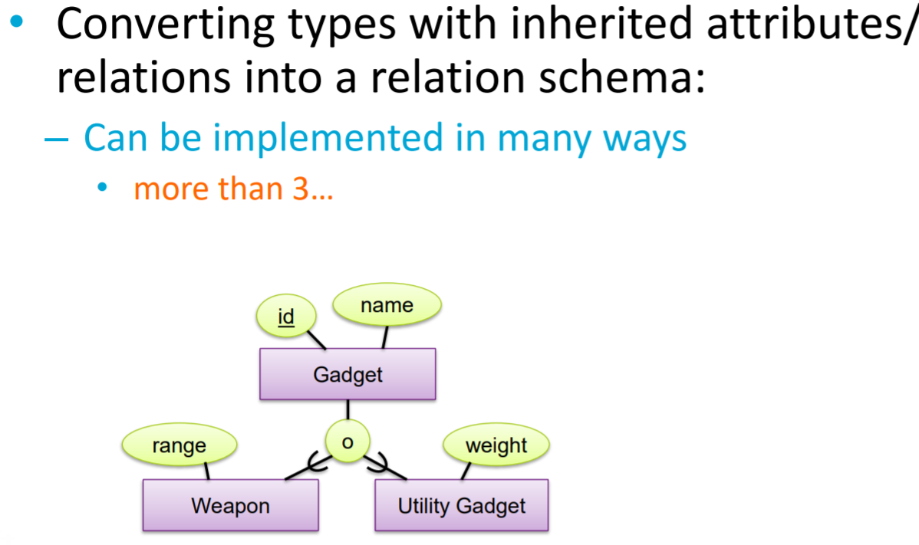

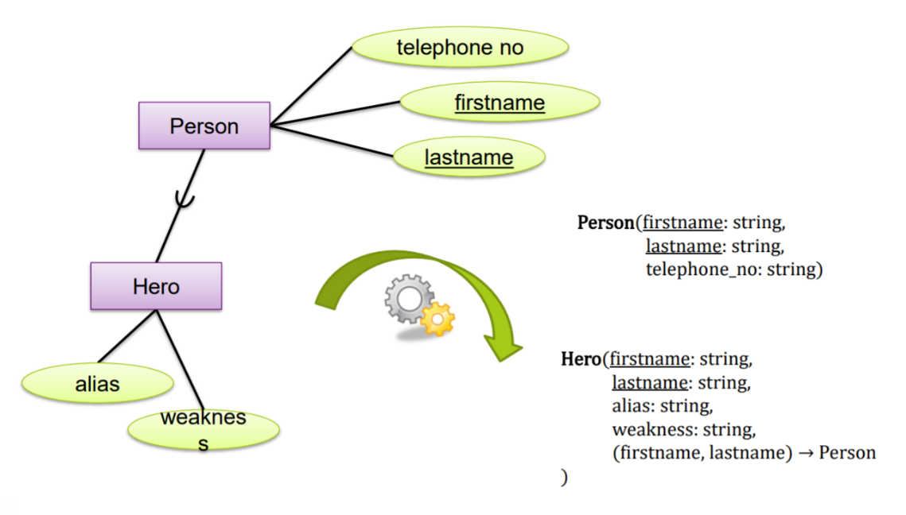

*Week 4. SQL*

# Lecture 7 – SQL

SQL is a high-level declarative language, that means the user defines what result he expects and know how it is executed. The exeuction of the relational algebra is left to the optimizer by the DBMS.

SQL is a comprehensive database language: It has statements for data definitions,

queries, and updates. Hence, it is both a DDL (**data definition language**, used by the DBA and by database designers to define conceptual and internal schemas.) *and* a DML (**data manipulation language** i.e. SCRUD). This course uses postgreSQL <https://www.postgresql.org/docs/11/index.html>

## 6.1 SQL Data Definition and Data Types

SQL uses the terms table, row, and column for the formal relational model terms relation, tuple, and attribute, respectively.

SQL command for data definition is the CREATE statement, which can be used to create databases (schemas), tables (relations), types, and domains, as well as other constructs such as views, assertions, and triggers.

An SQL schema (database) is identified by a schema name and includes an authorization identifier to indicate the user or account who owns the schema, as well as descriptors for each element in the schema. Schema elements include tables, types, constraints, views, domains, and other constructs (such as authorization grants) that describe the schema.

A schema is created via the CREATE SCHEMA statement, which can include all the schema elements’ definitions. Although these can be changed later.

the following statement creates a schema called COMPANY owned by the user with authorization identifier ‘Jsmith’.

**CREATE SCHEMA** COMPANY **AUTHORIZATION** ‘Jsmith’;

The privilege to create schemas, tables, and other constructs must be explicitly granted to the relevant user accounts by the system administrator or DBA.

A catalog is a collection of schemas. A catalog always contains a special schema called INFORMATION_SCHEMA, which provides information on all the schemas in the catalog and all the element descriptors in these schemas. Integrity constraints such as referential integrity can be defined between relations only if they exist in schemas within the same catalog. Schemas within the same catalog can also share certain elements, such as type and domain definitions.

The CREATE TABLE command is used to specify a new relation by giving it a name and specifying its attributes and initial constraints. The key, entity integrity, and referential integrity constraints can be specified within the CREATE TABLE statement after the attributes are declared, or they can be added later using ALTER TABLE.

Typically, the SQL schema in which the relations are declared is implicitly specified in the environment in which the CREATE TABLE statements are executed. Alternatively, we can explicitly attach the schema name to the relation name, separated by a period. For example, by writing:

**CREATE TABLE** COMPANY.EMPLOYEE

rather than

**CREATE TABLE** EMPLOYEE

In PostgreSQL we are always connected to a particular database/schema. So appending is not needed.

Example of table creation with constraints and keys:

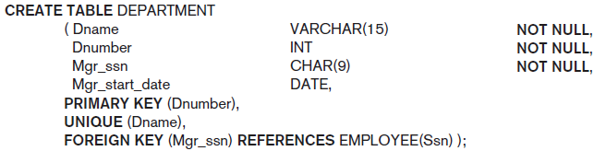

The relations declared through CREATE TABLE statements are called base tables (or base relations); this means that the table and its rows are actually created and stored as a file by the DBMS. Base relations are distinguished from virtual relations, created through the CREATE VIEW statement which do not correspond to a phyisical phile but a query. (It may correspond to a physical phile that contains the query script).

Declaring dependencies before the other tables have been created can lead to errors. Therefore it is often prefered to create all the tables without keys and constraints and later alter them to apply the dependencies and constraints.

## Data types

The basic data types available for attributes include numeric, character string, bit string, Boolean, date, and time. For numeric the most common are INT and DOUBLE

When specifying a literal string value, it is placed between single quotation marks (apostrophes), and it is *case sensitive*. String values are stored in n/char(length) or n/varchar(length), the first being of a fixed length and the second specifying the max length.

Difference between nvarchar and varchar (also for nchar and char): The n prefix stands for "national character set". An nvarchar column can store multi-byte characters such as Unicode data. A varchar column is restricted to an 8-bit codepage. Some people think that varchar should be used because it takes up less space. I believe this is not the correct answer. Codepage incompatabilities are a pain, and Unicode is the cure for codepage problems. With cheap disk and memory nowadays, there is really no reason to waste time mucking around with code pages anymore [[source](https://stackoverflow.com/questions/144283/what-is-the-difference-between-varchar-and-nvarchar)].

For example, if the value ‘Smith’ is for an attribute of type CHAR(10), it is padded with five blank characters to become ‘Smith’ if needed. Padded blanks are generally ignored when strings are compared. For comparison purposes, strings are considered ordered in alphabetic (or lexicographic)

order; if a string str1 appears before another string str2 in alphabetic order, then str1 is considered to be less than str2. There is also a concatenation operator denoted by || (double vertical bar) that can concatenate two strings.

A Boolean data type has the traditional values of TRUE or FALSE. In SQL, because of the presence of NULL values, a three-valued logic is used, so a third possible value for a Boolean data type is UNKNOWN.

Bit-string data types are either of fixed length n—BIT(n)—or varying length— BIT VARYING(n), where n is the maximum number of bits. Another variable-length bitstring data type called BINARY LARGE OBJECT or BLOB is also available to specify columns that have large binary values, such as images. As for CLOB, the maximum length of a BLOB can be specified in kilobits (K), megabits (M), or gigabits (G). For example, BLOB(30G) specifies a maximum length of 30 gigabits.

The DATE data type has ten positions, and its components are YEAR, MONTH, and DAY in the form YYYY-MM-DD. The TIME data type has at least eight positions, with the components HOUR, MINUTE, and SECOND in the form HH:MM:SS. Only valid dates and times should be allowed by the SQL implementation. This implies that months should be between 1 and 12 and days must be between 01 and 31; furthermore, a day should be a valid day for the corresponding month. The < (less than) comparison can be used with dates or times—an earlier date is considered to be smaller than a later date, and similarly with time. Literal values are represented by single-quoted strings preceded by the keyword DATE or TIME; for example, DATE ‘2014-09-27’ or TIME ‘09:12:47’.

A timestamp data type (TIMESTAMP) includes the DATE and TIME fields, plus a minimum of six positions for decimal fractions of seconds and an optional WITH TIME ZONE qualifier.

Another data type related to DATE, TIME, and TIMESTAMP is the INTERVAL data type. This specifies an interval—a relative value that can be used to increment or decrement an absolute value of a date, time, or timestamp. Intervals are qualified to be either YEAR/MONTH intervals or DAY/TIME intervals.

The format of DATE, TIME, and TIMESTAMP can be considered as a special type of string. Hence, they can generally be used in string comparisons by being cast (or coerced or converted) into the equivalent strings.

It is possible to specify the data type of each attribute directly, alternatively, a domain can be declared, and the domain name can be used with the attribute specification. This makes it easier to change the data type for a domain that is used by numerous attributes in a schema, and improves schema readability. For example, we can create a domain SSN_TYPE by the following statement:

**CREATE DOMAIN** SSN_TYPE **AS** CHAR(9);

## Constraints

If a primary key has a single attribute, the clause can follow the attribute directly. For example:

KvkNummer INT **PRIMARY KEY**,

Same goes for UNIQUE, NOT NULL (which is already implied for primary keys) DEFAULT *value*

To declare a composite primary key:

**PRIMARY KEY**(coulmn1, column2, ...)

Same goes for composite (and single) FOREIGN KEY.

Referential integrity constraint can be violated when tuples are inserted or deleted, or when a foreign key or primary key attribute value is updated. The default action that SQL takes for an integrity violation is to reject the update operation that will cause a violation, which is known as the RESTRICT option.

However, the schema designer can specify an alternative action to be taken by attaching a referential triggered action clause to any foreign key constraint. The options include SET NULL, CASCADE, and SET DEFAULT. An example with multiple constraints below:

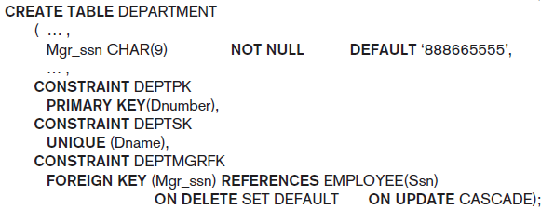

You can see that a constraint may be given a constraint name, following the keyword CONSTRAINT. The names of all constraints within a particular schema must be unique. A constraint name is used to identify a particular constraint in case the constraint must be dropped later and replaced with another constraint. Giving names to constraints is optional. It is also possible to temporarily defer a constraint until the end of a transaction.

CHECK(Column > 0 **AND** Column < 21); or CHECK(StartDate < EndDate); so you check for a boolean expression that returns 1 or 0. In that sense, it is possible to create a user-defined function that returns 1 or 0 by passing parameters from different tables as input. Here's an example check constraint using a function:

**ALTER TABLE** YourTable

**ADD CONSTRAINT** chk_CheckFunction

**CHECK** (dbo.CheckFunction() = 1)

Where you can define the function like:

**CREATE FUNCTION** dbo.CheckFunction()

**RETURNS INT**

**AS BEGIN**

**RETURN** (SELECT 1 /* Query with different table inputs that either returns 1 or 0*/)

**END**

## 6.3 Basic Retrieval Queries in SQL

The basic form of the SELECT statement, sometimes called a mapping or a select-from-where block, is formed of the three clauses SELECT, FROM, and WHERE and has the following form:

**SELECT** <attribute list>

**FROM** <table list>

**WHERE** <condition>;

By the way != in SQL is <>, && is AND || is OR (because || in SQL is the concatenate operator).

SQL will iterate through the whole set of tuples and evaluate them against the boolean condition

A query that involves only selection and join conditions plus projection attributes is known as a select-project-join query. The next example is a select-project-join query with two join conditions.

In SQL, the same name can be used for two (or more) attributes as long as the attributes are in different tables. If this is the case, and a multitable query refers to two or more attributes with the same name, we must qualify the attribute name with the relation name to prevent ambiguity. This is done by prefixing the relation name to the attribute name and separating the two by a period.

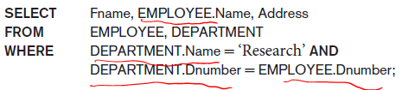

The ambiguity of attribute names also arises in the case of queries that refer to the same table twice, as in the following example. But we can use AS newName to define the new name of a table and a column as well.

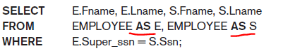

If more than one relation is specified in the FROM clause and there is no WHERE clause, then the CROSS PRODUCT—all possible tuple combinations—of these relations is selected. This will often result in incorrect and very large relations.

To retrieve all the attribute values of the selected tuples, we do not have to list the attribute names explicitly in SQL; we just specify an asterisk (*), which stands for all the attributes. The * can also be prefixed by the relation name or alias; for example, EMPLOYEE.* refers to all attributes of the EMPLOYEE table.

## Duplicates

As we mentioned earlier, SQL usually treats a table not as a set but rather as a multiset; duplicate tuples can appear more than once in a table, and in the result of a query. SQL does not automatically eliminate duplicate tuples in the results of queries, for the following reasons:

■ Duplicate elimination is an expensive operation. One way to implement it is to sort the tuples first and then eliminate duplicates.

■ The user may want to see duplicate tuples in the result of a query.

■ When an aggregate function is applied to tuples, in most cases we do not want to eliminate duplicates.

Duplicates are not possible if you have a primary key.

Anyway the DISTINCT keyword after SELECT will display unique tuples.

SELECT ALL is already implied when only writing SELECT

## Set Operators

It is possible to use the set operations from mathematical set theory, set union (UNION), set difference (EXCEPT), and set intersection (INTERSECT). These set operations apply only to typecompatible relations, so we must make sure that the two relations on which we apply the operation have the same attributes and that the attributes appear in the same order in both relations.

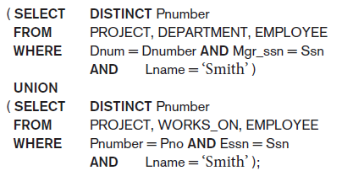

## Substring Pattern Matching

The first feature allows comparison conditions on only parts of a character string, using the LIKE comparison operator. This can be used for string pattern matching. Partial strings are specified using two reserved characters: % replaces an arbitrary number of zero or more characters, and the underscore (_) replaces a single character.

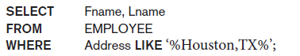

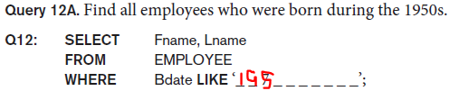

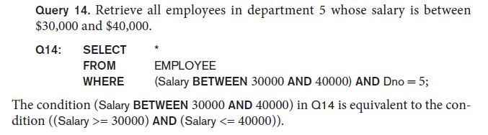

## Ordering

The default order is in ascending order of values. We can specify the keyword DESC if we want to see the result in a descending order of values. The keyword ASC can be used to specify ascending order explicitly. Order by goes after where.

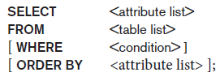

## INSERT, DELETE and UPDATE

In SQL, three commands can be used to modify the database: INSERT, DELETE, and UPDATE.

In its simplest form, INSERT is used to add a single tuple (row) to a relation (table). We must specify the relation name and a list of values for the tuple. The values should be listed in the same order in which the corresponding attributes were specified in the CREATE TABLE command

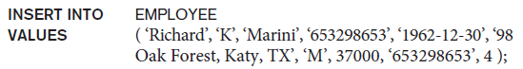

If you don’t know the order or if you only want to add partial elements then you can explicitly list these attributes and then it’s values, in the same order.

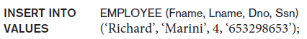

Just be sure that the missing attributes don’t have NOT NULL constraint. It is also possible to insert into a relation multiple tuples separated by commas in a single INSERT command. The attribute values forming each tuple are enclosed in parentheses.

The DELETE command removes tuples from a relation. It includes a WHERE clause, similar to that used in an SQL query, to select the tuples to be deleted. Tuples are explicitly deleted from only one table at a time. However, the deletion may propagate to tuples in other relations if referential triggered actions are specified in the referential integrity constraints of the DDL. Depending on the number of tuples selected by the condition in the WHERE clause, zero, one, or several tuples can be deleted by a single DELETE command. A missing WHERE clause specifies that all tuples in the relation are to be deleted; however, the table remains in the database as an empty table. We must use the DROP TABLE command to remove the table definition. DROP TABLE EMPLOYEE;

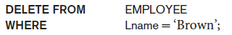

The UPDATE command is used to modify attribute values of one or more selected tuples. As in the DELETE command, a WHERE clause in the UPDATE command selects the tuples to be modified from a single relation. However, updating a primary key value may propagate to the foreign key values of tuples in other relations if such a referential triggered action is specified in the referential integrity constraints of the DDL. An additional SET clause in the UPDATE command specifies the attributes to be modified and their new values:

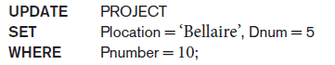

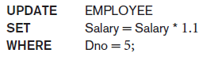

(10% raise to employee 5)

Notice that

Each UPDATE command explicitly refers to a single relation only. To modify multiple relations, we must issue several UPDATE commands.

## Comparison involving NULL and three-valued logic

SQL has various rules for dealing with NULL values. NULL is used to represent a missing value, but that it usually has one of three different interpretations—value unknown (value exists but is not known, or it is not known whether or not the value exists), value not available (value exists but is purposely withheld), or value not applicable (the attribute does not apply to this tuple or is undefined for this tuple).

It is often not possible to determine which of the meanings is intended; for example, a NULL for the home phone of a person can have any of the three meanings. Hence, SQL does not distinguish among the different meanings of NULL.

Each individual NULL value is considered to be different from every other NULL value in the various database records. When a record with NULL in one of its attributes is involved in a comparison operation, the result is considered to be UNKNOWN (it may be TRUE or it may be FALSE). Hence, SQL uses a three-valued logic with values TRUE, FALSE, and UNKNOWN instead of the standard two-valued (Boolean) logic with values TRUE or FALSE.

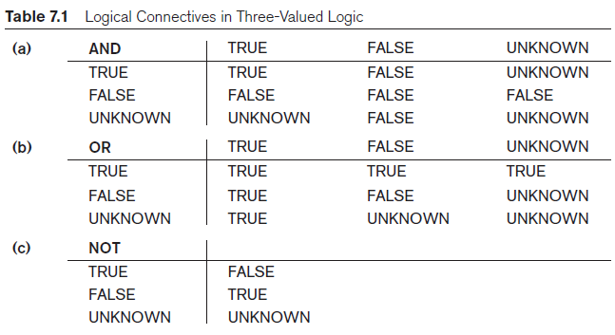

In select-project-join queries, the general rule is that only those combinations of tuples that evaluate the logical expression in the WHERE clause of the query to TRUE are selected. Tuple combinations that evaluate to FALSE or UNKNOWN are not selected (unless it is outer join).

SQL allows queries that check whether an attribute value is NULL. Rather than using = or <> to compare an attribute value to NULL, SQL uses the comparison operators IS or IS NOT**. This is because SQL considers each NULL value as being distinct from every other NULL value, so equality comparison is not appropriate.**

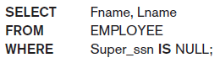

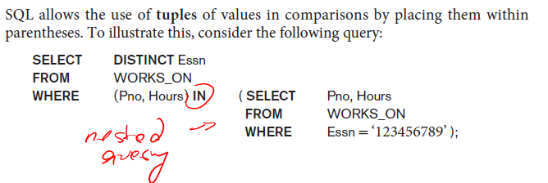

## Nested Queries

IN can also refer to a list of values:

**SELECT** name, population **FROM** world **WHERE** name **IN** ('Brazil', 'Russia', 'India', 'China');

**= ANY** and = **SOME** have the same effect as **IN**

Other operators that can be combined with ANY (or SOME) include >, >=, <, <=, and <>. The keyword **ALL** can also be combined with each of these operators.

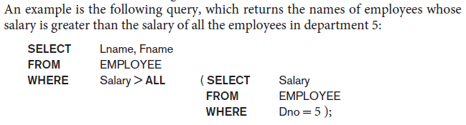

EXISTS and NOT EXISTS in SQL is used to check whether the result of a nested query is *empty* (contains no tuples) or not.

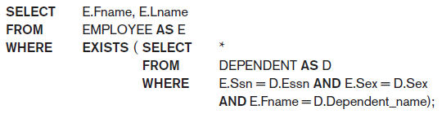

## Lecture - Joins

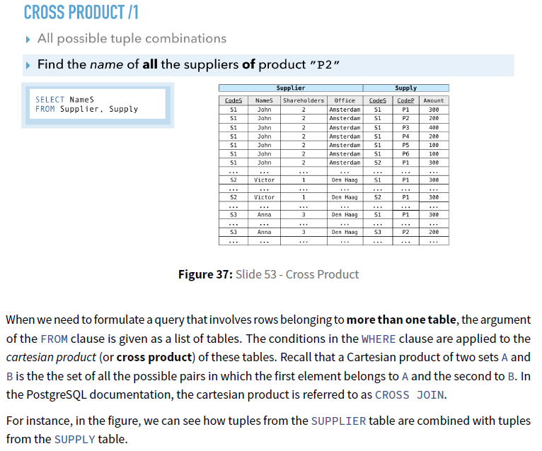



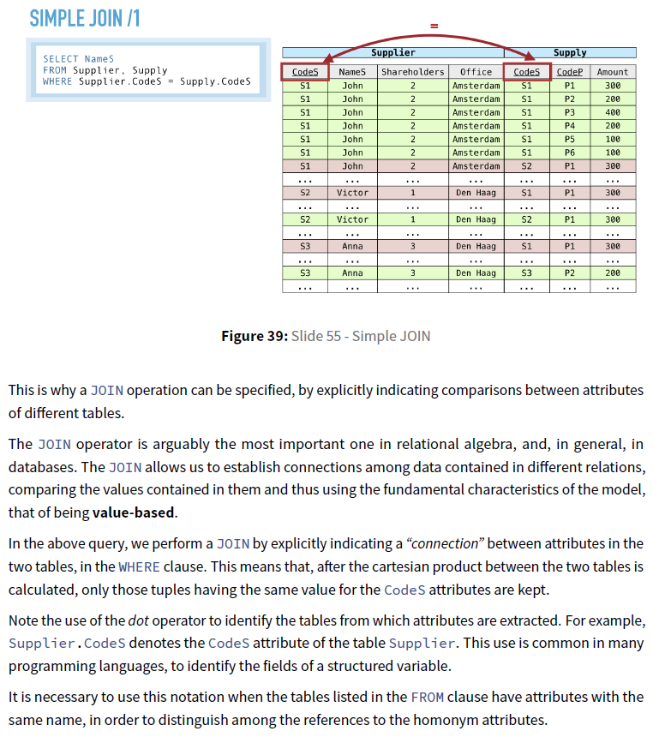



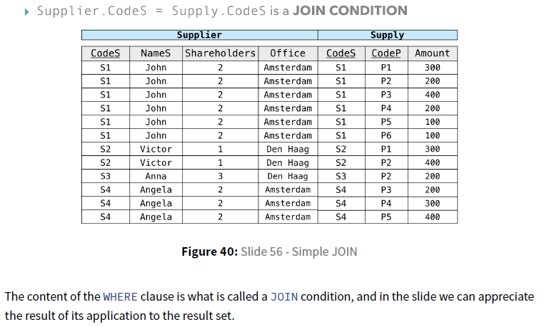

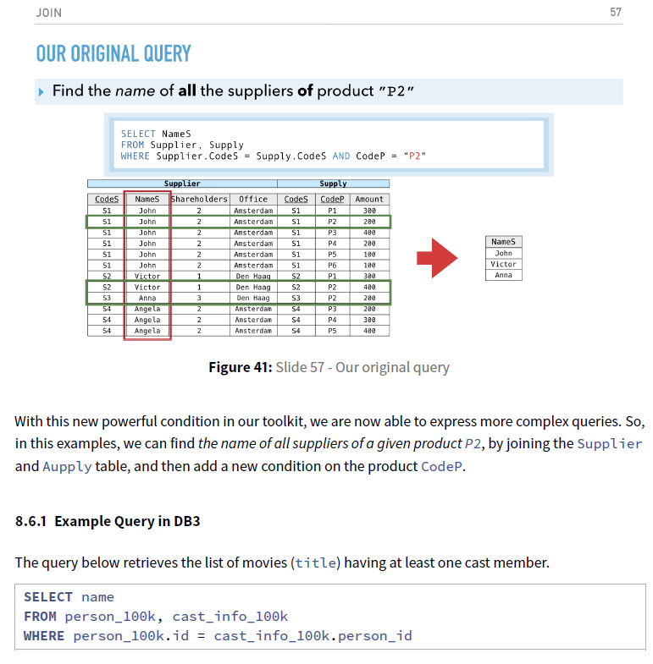

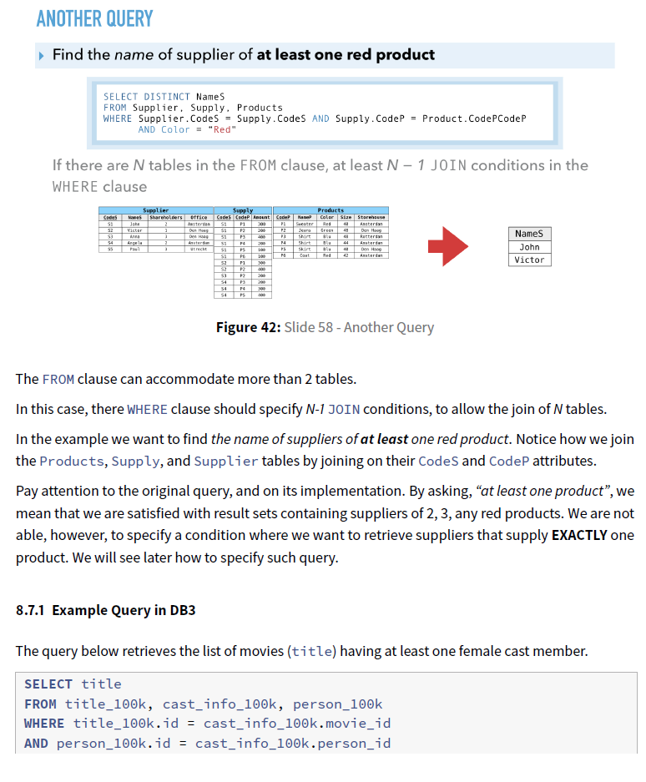

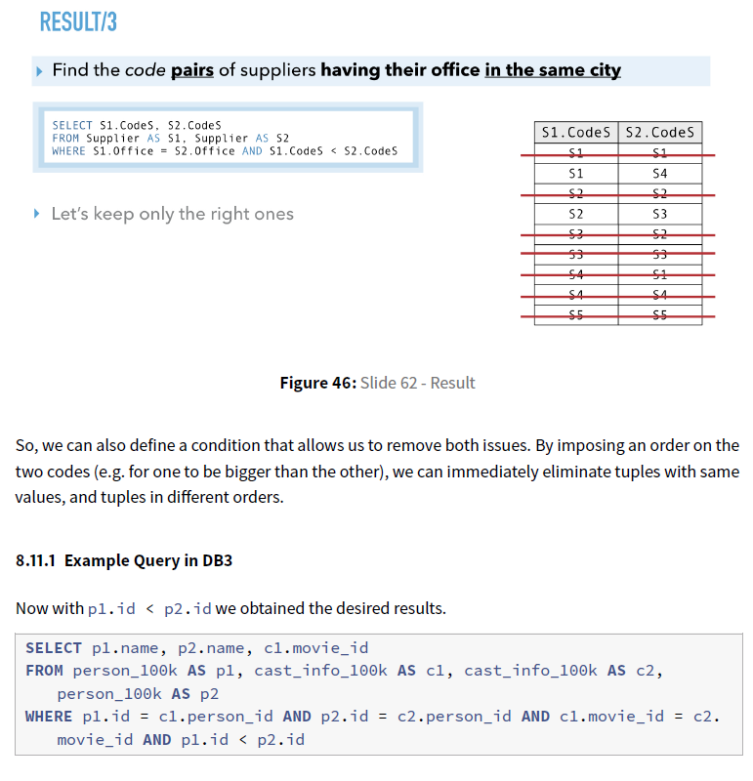

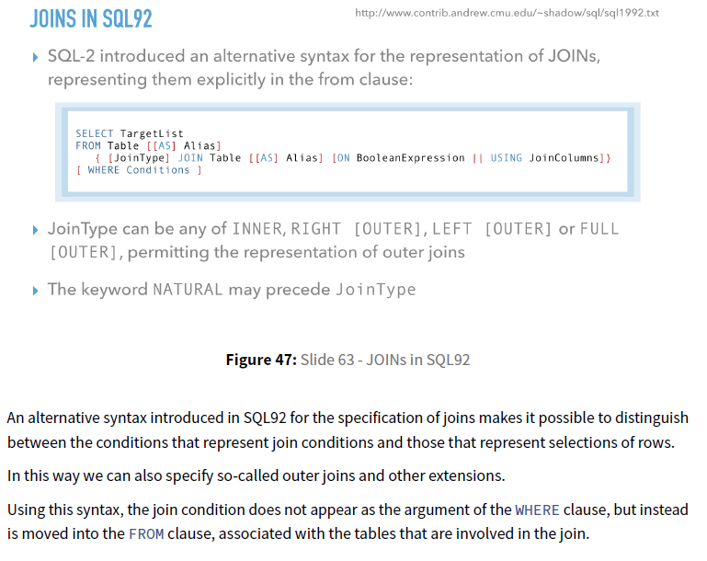

The keyword CROSS JOIN is used to specify the CARTESIAN PRODUCT operation although this should be used only with the utmost care because it generates all possible tuple combinations, some of which may not exist in the real tables and thus wrong data!

It is also possible to nest join specifications; that is, one of the tables in a join may itself be a joined table. This allows the specification of the join of three or more tables as a single joined table, which is called a multiway join.

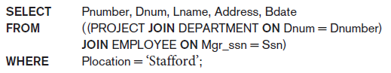

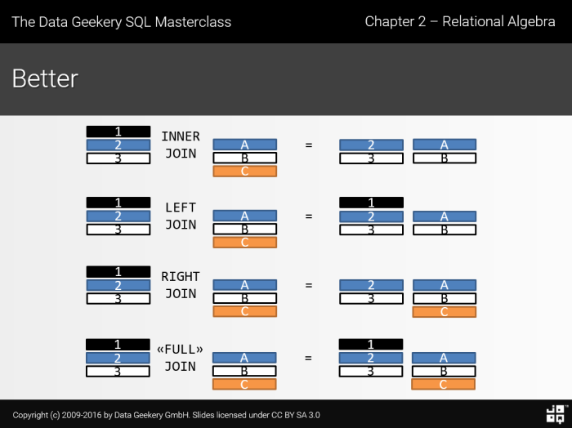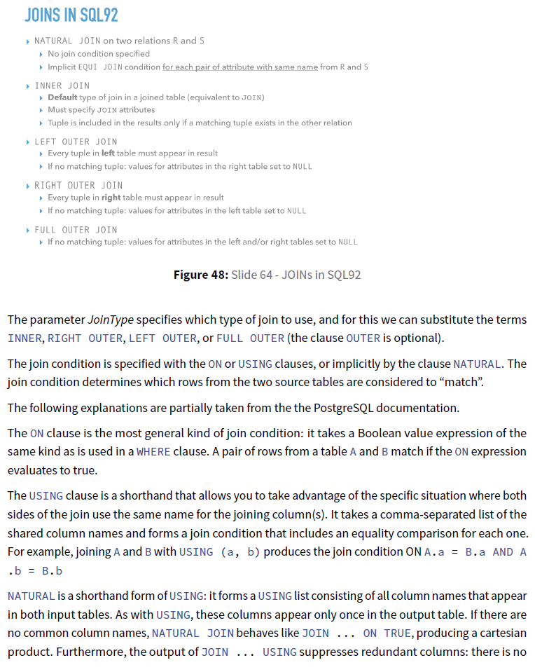

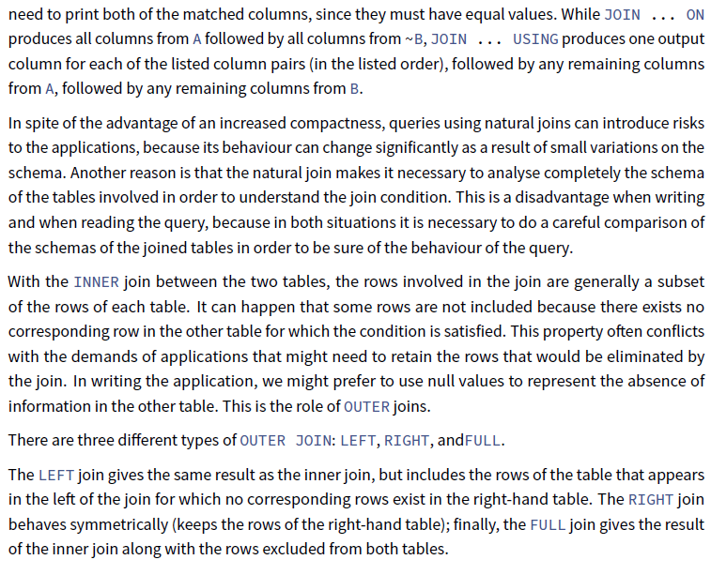

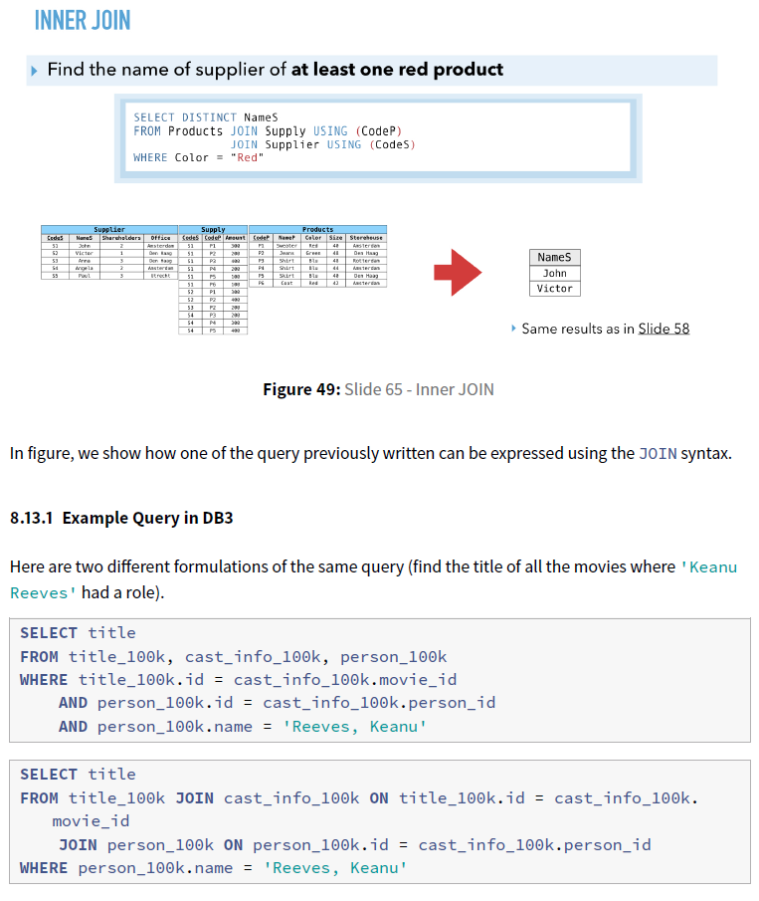

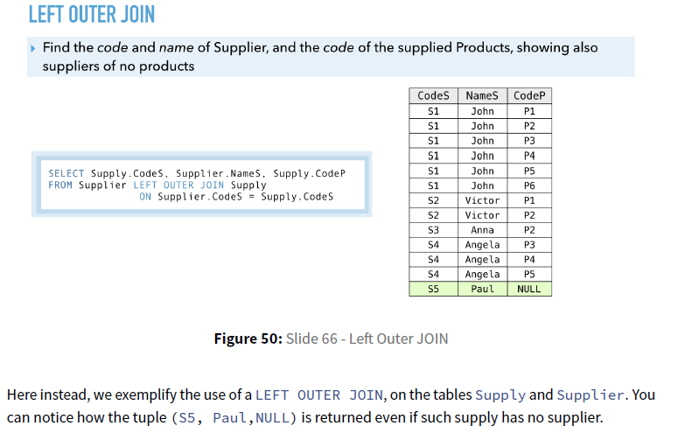

## Alter Tables

### Add column

ALTER TABLE products ADD COLUMN description text;

### Drop column

ALTER TABLE products DROP COLUMN description CASCADE;

### Add constraint

ALTER TABLE products ADD CHECK (name <> '');

ALTER TABLE products ADD CONSTRAINT some_name UNIQUE (product_no);

ALTER TABLE products ADD FOREIGN KEY (product_group_id) REFERENCES product_groups;

ALTER TABLE products ALTER COLUMN product_no SET NOT NULL;

### Drop constraint

ALTER TABLE products DROP CONSTRAINT some_name;

### Change default, data type

ALTER TABLE products ALTER COLUMN price SET DEFAULT 7.77;

ALTER TABLE products ALTER COLUMN price DROP DEFAULT;

ALTER TABLE products ALTER COLUMN price TYPE numeric(10,2);

### Renaming column, table

ALTER TABLE products RENAME COLUMN product_no TO product_number;

ALTER TABLE products RENAME TO items;

# Lecture 8

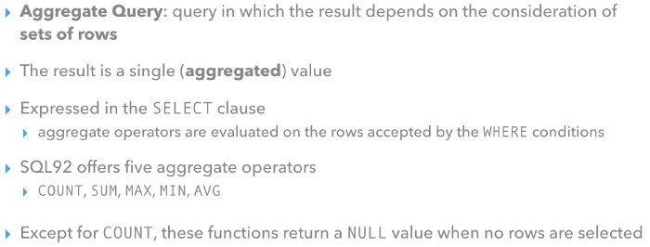

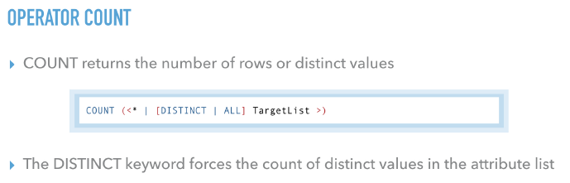

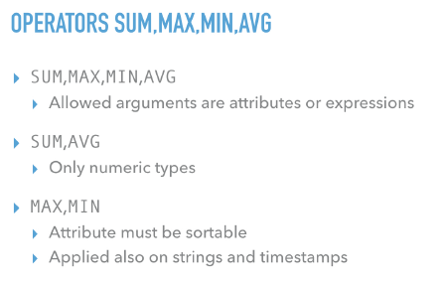

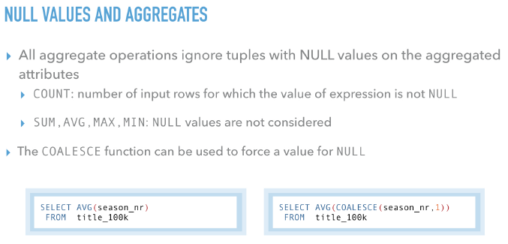

To use an aggregate function it must be explicitly stated to which subset of rows it must adhere to. That is achieved with the **GROUP BY clause**. The clause accepts as argument a set of attributes, **the query will operate separately on each set of rows that possess the same values for these set of attributes**.

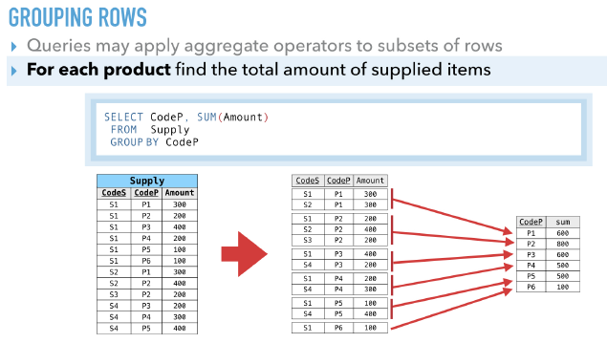

Once the rows are partitioned into subsets, **the aggregate operator is applied separately to each subset**. **Each separate result is reported as a corresponging row in the result query**.

The attributes that can appear in the select clause must be a subset of the attributes used in the GROUP BY clause. Usually it is the list of all selected attributes (except the aggregate one).

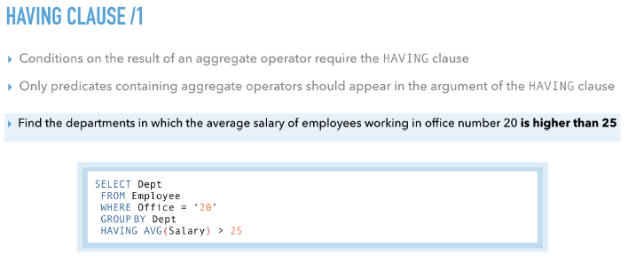

The syntax also allows for the definition of queries using the HAVING clause, without a corresponding GROUP BY clause. The having clause will also accept as argument a boolean expression of simple predicates. The simple predicates are generally comparisons between the result of the evaluation of an aggregate operator and a generic expression.

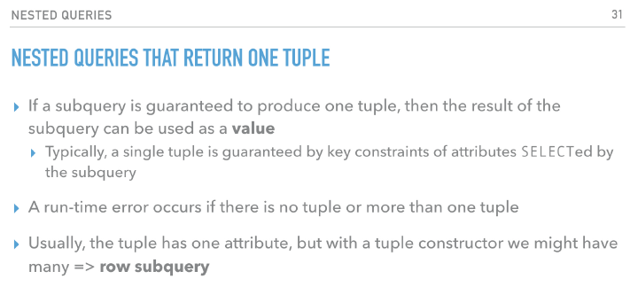

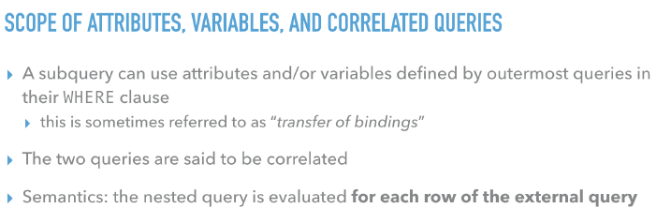

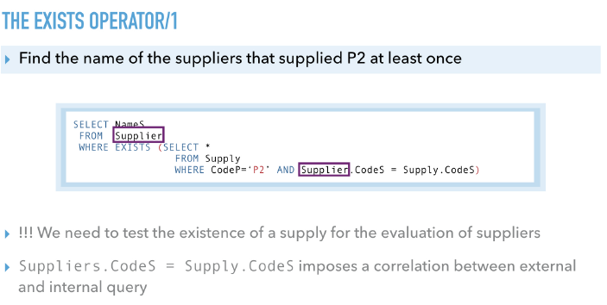

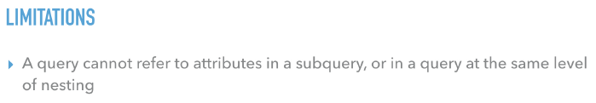

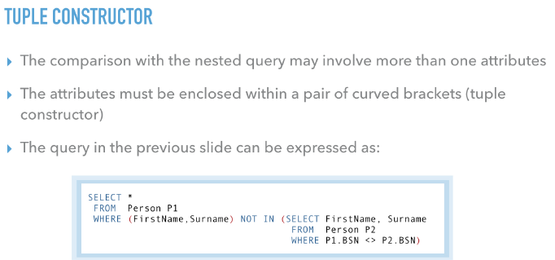

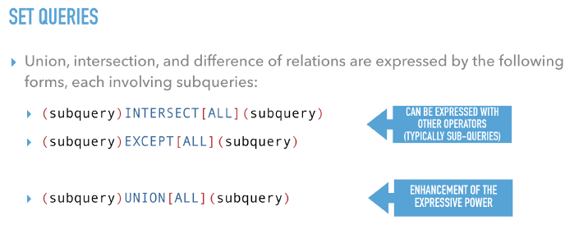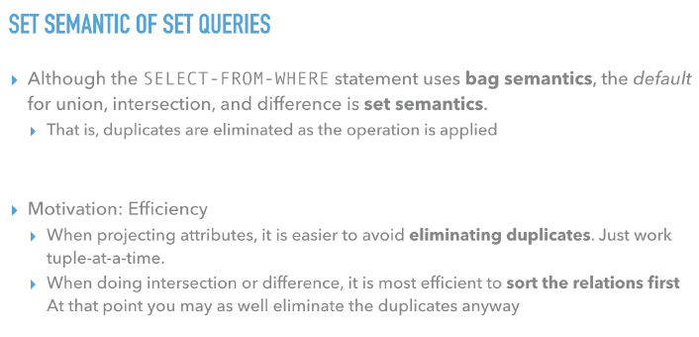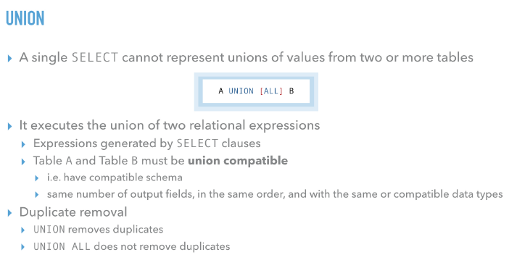

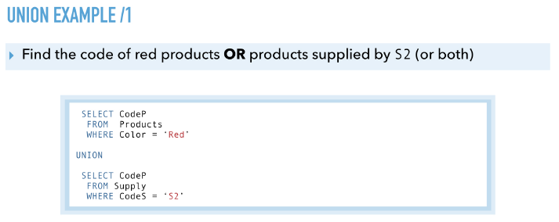

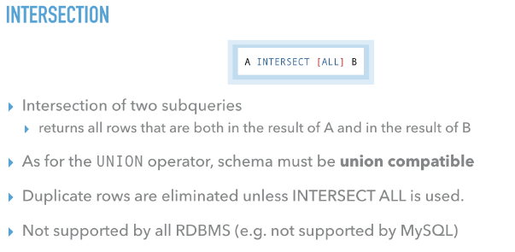

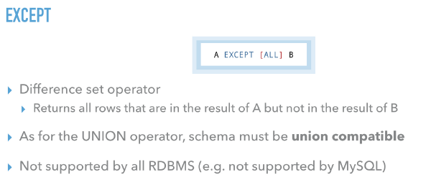

*Use of SQL for the definition of database schemas (DDL)*

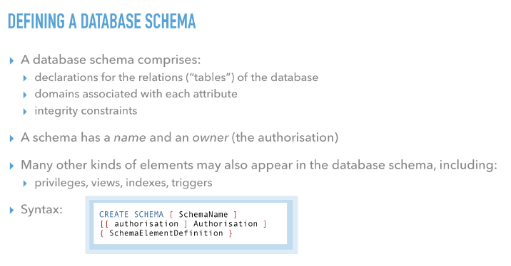

SQL makes it possible to define a database schema as a collection of objects; each schema consists of a set of domains and tables, defined by the syntax in the slide. A schema also includes indices, assertions, views and privileges. Authorization represents the name of the user who owns the schema. If the term is omitted, it is assumed that the user who issued the command is the owner. The name of the schema can be omitted and, in this case, the name of the owner is adopted as the name of the schema. After the create schema command, the user can define the schema components.

It is not necessary for all the components to be defined at the same time as the schema is created.

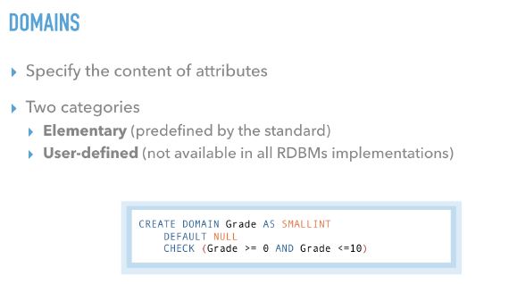

A domain is essentially a data type with optional constraints (restrictions on the allowed set of values). The user who defines a domain becomes its owner.

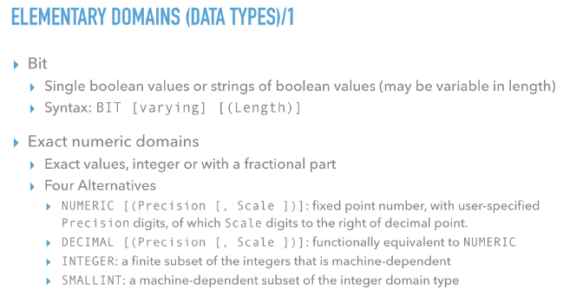

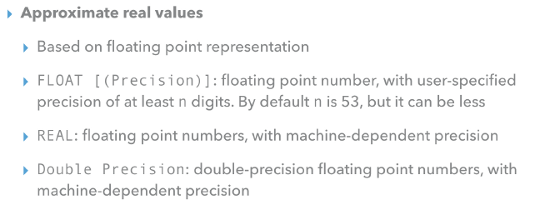

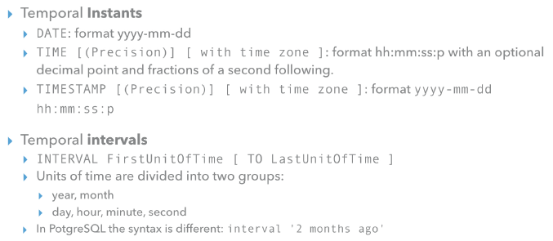

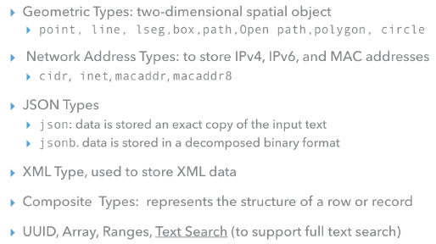

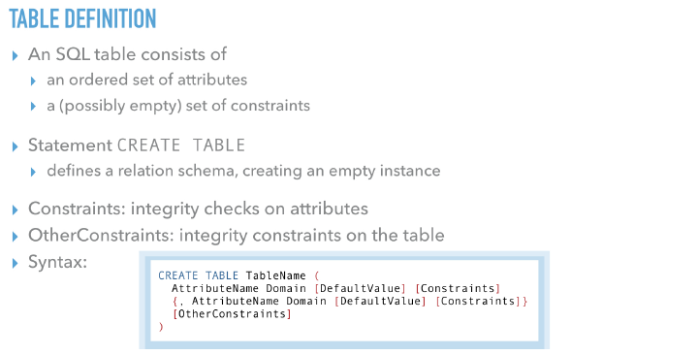

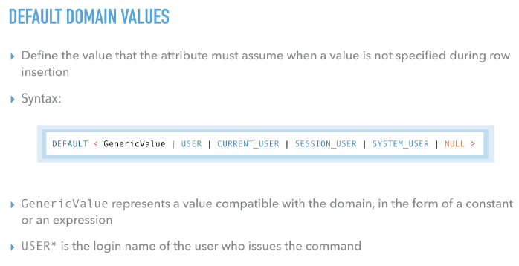

A common example is for a timestamp column to have a default of CURRENT_TIMESTAMP, so that it gets set to the time of row insertion. Another common example is generating a “serial number” for each row. In PostgreSQL this is typically done by using the SERIAL data type.

